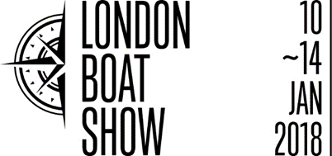

Press release
June 2017
Beneteau joins big names at London Boat Show 2018
The latest brand to sign up to the London Boat Show is the world-renowned French sail and motor boat manufacturer, Beneteau. This latest addition is hot on the heels of news that big brands are quickly signing up to take space at the acclaimed Show, following the unveiling of the re-defined event.
Beneteau has enjoyed a prominent position at the London Boat Show for many years, receiving continued business success. The re-imagined Show will offer further business opportunities and new audiences to the Beneteau brand.
Jean Francois Lair, Export Director at Beneteau, comments: “We welcome the changes British Marine Boat Shows has made to the London Boat Show with much enthusiasm and we are eager to see the results they will deliver to this important UK boat show. Since our return in 2015, the London Boat Show has remained a fundamental platform for Beneteau’s brand exposure in the UK, as well as a valuable event to make sales and meet potential new business. We are confident about the future success of the London Boat Show for years to come and we will be investing in 2018’s Show with a strong Beneteau representation.”
Murray Ellis, Chief Officer of Boat Shows at British Marine add: “The London Boat Show is renowned for showcasing an array of international names from around the world, alongside the best of Britain’s iconic marine industry, and we’re delighted that Beneteau has confirmed their presence at the forthcoming Show.
“We are confident that the dynamic changes being made to this iconic Show will prove successful in delivering something brand new and unique for both our visitors and exhibitors and we look forward to welcoming more big company names in the coming months.”

ENDS

For more information, please contact Annabel Wildey on 01784 223811 or email awildey@britishmarine.co.uk.

Notes to editors:
About British Marine Boat Shows:

The London Boat Show at ExCeL London and TheYachtMarket.com Southampton Boat Show are organised by British Marine Boat Shows, a division of British Marine.

The 2018 London Boat Show will take place from 10-14 January 2018 at ExCeL London. For more information visit www.londonboatshow.com

TheYachtMarket.com Southampton Boat Show 2018 takes place from 14–23 September 2018, see www.southamptonboatshow.com for more details

