Release date: 13th November 2017
METStrade 14th – 16th November 2017
03.128. British Pavilion

Crewsaver announces fresh new look for 2018 watersports range
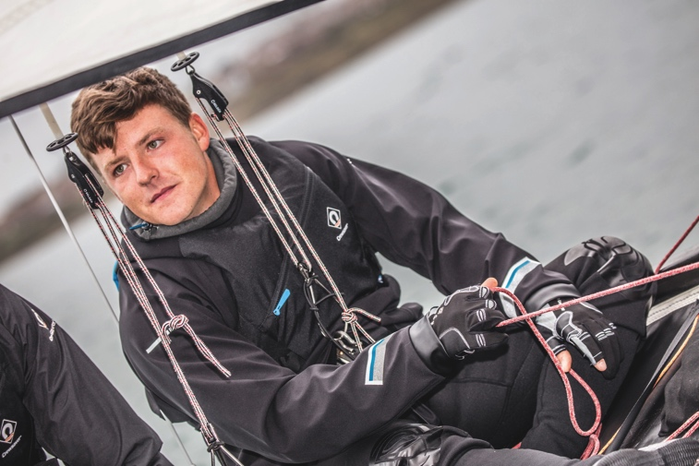
Crewsaver will launch its 2018 watersports range to the industry at METStrade 14th-16th November 2017. The range, which has a fresh new look and features advanced fabrics, is packed full of adventure-aiding essentials, including performance clothing, accessories and luggage. The new range is aimed at all watersport enthusiasts and joins Crewsaver’s recently launched Atacama drysuits and Fusion 3D buoyancy aids. Crewsaver, who has a proven track record in this market, is celebrating its 60th anniversary this year and can trace its history of manufacturing these types of products to the 1960s!

Performance Clothing
Lightweight and compact, the Crewsaver Race Top is an unmissable addition for any watersport enthusiast, setting the bar for breathable performance thermals. Its waterproof fabric with a 10K hydrostatic head is fused with soft internal fleece lining providing the thermal protection needed to stay on the water for longer. Another benefit is the additional thermal protection offered by the foldable collar for optional face coverage. Child/ Junior RRP £68. Adult RRP £80

The Crewsaver Spray Top is the perfect solution for those seeking the next level in performance technology. The durable fabric has a hydrostatic head waterproof rating to 20K and is breathable up to 6K, making this one of the most advanced and affordable spray tops on the market. With uniquely tailored panels, the articulated shape of this spray top provides much sought-after unhindered freedom of movement. Child/ Junior RRP £64.50. Adult RRP £76.50

Gloves
Protection, warmth and dexterity. The Crewsaver glove collection provides everything needed to keep hands happy whilst on the water. With short finger, three finger and neoprene options available (all integrated with supple Amara palm protection) there is a style to suit, no matter what the demand. Gloves RRPs £19 - £26

Footwear
Choose from a wide range of styles and fabrics including a choice of 5mm or 3mm neoprene construction, zip entry vs slip-on and boot vs shoe. All designed from highly flexible and durable materials with easy donning in mind. Look out for the zip boot and ¾ boot, which feature reinforced panelling, perfect protection for hiking and trapezing. Footwear RRPs £20 - £44

Luggage
Built for adventure. The new luggage collection is practical, stylish and tough. Featuring traditional holdalls, drybags and wet/dry hybrids, these bags are truly life proof. Luggage RRPs £18 - £60

Crewsaver at M ETStrade 2017
Crewsaver is delighted to announce its attendance at METStrade 2017, the world’s biggest and most visited B2B leisure marine equipment show. Join the Crewsaver team on the 14th – 16th November (03.128, British Pavilion) for;
- New Product range unveiling
- 60 year anniversary celebrations
- Expert product advice
- Marketing support
- Find out more about the #LifejacketSafe & product registration campaigns

To book an appointment with a Crewsaver representative, please contact Hazel Proudlock; hazel.proudlock@survitecgroup.com.

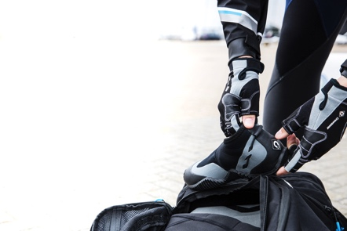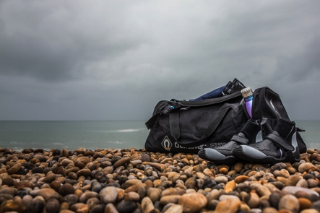
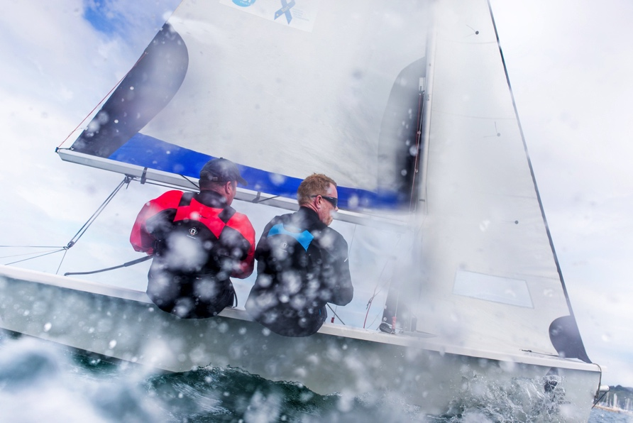
//ENDS//

For media information, hi-res images or product tests please contact:

Crewsaver
Hazel Proudlock, Marketing Dept
T +44 (0) 1329 820406
E hazel.proudlock@survitecgroup.com

Alison Willis – Marine Advertising Agency Ltd
T +44 (0) 23 9252 2044
E Alison@marineadagency.com

Notes to Editors

Crewsaver is a world-leading manufacturer of marine safety equipment and clothing for the commercial and leisure marine industries. Based in Gosport, Hampshire, the company designs and manufactures bespoke safety equipment for several countries’ Special Forces, and the aviation and oil industries. Crewsaver is the only company to hold an exclusive contract to supply lifejackets to the UK government’s Environment Agency and the Royal National Lifeboat Institution (RNLI). They are part of the Survitec Group.

www.crewsaver.com

Survitec Group Survitec is a global leader in survival and safety solutions to the marine, defence, aviation and offshore markets. Survitec has over 3,000 employees worldwide covering 8 manufacturing facilities, 15 offshore support centres and over 70 owned service stations. It is further supported by a network of over 500 3rd party service stations and distributors. Across its 160-year history, Survitec Group has remained at the forefront of innovation, design and application engineering and is the trusted name when it comes to critical safety and survival solutions.

www.survitecgroup.com

