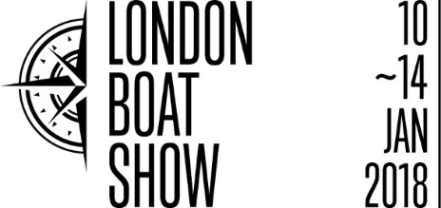

**Press release**

24 OCTOBER 2017

**New format for London Boat Show attracts**

**new exhibitors**

**Further plans and Show layout unveiled**

The new five-day London Boat Show ([10-14 January 2018](x-apple-data-detectors://9)) continues to prove popular with industry, with a variety of new exhibitors enquiring to take space.

Following on from a successful [TheYachtMarket.com](http://theyachtmarket.com/) Southampton Boat Show 2017, some 162 companies, who didn’t exhibit at London 2017, have enquired about exhibiting at the forthcoming event. Significant changes to the Show, specifically the new five-day format and broadening the appeal of the Show to new audiences, have sparked this interest.

To date, exhibitor numbers for the 2018 event – either those who have signed contracts or are having significant, detailed conversations about being present - match the total numbers at London 2017. These include recent sign ups such as Andark, Hobie Cat, Sail Ionian and Arba Nautika. Further conversations taking place with an additional number of businesses will ensure more companies and brands than at previous recent Shows, giving visitors a fuller experience.

This demand, together with feedback from a cross section of the industry, has enabled plans to be further redefined and strengthened. London Boat Show takes centre stage, with the many boats on display being the stars of the Show. The new Boating & Watersports Holiday Show has also delivered real interest, from the likes of Sunsail, Sailing Holidays and DI Yachting, with this feature Show widening the appeal to new audiences, offering further marketing opportunities and taking advantage of the prime holiday booking period. Bespoke London has been repositioned as a feature element within the London Show, centred around a champagne bar with a complementary retail experience. This allows for more boats and more marine exhibitors to take space.

Further enhancing these plans help to ensure incredible business opportunities for exhibitors whilst providing visitors with a fantastic event with new things to see and do at every turn. Attractions at the Show this year offer visitors the chance to learn, have a go and or plan family adventures:

* The Lock & Waterside Pub celebrates the inland network and the Broads in Norfolk whilst the Beach Club & Activity Pool give visitors the chance to learn the art of dinghy sailing, kayaking or Stand Up Paddleboarding
* The Legends Theatre and Practical Boating Theatre provide expert advice, live and practical demonstrations plus the chance to see, hear and meet the legends of the sailing world
* The Show’s signature bar, the Black & White Bar returns, alongside the all-new Yachtsman’s Bar
* Bespoke London offers visitors the chance to enjoy an element of luxury whilst indulging in a glass of champagne

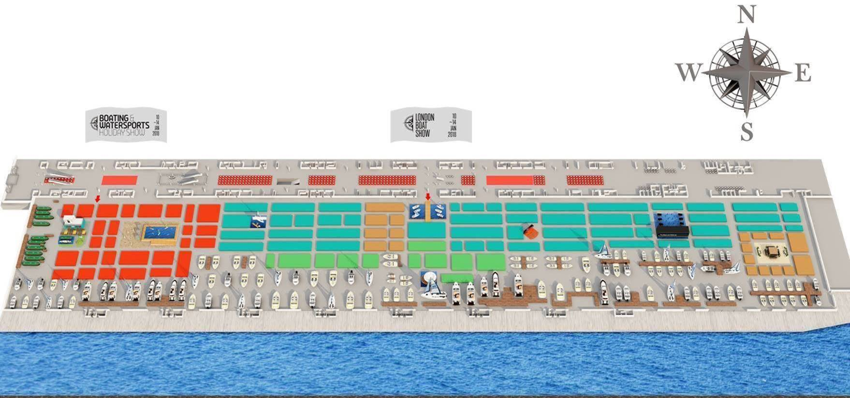

**ENDS**

For more information, please contact Annabel Wildey on 01784 223811 or email [awildey@britishmarine.co.uk](mailto:awildey@britishmarine.co.uk).

**Notes to editors:**

**About British Marine Boat Shows:**

The London Boat Show at ExCeL London and TheYachtMarket.com Southampton Boat Show are organised by British Marine Boat Shows, a division of British Marine.

The 2018 London Boat Show will take place from 10-14 January 2018 at ExCeL London. For more information visit [www.londonboatshow.com](http://www.londonboatshow.com)

TheYachtMarket.com Southampton Boat Show 2018 takes place from 14–23 September 2018, see [www.southamptonboatshow.com](http://www.southamptonboatshow.com) for more details