News Release

9th November 2017

Ancasta announces London Boat Show 2018 line-up from Beneteau and Prestige

Ancasta has announced the line-up of new boats from Prestige and Beneteau that will be heading to London Boat Show (10-14 January 2018).
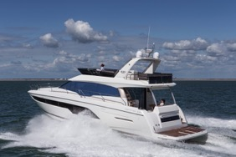

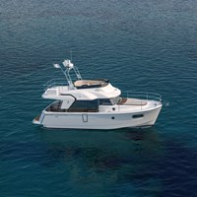
UK buyers looking to stay local and see new boats from these top brands will not be disappointed and should contact Ancasta to make appointments to view (enquiries@ancasta.com, +44 2380 450000, www.ancasta.com ). Prestige is once again showing the strategic importance of the UK market by bringing three of its luxury motor yachts to the show – the Prestige 460, 520 and 630 will all be available to view. The Prestige range is founded on the key concepts of having living spaces all on one level, giving those onboard 360º panoramic views and creating an independent owner’s suite. These set Prestige apart from its competitors. The brand is thriving with over 3,600 Prestige motor yachts currently cruising waters around the globe.
See the Prestige 630 in London with Ancasta

From Beneteau Sail, UK buyers will be able to see a range of yachts from the Oceanis range, which produces elegant, fast, easy-to-handle yachts. The Oceanis 38.1, 41.1 and 35.1 will all be presented in London.

Beneteau Power brings the Swift Trawler 35, one of the latest models in the popular Swift Trawler range with a semi-planing flared hull and a distinctive long cruise temperament. A wheelhouse with a 360º view bathes the interior in natural light. From the fast, fun Gran Turismo range, visitors will be able to experience the Gran Turismo 40 and 46, both of which feature the Beneteau-designed Air Step® planing hull, twin high-performance, high-technology engines and the latest innovations for great sea-keeping.
See the Swift Trawler 35 in London with Ancasta

The list of boats on show is as follows:

Prestige MotorYachts

Prestige 460/520/630

Beneteau Sail

Oceanis 38.1/41.1/35.1

Beneteau Power

Gran Turismo 40/46

Swift Trawler 35

Contact Ancasta now to make an appointment to view any of the above, email enquiries@ancasta.com or call +44 2380 450000.

For more information visit:

https://www.ancasta.com/events/london-boat-show-2018/

ENDS

Notes to editors
- Ancasta International Boat Sales has 14 offices across Europe
- Ancasta is the UK’s largest Prestige Luxury Motor Yachts dealer, the UK’s largest Beneteau Power and the UK’s largest Beneteau Sail dealer
- Ancasta is exclusive UK dealer for Lagoon Catamarans
- In addition Ancasta is a new boat dealer for CNB Yacht Builders and McConaghy Yachts
- The Ancasta Group incorporates Hamble Yacht Services Refit & Repair and Advanced Rigging and Hydraulics, both operating from Port Hamble.
- For more information on Ancasta visit www.ancasta.com
Media enquiries via Marine Advertising Agency: Alison Willis - alison@marineadagency.com Tel: 023 9252 2044

