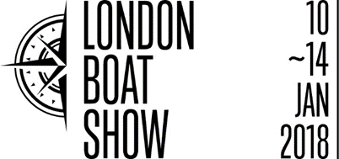

Press release
June 2017

Sunseeker International confirmed as latest exhibitor at the 2018 London Boat Show
British Marine Boat Shows is delighted to announce that Sunseeker International will be exhibiting at the forthcoming re-defined London Boat Show in January. Hot on the heels of news of the exciting changes to the Show, Sunseeker International will be displaying a stunning selection of models from its luxury motor yacht range.
Sunseeker International has been a notable part of the London Boat Show for 60 years, showcasing their brand to thousands of visitors at the event. The re-imagined Show will offer further business opportunities, networking and new audiences to the Sunseeker family.
Sean Robertson from Sunseeker International comments: “We are delighted to be returning once again to the world-famous London Boat Show. The new changes that have been announced promise for an exciting start to the 2018 season and we’re very much looking forward to being a part of it.”
Murray Ellis, Chief Officer of Boat Shows at British Marine, comments: “We’re pleased to welcome Sunseeker International to the 2018 London Boat Show, a key British manufacturer. I am confident that the new plans we have in place for next year’s Show will drive new visitors to the event, introducing them to the Sunseeker brand amongst others.”
Murray concludes: “Over the coming weeks, we look forward to confirming the attendance of a number of other key brands at the 2018 Show and look to unveil more state-of-the-art attractions and concepts for next year’s event.”
Alongside Sunseeker International, other UK and international companies are continually confirming their attendance at the London Boat Show 2018, including Beneteau, Dometic, English Harbour Yachts, Ribeye, Garmin and Navigators & General. For the full list of confirmed exhibitors, click here.
Starting on Wednesday 10 January until Sunday 14 January, the London Boat Show 2018 will offer something for everyone. Whilst the boats will remain the stars of the Show, located at the heart of the event, they will be complemented by the new-dynamic Boating & Watersports Holiday Show.

ENDS

For more information, please contact Annabel Wildey on 01784 223811 or email awildey@britishmarine.co.uk.

Notes to editors:
About British Marine Boat Shows:

The London Boat Show at ExCeL London and TheYachtMarket.com Southampton Boat Show are organised by British Marine Boat Shows, a division of British Marine.

The 2018 London Boat Show will take place from 10-14 January 2018 at ExCeL London. For more information visit www.londonboatshow.com

TheYachtMarket.com Southampton Boat Show 2018 takes place from 14–23 September 2018, see www.southamptonboatshow.com for more details

