Cupernham House, Cupernham Lane, Romsey, Hampshire SO51 7LF T +44 (0) 1794 521 111 F +44 (0) 1794 521 271
techsupport@westsysteminternational.com westsysteminternational.com

WSI announces live demos of WEST SYSTEM® Epoxy Products at London Boat Show
7 December 2017
West System International (WSI) has announced that it will be running a series of live demonstrations covering the use of WEST SYSTEM Epoxy Products at London Boat Show 2018. As well these demonstrations, visitors to stand LB090 will be able to discuss their projects face to face with WSI’s technical experts and gain advice on the use of epoxy for boat building, repair and maintenance in addition to using epoxy to construct composites structures.
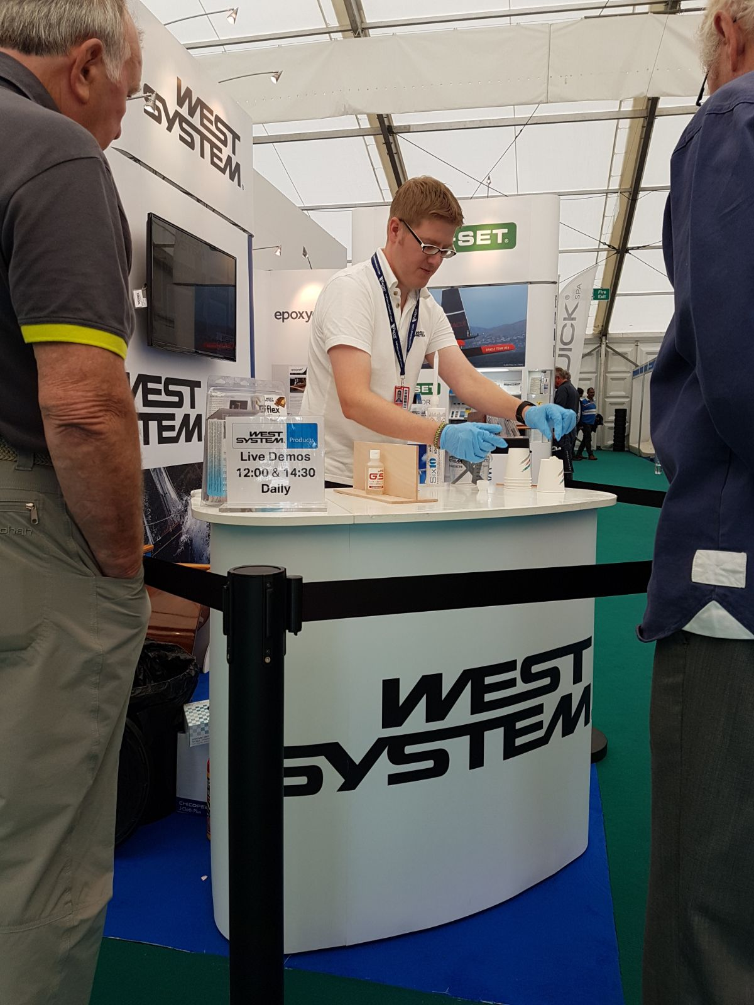
The live demonstrations, showing visitors how to get the most from their epoxy products, will be held at 12:00 and 14:30 each day.
“Our live demonstrations are something that we really look forward to at boat shows. We value the chance to share our epoxy knowledge, meet the people who are using our products and hear about their projects, so we can’t wait for the re-defined London Boat Show 2018.” - Ian Oliver, Managing Director of WSI.
WEST SYSTEM and PRO-SET products are market- leading and trusted by both professional boat builders and home project hobbyist’s worldwide.
West System International, manufactures WEST SYSTEM and PRO-SET epoxy products in the UK under license from Gougeon Brothers Inc., and distributes these leading brands across the whole of Europe, Africa and the Middle East via a well-respected distribution network.
This year’s re-defined and re-imagined London Boat Show runs from 10th to 14th January 2018.
ENDS
Notes to Editors:
West System International (a division of Wessex Resins and Adhesives) manufactures and provides international support for the world-renowned WEST SYSTEM and PRO-SET marine epoxy brands. Since Michigan boatbuilding brothers Meade, Joel and Jan Gougeon first experimented with the bonding power of epoxy over 50 years ago, the WEST SYSTEM® and PRO-SET® product ranges have become the epoxies of choice for private boat owners, boat manufacturers, chandlers and naval engineers throughout the world. West System International (WSI) has been working in partnership with Gougeon Brothers, Inc. for more than 36 years, manufacturing WEST SYSTEM and PRO-SET epoxies here in the UK. WEST SYSTEM and PRO-SET epoxy systems have a long-distinguished history that has earned a unique place at the heart of the worldwide epoxy user community. Whether you need an epoxy for laminating, bonding, coating, tooling or infusion, the combined breadth of WEST SYSTEM and PRO-SET products will provide the solution. Both ranges have passed extensive quality testing and are certified by Lloyds Register.
Media enquiries:
Marine Advertising Agency – Alison Willis, Alison@marineadagency.com 023 9252 2044
West System International – Hamish Cook, Hamish.cook@wessex-resins.com 01794 521 111

