For immediate release:
18th December 2017
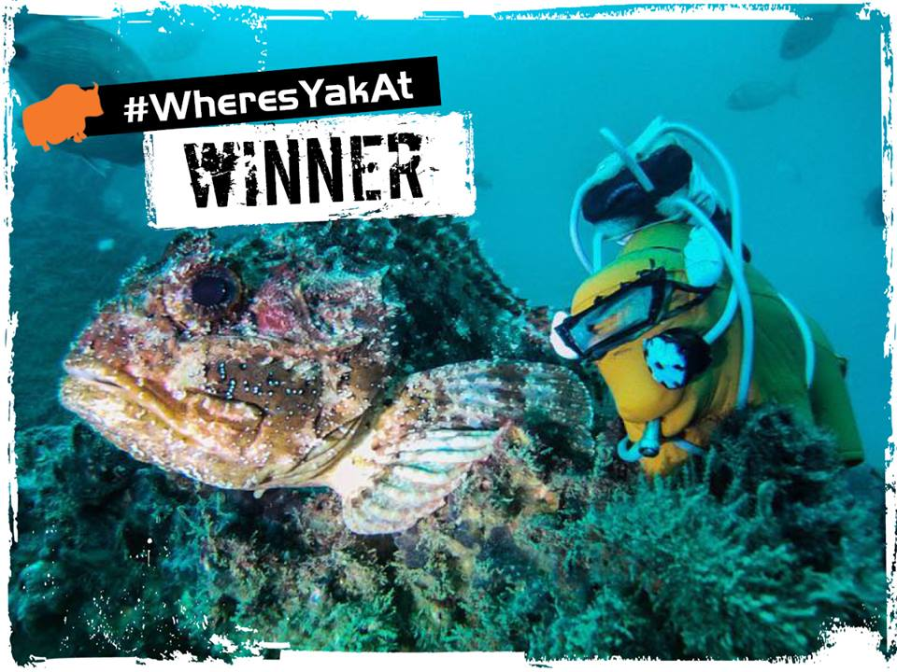
#WheresYakAt & #WheresYakAtTripleUp – Christmas comes early as winners announced!

This year Yak Adventure Equipment distributed thousands of orange Popsicle Yaks to the paddling community, with the aim of capturing as many images as possible of Yak out on his adventures. The winners have now been announced with the most adventurous Yak out there receiving £500 worth of Yak gear! In addition, for the Yak addict who had collected both blue and green Yaks from the previous #WheresYakAt competitions as well as this year’s orange Yak, the #WheresYakAtTripleUp challenge also ran! The winner of #WheresYakAtTripleUp receives a whopping £1,000 worth of Yak gear!

WINNERS ANNOUNCED
The winners of both #WheresYakAt and #WheresYakAtTripleUp are as follows:

· CONGRATULATIONS WILL FAULKNER who took 'Jack the Yak' diving in Portugal with his own custom dive kit! He wins £500 worth of Yak gear! #WheresYakAt

· CONGRATULATIONS to FIONA KELLY, who has been crowned victorious in the #WheresYakAtTripleUp competition! Fiona has perfectly captured the roadtrippin' adventure vibes that we love so much! It also looks like the squishy Yak squad made a friend!

SPECIAL MENTIONS

Yak also couldn’t help but award a number of special mentions to the following, each photographer will receive a pair of Yak paddle mitts for the brilliant images shared.

· Woah! Yak goes cliff camping!! Great shot Hi-Impact Simon! #WheresYakAt

· Waterside adventures are what summer days are made for! Awesome photo Matthew Cutler! #WheresYakAt

· We're 100% feeling these camp vibes - captured by Caroline Fry! Bring back the summer! #WheresYakAt

//ENDS//

For media information, hi-res images or product tests please contact:

Hazel Proudlock, Marketing Dept - Yak Adventure Equipment
T +44 (0) 1329 820406
E hazel.proudlock@survitecgroup.com

Or

Alison Willis – Marine Advertising Agency Ltd
T +44 (0) 23 9252 2044
E Alison@marineadagency.com

Notes to Editors
Part of the Survitec Group which also owns Crewsaver. Yak Adventure Equipment produces and manufactures products that are purposely designed for whitewater, recreational and touring kayaking as well as canoeing. A wide range of products suit all styles and experience, giving paddlers more choice and opportunity to enjoy their sport with total peace of mind. Yak’s products include buoyancy aids, drysuits, cags, trousers, spray decks, gloves, footwear, headwear and buoyancy bags. Together with Crewsaver, Yak has 60 years of experience manufacturing marine safety products that combine cutting edge technology with high performance and ultimate practicality.
www.yakadventureequipment.com

Survitec Group is a global leader in survival and safety solutions to the marine, defence, aviation and offshore markets. Survitec has over 3,000 employees worldwide covering 8 manufacturing facilities, 15 offshore support centres and over 70 owned service stations. It is further supported by a network of over 500 3rd party service stations and distributors. Across its 160-year history, Survitec Group has remained at the forefront of innovation, design and application engineering and is the trusted name when it comes to critical safety and survival solutions.
www.survitecgroup.com

