For Immediate Release: 15.01.18
Boot Düsseldorf: 20.01.18 – 28.01.18
Crewsaver Stand: Hall 11, B42
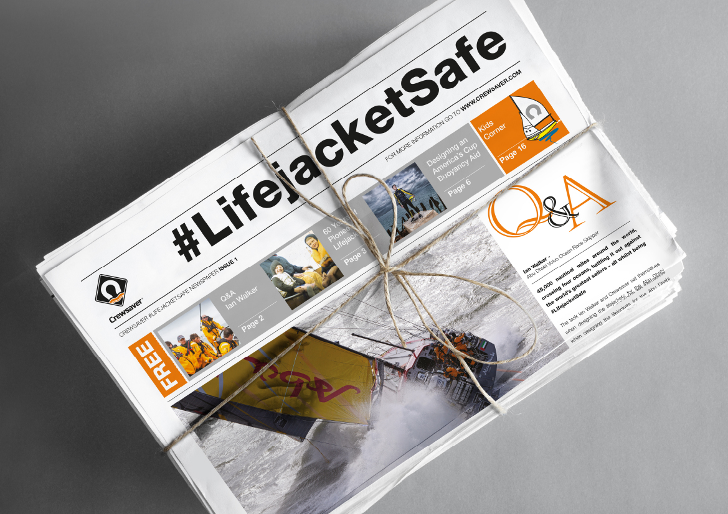
Pioneering #LifejacketSafe newspaper now available in German for Boot Düsseldorf 2018
Translated specially for Boot Düsseldorf in conjunction with German distributor, Nordwest-Funk GmbH (Hall 11, B41), the #LifejacketSafe newspaper is packed full of lifejacket safety tips, guest articles and games. The newspaper aims to highlight the importance of the trusted (and sometimes neglected) lifejacket. Visitors to Boot Düsseldorf can pick up their free copy from the Crewsaver stand (Hall 11, B42) to get an insight into the importance of maintaining their lifejacket and discover ways they can keep it action ready, should the unexpected happen.
In addition, the newspaper explores the history of the lifejacket, its origins and how lifejacket technology has developed - today’s lifejackets would certainly be unrecognisable to the seafaring community of the 1700’s! Plus, with Crewsaver having celebrated its 60th anniversary last year, readers can also reflect (and reminisce!) on some of the lifejacket manufacturer’s key milestones. Look out for 60 Years of Pioneering Lifejackets on page 3.
The #LifejacketSafe newspaper – a sneak peek
- Q&A – Ian Walker
- Designing an America’s Cup buoyancy aid
- Kid’s corner
- #LifejacketSafe safety tips
- Which lifejacket when?
- Take the #LifejacketSafe Challenge - WIN the ultimate lifejacket package
- Flying with your lifejacket
- Lifejackets for defence operatives
And much more!
“As a leading lifejacket manufacturer, our service to our customers does not simply stop at the initial supply. We want to help our customers keep as safe and as well informed as possible through the entire life of their product. This newspaper aims to do just that.” - Hannah Burywood, Crewsaver Marketing Manager.
Crewsaver, which champions lifejacket safety through its #LifejacketSafe campaign, aims to increase safety awareness by highlighting the importance of not only wearing a personal flotation device, but also making sure it is worn correctly and is well maintained. The #LifejacketSafe newspaper embodies this campaign and Crewsaver’s philosophy perfectly and the company hopes readers find it an inspiring and enlightening read.
//ENDS//

For media information, hi-res images or product tests please contact:

Crewsaver
Hazel Proudlock, Marketing Dept
T +44 (0) 1329 820406
E hazel.proudlock@survitecgroup.com

Marine Advertising Agency Ltd
Alison Willis
T +44 (0) 23 9252 2044
E Alison@marineadagency.com

Notes to Editors

Crewsaver is a world-leading manufacturer of marine safety equipment and clothing for the commercial and leisure marine industries. Based in Gosport, Hampshire, the company designs and manufactures bespoke safety equipment for several countries’ Special Forces, and the aviation and oil industries. Crewsaver is the only company to hold an exclusive contract to supply lifejackets to the UK government’s Environment Agency and the Royal National Lifeboat Institution (RNLI). It is part of the Survitec Group.

www.crewsaver.com

Survitec Group Survitec is a global leader in survival and safety solutions to the marine, defence, aviation and offshore markets. Survitec has over 3,000 employees worldwide covering 8 manufacturing facilities, 15 offshore support centres and over 70 owned service stations. It is further supported by a network of over 500 3rd party service stations and distributors. Across its 160-year history, Survitec Group has remained at the forefront of innovation, design and application engineering and is the trusted name when it comes to critical safety and survival solutions.
www.survitecgroup.com

