News Release

FOR IMMEDIATE RELEASE

11th January 2018

Marine companies honoured at British Marine Trades Association Awards dinner

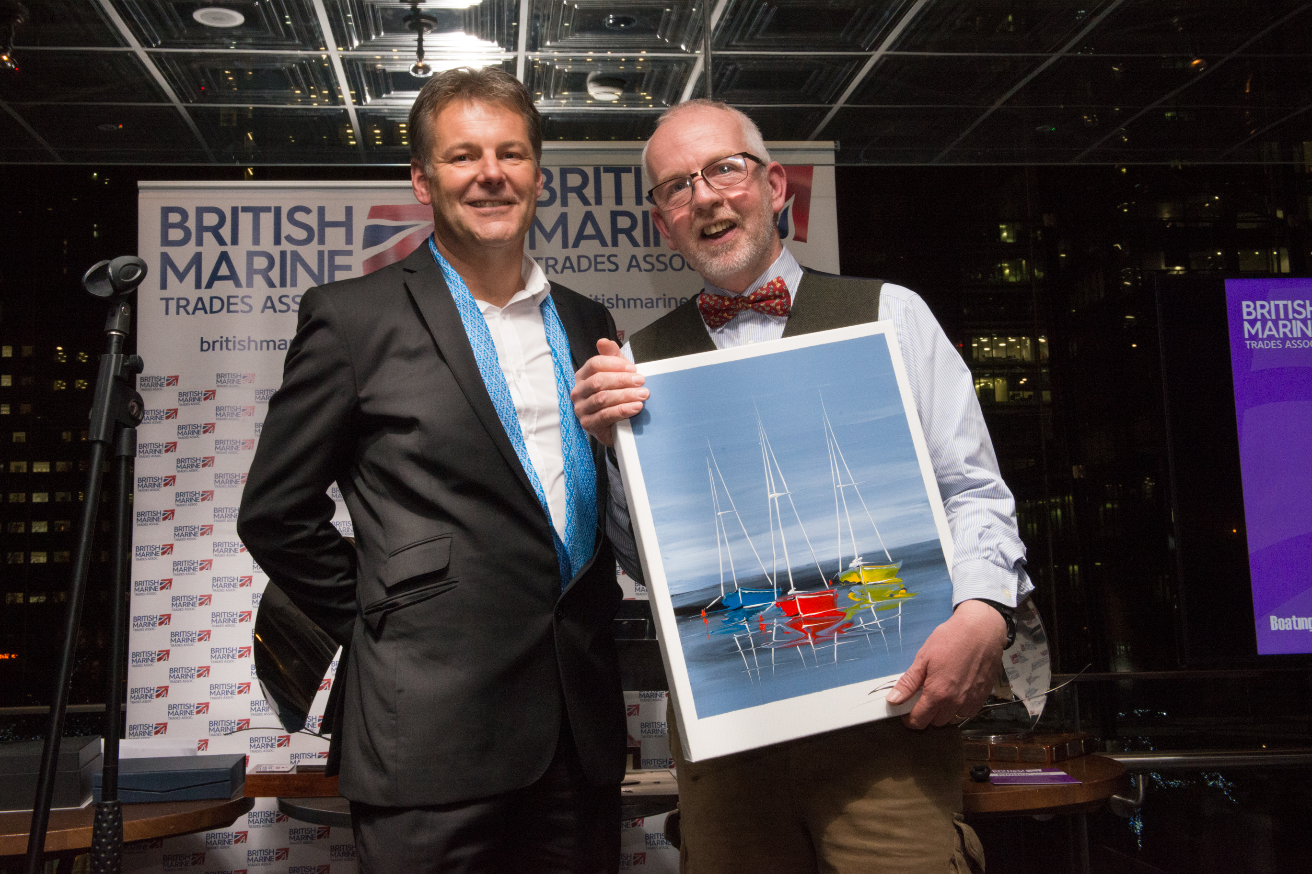
The 2018 British Marine Trades Association Awards dinner last night (Wednesday 10 January) crowned a highly successful first day at the London Boat Show 2018 for many and provided a welcome opportunity to focus on the achievements of leading personalities and companies in the industry.

The highlight of the evening was the host of awards up for grabs. British Marine group associations, British Marine Trades Association and British Marine Leisure Boating had a combined five awards on offer, with industry publication, Boating Business, issuing another five on the night.

The awards winners were:

British Marine Trades Association Awards

Business of the Year: E.P. Barrus Ltd

Personality of the Year: Sam Taylor-Nobbs, ICOM UK

Chairman’s Special Award: Neil Chapman, Boatshed.com UK

David Coleman Excellence in Exporting Award: Scanstrut

British Marine Leisure Boating Association Award

Customer Service: Hamble Point Yacht Charters

Boating Business Awards

Environment Award: Starbrite

Website Award: Timage

Young Business Persons Award: Chris Fower, Fischer Panda UK

Woman in the Marine Industry Award: Suzanne Blaustone, Barton Marine

Lifetime Achievement Award: Andy Fitzgerald, Oceanair

Speaking immediately after the event, British Marine Trades Association Chairman, Paul Martin, stated: “This was another highly successful dinner that was completely sold out and very well supported.

“It was great to recognise E P Barrus as our Business of the Year – both in light of the company’s noteworthy 100th anniversary and its excellent level of service to retail and trade. Our Marine Personality of the Year, Sam Taylor-Nobbs of ICOM UK, was a very popular choice among a field of strong nominations. I was also personally pleased to name the Chairman’s Special Award recipient as Neil Chapman of Boatshed.com for his individuality and character – a long-standing personality in the industry who always makes you smile when you meet up with him.”

Rob Clark, Chairman of British Marine Leisure Boating, commented on Hamble Point Yacht Charter’s Customer Service Award: "As an industry sector we have many outstanding examples of customer care demonstrated as standard practice by our members. Over the last few years this has been further highlighted by companies who have been highly recommended or awarded the British Marine Leisure Boating Customer Service Award.

“This has been no different in 2018 and this year’s winners, Hamble Point Yacht Charters, have based their success on looking after their customers first and foremost and ensuring that every person who comes into contact with them is greeted by a friendly, knowledgeable response.”

The British Marine Trades Association Awards and Dinner was sponsored by Boating Business, PSP Marine, C-Quip, Marine Resources, A-Plan, Ocean Safety, Aquafax and Boatshed.

Paul Martin concluded on the evening: "It is a privilege, as Chairman of British Marine Trades Association, to host this event and we’re already planning for the next one in 2019."

ENDS//

For more information please contact Andrew Harries at aharries@britishmarine.co.uk or call 01784223634.

NOTES TO EDITORS:

Attached Image: (L-R) British Marine Trades Association ‘Chairman’s Special Award’ - Paul Martin, Chairman, British Marine Trades Association; Neil Chapman, Founder, Boatshed

Additional images are available upon request.

About British Marine Trades Association:
British Marine Trades Association is a group association within British Marine. It was started over 50 years ago specifically to represent the national interest of chandlers, wholesalers, distributors and manufacturers of marine equipment. The association represents some 300 member companies and has a management committee, made up of a dozen annually elected volunteers, all of whom operate with marine businesses of various sizes in the industry.

About British Marine Leisure Boating:
British Marine Leisure Boating is a group association within British Marine representing the marine training, charter and holiday industry. Its role is to promote its members and provide services and advice to them. British Marine Leisure Boating is represented on various National Committees throughout the marine industry to safeguard both the interests of its members and their customers.

About British Marine:
British Marine (the trading name of British Marine Federation Limited) is a membership organisation leading the UK leisure, superyacht and small commercial marine industry. It has over 1,600 member companies drawn from both seagoing and inland sectors and represents an industry employing more than 33,000 people in the UK. For more information about the work of British Marine and how to join, please visit the website: www.britishmarine.co.uk.

Media enquiries (including requests for hi-res images):
Marine Advertising Agency, Mike Shepherd
Email: mike@marineadagency.com
Tel: +44 (0) 23 9252 2044
Tel: +44 (0)7786 265 455

