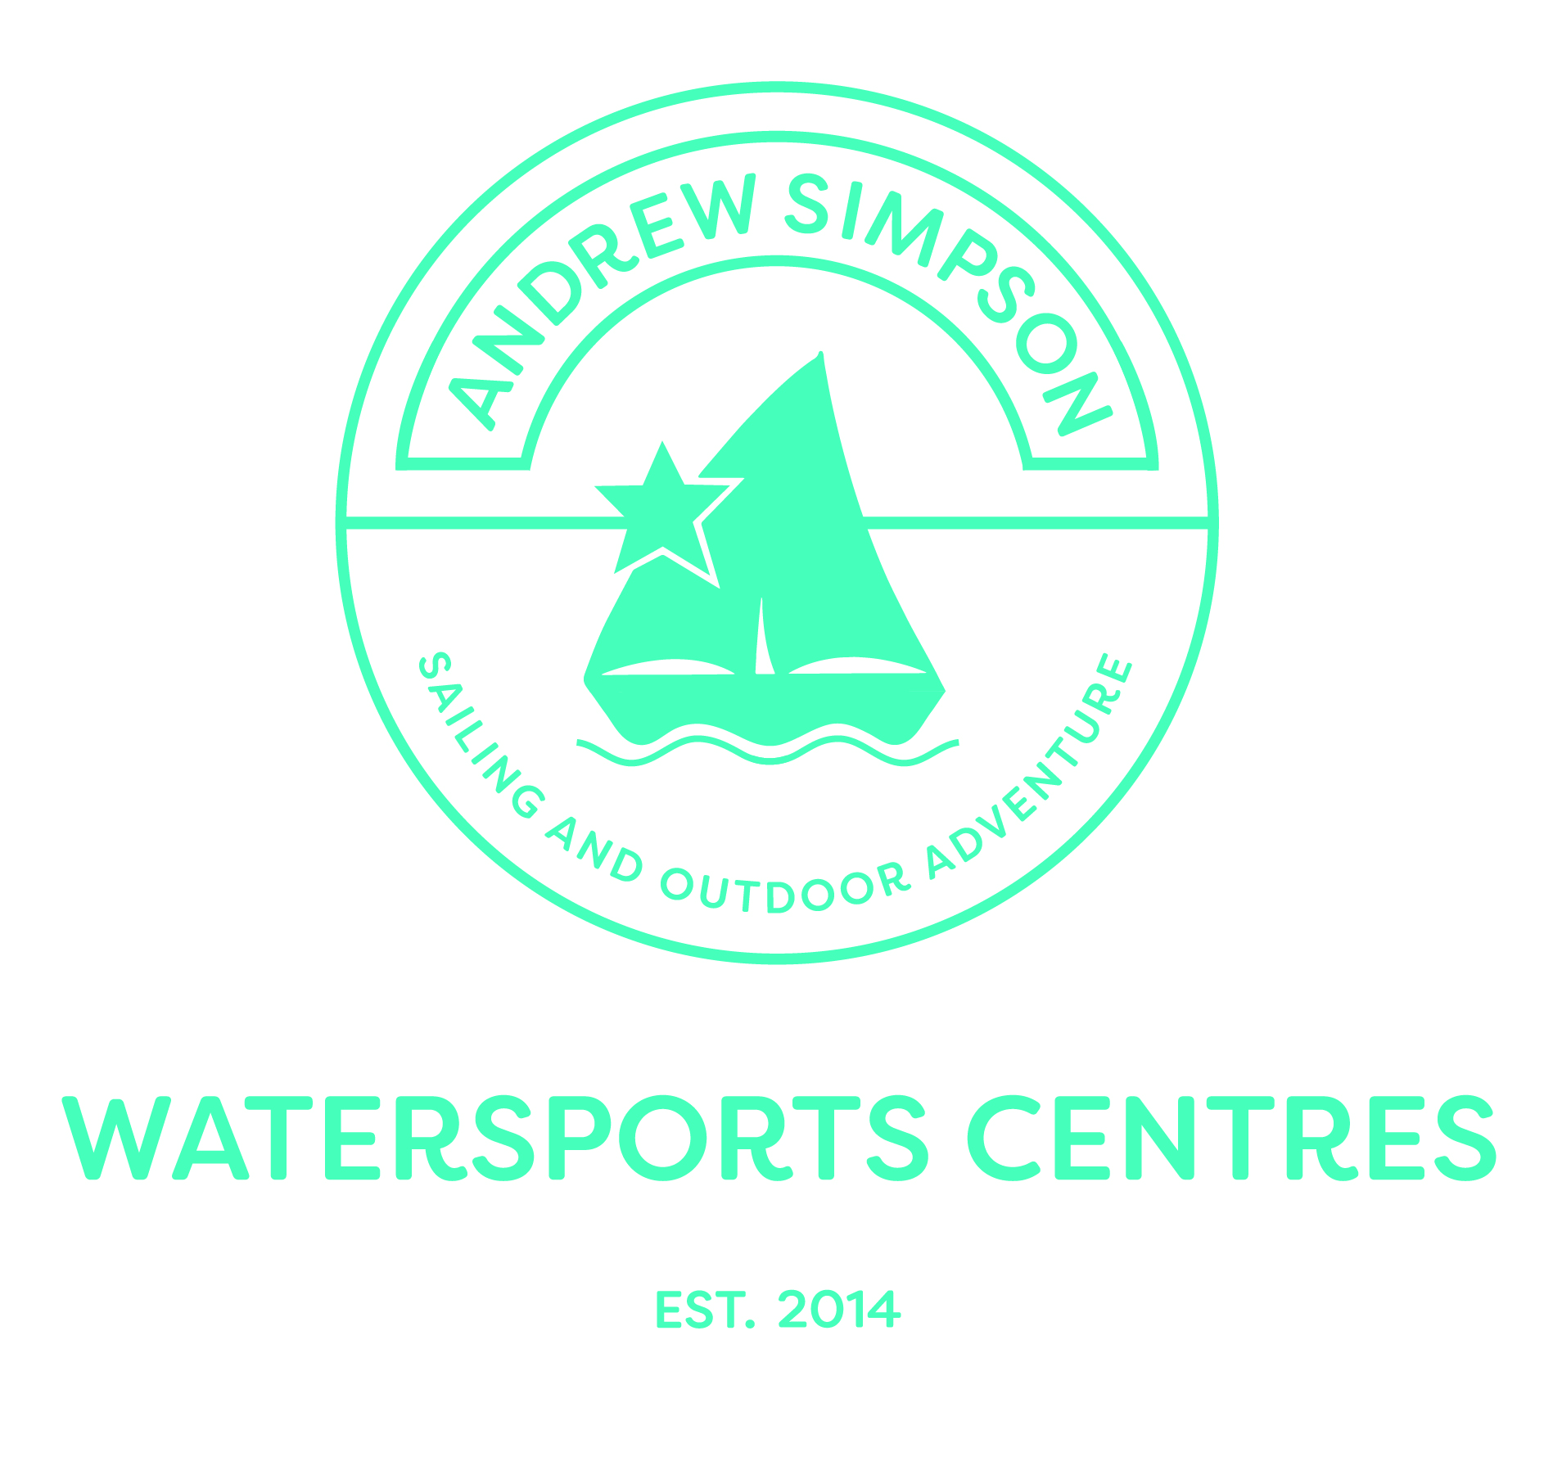
For immediate release: 16th May 2018
Crewsaver donates essential safety equipment to three new Andrew Simpson Watersports Centres
As part of its partnership, created four years ago, Crewsaver continues to supply essential safety equipment and clothing to the Andrew Simpson Foundation (ASF) - including three new Andrew Simpson Watersports Centres (ASWC). Crewsaver is the ASF’s official safety sponsor and supports their mission of increasing sailing participation and improving the lives of young people through sailing.
The ASF has undertaken extensive research into the benefits of regular sailing participation and over the course of the partnership has achieved the remarkable. Including; Bart’s Bash - the largest mass participation sailing event and Bike4Bart events, delivery of seven Community Sailing Programmes and training of volunteer coaches.
The ASF now runs four watersports centres located at Portland (UK National Sailing Academy), Portsmouth, Reading and Lake Garda. These centres are fully kitted with Crewsaver safety equipment and clothing - allowing the centres to operate to the highest safety standards. The Portland centre alone has provided opportunities for over 4,000 children to experience sailing through their charitable programmes. Alongside this, with the support from Crewsaver, the ASF has been able to supply over 15 sailing clubs and training centres worldwide with Club Safety Packs. These include Crewsaver wetsuits, buoyancy aids and helmets to enable them to increase their capacity of allowing people to sail.
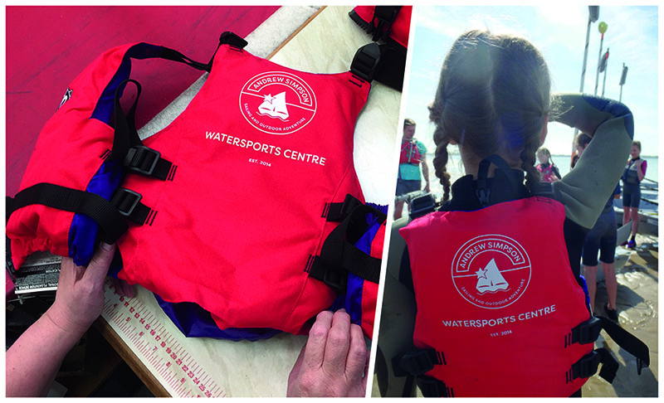
“Crewsaver’s sponsorship and support is invaluable to the Foundation’s work of increasing participation and improving the lives of disadvantaged young people. We are excited to be able to provide the opportunity for many more people to experience the incredible health and wellbeing benefits of sailing in a safe and enjoyable environment.” - Richard Percy, Andrew Simpson Foundation CEO.
“It has been our privilege to work with the Andrew Simpson Foundation over the years. The three new watersports centres will open the world of sailing to so many who would not normally have the opportunity. We are a proud supporter of their mission and are delighted to provide the essential safety kit needed to help them achieve it.” – Matt Bridge, Crewsaver Commercial Director
//ENDS//

For media information, hi-res images or product tests please contact:

Crewsaver
Hazel Proudlock, Marketing Dept
T +44 (0) 1329 820406

E hazel.proudlock@survitecgroup.com

Alison Willis – Marine Advertising Agency Ltd
T +44 (0) 23 9252 2044

E Alison@marineadagency.com

Notes to Editors

Crewsaver is a world-leading manufacturer of marine safety equipment and clothing for the commercial and leisure marine industries. Based in Gosport, Hampshire, the company designs and manufactures bespoke safety equipment for several countries’ Special Forces, and the aviation and oil industries. Crewsaver is the only company to hold an exclusive contract to supply lifejackets to the UK government’s Environment Agency and the Royal National Lifeboat Institution (RNLI). They are part of the Survitec Group.

www.crewsaver.com

Survitec Group Survitec is a global leader in survival and safety solutions to the marine, defence, aviation and offshore markets. Survitec has over 3,000 employees worldwide covering 8 manufacturing facilities, 15 offshore support centres and over 70 owned service stations. It is further supported by a network of over 500 3rd party service stations and distributors. Across its 160-year history, Survitec Group has remained at the forefront of innovation, design and application engineering and is the trusted name when it comes to critical safety and survival solutions.
www.survitecgroup.com
The Andrew Simpson Foundation is a registered charity. Its overarching objective is to increase sailing participation and improve the lives of young people through sailing. The ASF uses the challenges of sailing to develop young people by promoting health & wellbeing and building the personal skills that will improve their ability to succeed in life and work.
To achieve its objectives the ASF is engaged in the following charitable activities: i) the delivery of the annual Bart’s Bash (the world’s largest mass-participation sailing event) and Bike4Bart cycling events, ii) research into the benefits of regular sailing participation, iii) delivery of Community Sailing Programmes and iv) the training of Volunteer Coaches / Instructors. It also provides practical assistance and small grants to other, likeminded, not-for-profit sailing organisations.

To deliver its Community Sailing Programmes and provide a sustainable source of income, the ASF currently runs four Andrew Simpson Watersports Centres (ASWC). The centres are located at Portland (UK National Sailing Academy), Portsmouth, Reading and Lake Garda. The watersports centres are all part of a wholly owned, not-for-profit, subsidiary of ASF. More information on the sailing and watersports centres can be found at www.aswc.co.uk.

www.andrewsimpsonfoundation.org

