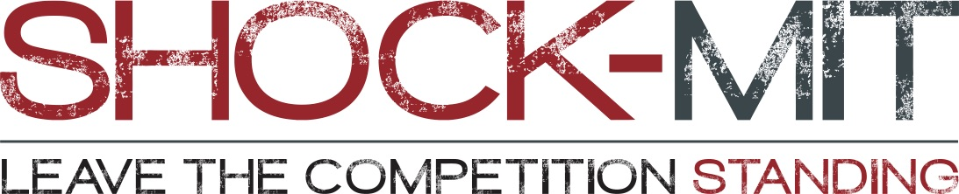

News Release

For immediate release
15 May 2018

SHOCK-MIT introduces its latest engineering solutions designed for, and proven to, combat whole body vibration.

SHOCK-MIT will be showcasing its new ranges of shock mitigation solutions throughout 2018 at SEAWORK, SMM Hamburg, Southampton Boat Show, Friedrichafen Boat Show and METS.

Designed, tested and manufactured in the UK to reduce whole body vibration via an under-seat retro-fit shock mitigation system, SHOCK-MIT’s new ranges are specifically designed for commercial vessels (C-series), pedestals (P-series) and RIBS (R-series).

“We’ve been creating innovative engineering solutions since 1956,” says Graham Brown, managing director. “And we’re particularly proud of SHOCK-MIT. Our original unit was a one-size-fits-all solution to aching bones after hours on the water, but we quickly realised that we could improve on that. Our second generation featured evolved movement and lateral support for real comfort, before we made the breakthrough into our third generation – that of engineering specific SHOCK-MIT series for commercial vessels, pedestals and RIBS. We are able to improve and evolve quickly with our in-house design and manufacturing capabilities and have taken real strides forward to launch our latest units for different boats and seating types.”

SHOCK-MIT’s range for commercial vessels (C-series), pedestals (P-series) and RIBS (R-series), has been iteratively developed and manufactured in Warsash, Southampton by parent company Sea Sure. Each series is carefully designed and tested multiple times. As well as hundreds of hours on the water testing, SHOCK-MIT is also tested on Sea Sure’s in-house ISO certified drop test rig. Data from both testing systems are used through development to further improve the performance.

Graham continues: “We’ve seen fantastic take-up from the Swedish coastguard among many others. As we are all well aware, EU directives mean that boat owners have responsibilities, so we’re delighted that SHOCK-MIT works so well to decrease whole body vibration. Our engineering can really help owners with their duty of care to passengers and crew.”

The full, third generation engineering SHOCK-MIT range is being showcased throughout 2018 at SEAWORK, SMM Hamburg, Southampton Boat Show, Friedrichafen Boat Show and METS. Appointments to discuss specific needs can be booked in advance with danielhenderson@sea-sure.co.uk.

For more information about SHOCK-MIT and / or Sea Sure, visit: www.sea-sure.co.uk.

ENDS

Notes to editors

- SHOCK-MIT is part of the Sea Sure group.
- Sea Sure has been creating innovative engineering solutions since 1956.
- Sea Sure is the exclusive UK dealer for SKYDEX.
- Sea Sure incorporates Blakes of Gosport, Lavac and Taylors Heater and Cookers.
- For more information about Sea Sure and / or SHOCK-MIT, visit https://www.sea-sure.co.uk

For media enquiries, more information, product tests, or hi-res images:

Marine Advertising Agency

Zella Compton or Mike Shepherd
Email: zella@marineadagency.com Email: mike@marineadagency.com
Tel: +44 (0) 23 9252 2044 Tel: +44 (0) 23 9252 2044

