Cupernham House, Cupernham Lane, Romsey, Hampshire SO51 7LF T +44 (0) 1794 521 111 F +44 (0) 1794 521 271
techsupport@westsysteminternational.com westsysteminternational.com

West System International helps give young people an Oarsome Chance
17th May 2018

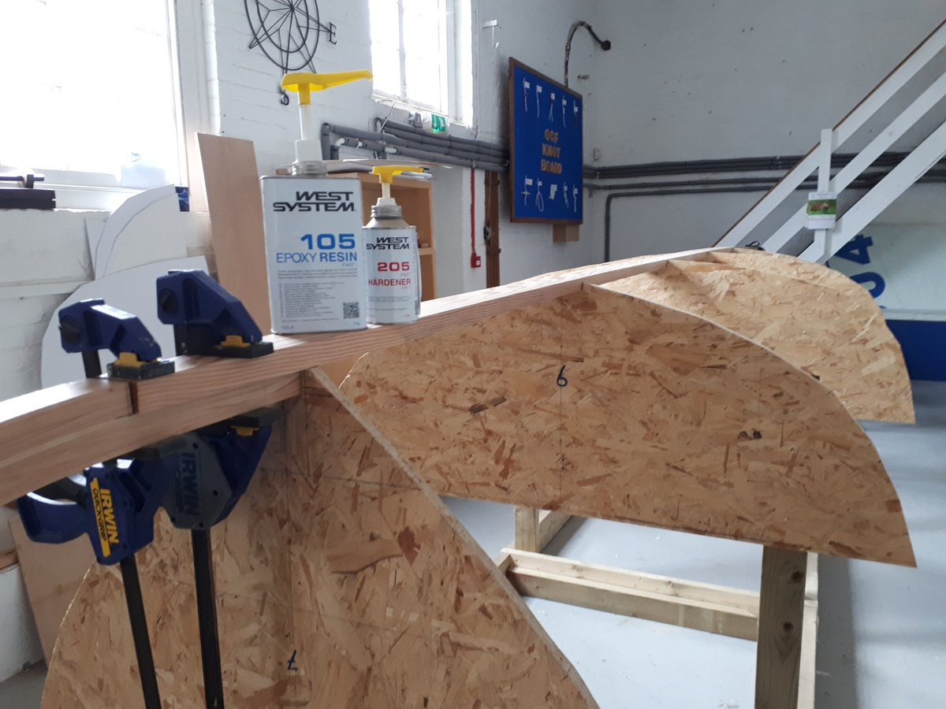
West System International (WSI) has provided an extensive range of WEST SYSTEM® products and other materials to ground-breaking new charity, Oarsome Chance, for use in its OC 24 Skiff build project.

Oarsome Chance works to bring about change for disadvantaged young people in the Portsmouth, Gosport and Havant areas by using the powerful incentive of sport in combination with vocational training. As part of its work, the charity is developing the OC 24 Skiff – a purpose-built boat designed for it by Paul Fisher for the young people to build and then row. West System International is delighted to be involved with the build project through materials sponsorship.

Paul O’Grady, Oarsome Chance founder and Chair of Trustees expressed his thanks on behalf of the Oarsome Chance team, “I cannot thank West System International enough on behalf of our local youngsters for their very generous donation of materials for the build of our first OC 24 Skiff. The OC 24 is a very exciting project for us all.”

Hamish Cook from West System International said, “We are pleased to be involved and look forward to seeing the OC 24 Skiff in the water helping to have a positive influence on young people’s lives.”

Epoxycraft (http://epoxycraft.com), the online magazine for all things epoxy, which is published by West System International, will be following the OC 24 project.

Find out more about Oarsome Chance https://oarsome-chance.co.uk

ENDS

Notes to Editors:
West System International (a division of Wessex Resins and Adhesives) manufactures and provides international support for the world-renowned WEST SYSTEM and PRO-SET marine epoxy brands. Since Michigan boatbuilding brothers Meade, Joel and Jan Gougeon first experimented with the bonding power of epoxy over 50 years ago, the WEST SYSTEM® and PRO-SET® product ranges have become the epoxies of choice for private boat owners, boat manufacturers, chandlers and naval engineers throughout the world. West System International (WSI) has been working in partnership with Gougeon Brothers, Inc. for more than 36 years, manufacturing WEST SYSTEM and PRO-SET epoxies here in the UK. WEST SYSTEM and PRO-SET epoxy systems have a long-distinguished history that has earned a unique place at the heart of the worldwide epoxy user community. Whether you need an epoxy for laminating, bonding, coating, tooling or infusion, the combined breadth of WEST SYSTEM and PRO-SET products will provide the solution. Both ranges have passed extensive quality testing and are certified by Lloyds Register.

Media enquiries:

Marine Advertising Agency – Alison Willis, Alison@marineadagency.com 023 9252 2044
West System International – Hamish Cook, Hamish.cook@wessex-resins.com 01794 521 111

