Cupernham House, Cupernham Lane, Romsey, Hampshire SO51 7LF
T +44 (0) 1794 521 111 F +44 (0) 1794 521 271
techsupport@westsysteminternational.com westsysteminternational.com

WSI to run live demos of WEST SYSTEM® Epoxy Products at TheYachtMarket.com Southampton Boat Show

For immediate release
7 August 2018
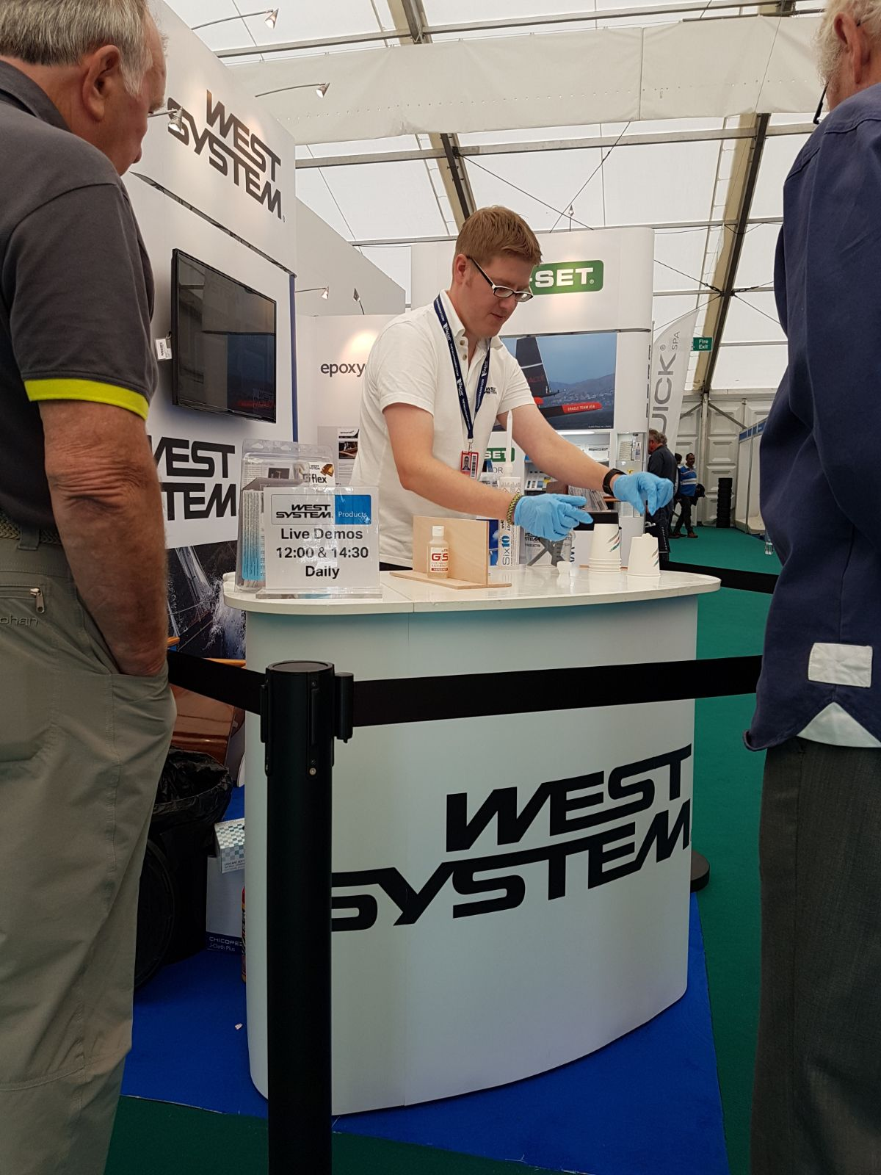
West System International (WSI) will be running a series of live demonstrations on its stand (J401, Ocean Hall) at TheYachtMarket.com Southampton Boat Show showing visitors how to get the most from its epoxy products. The Show takes place from 14th to 23rd September 2018.
The WSI team will be on hand throughout the Show to answer any questions about the company’s WEST SYSTEM® products. WSI’s technical experts will be able to offer advice on visitors’ projects and the use of epoxy for boat building, repair and maintenance. The team will also be able to talk to visitors about the PRO-SET® range of versatile epoxies for high-performance composites. PRO-SET epoxy is used in the production of the supremely successful Maguire Boats Exocet Moth.
Live demonstrations will be held at 12:00 and 14:30 each day on the West System International stand (J401).
Hamish from the West System International technical team runs a demonstration at the 2017 Southampton Boat Show.
“Sharing our knowledge is a key element of what we do at West System International so we really look forward to running our live demonstrations at the Show. Southampton Boat Show is also a great opportunity for us to talk to the people who use our products and to hear about their projects.” - Ian Oliver, Managing Director of WSI.
WEST SYSTEM and PRO-SET products are market- leading and trusted by both professional boat builders and home project hobbyists worldwide.

West System International, manufactures WEST SYSTEM and PRO-SET epoxy products in the UK under license from Gougeon Brothers Inc., and distributes these leading brands across the whole of Europe, Africa and the Middle East via a well-respected distribution network.
ENDS

Notes to Editors:
West System International (a division of Wessex Resins and Adhesives) manufactures and provides international support for the world-renowned WEST SYSTEM and PRO-SET marine epoxy brands. Since Michigan boatbuilding brothers Meade, Joel and Jan Gougeon first experimented with the bonding power of epoxy over 50 years ago, the WEST SYSTEM® and PRO-SET® product ranges have become the epoxies of choice for private boat owners, boat manufacturers, chandlers and naval engineers throughout the world. West System International (WSI) has been working in partnership with Gougeon Brothers, Inc. for more than 36 years, manufacturing WEST SYSTEM and PRO-SET epoxies here in the UK. WEST SYSTEM and PRO-SET epoxy systems have a long-distinguished history that has earned a unique place at the heart of the worldwide epoxy user community. Whether you need an epoxy for laminating, bonding, coating, tooling or infusion, the combined breadth of WEST SYSTEM and PRO-SET products will provide the solution. Both ranges have passed extensive quality testing and are certified by Lloyds Register.

Media enquiries:
Marine Advertising Agency – Alison Willis, Alison@marineadagency.com 023 9252 2044
West System International – Hamish Cook, Hamish.cook@wessex-resins.com 01794 521 111

