PRESS RELEASE
For release 24th February 2015

Crewsaver – RYA Suzuki Dinghy Show 2015 Stand No. C16

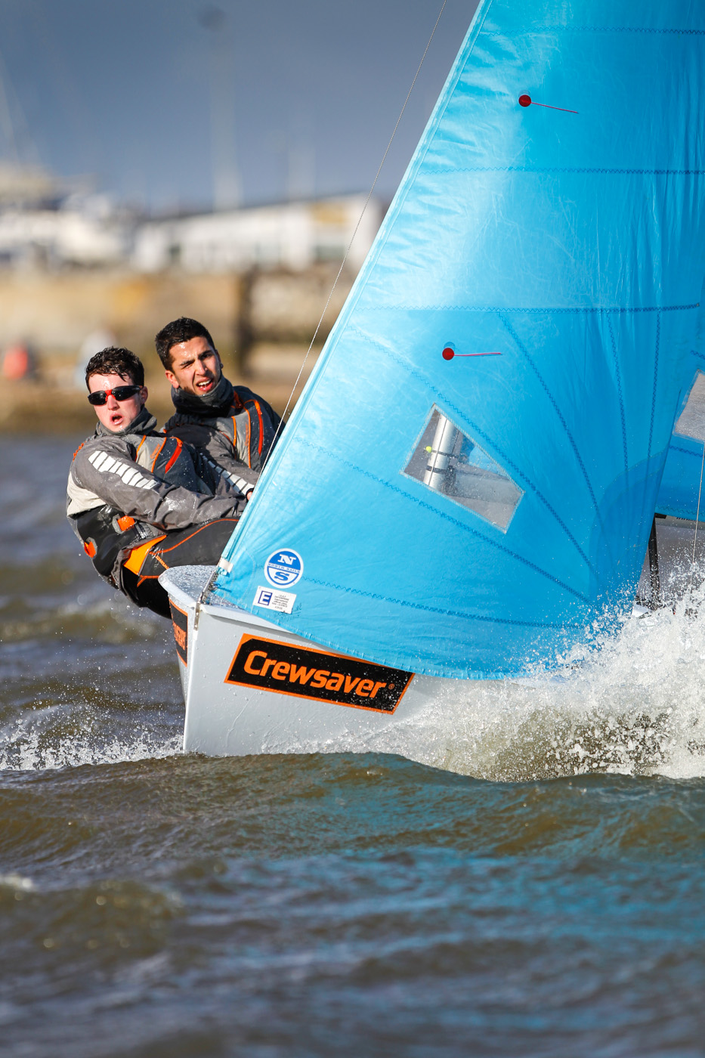
A year on from the successful launch of the Crewsaver Phase2 complete dinghy range Crewsaver is thrilled to be able to return to the RYA Suzuki Dinghy Show with a brand new stand, showcasing the entire Crewsaver Dinghy and Activity Centre ranges.

Ross Wilkinson, Managing Director for Crewsaver says ‘We are very much looking forward to displaying all of our products at this year’s RYA Suzuki Dinghy Show. We look forward to meeting all of the visitors to the show, showing them our complete product ranges and helping them select the right products suited to their needs.’

To celebrate Crewsaver’s return to the show customers will be able to take advantage of some fantastic offers including:

- A pair of Crewsaver Phase2 Zip Boots completely FREE when you spend over £150 on any Crewsaver Phase2 dinghy gear*
- Purchase a pair of Crewsaver Phase2 Pro Hiking Pads and Phase2 Hikers together at a reduced cost of £99.95*

Customers visiting the show will be able to purchase products from the Crewsaver range at the following stands:
- Andark Diving and Watersports – Stand No. F6
- P&B – Stand No. A10
- Jimmy Green Marine – Stand No. D12
- Nucleus Watersports – Stand No. H2

Competition Time!

Each day visitors to the show will be in with a chance of winning an entire set of Crewsaver Phase2 dinghy gear! To win this fantastic prize visitors should bring a completed entry form to the Crewsaver stand (C16) at 4pm where a winner will be selected at random – Remember, visitors have to be on the stand at 4pm with their completed entry cards to be in with a chance of winning.

*Max 1 per purchase. Max 1 per customer. E&OE. Terms and conditions apply. Redeemable on the Crewsaver Stand, C16. Boots will be despatched after the show.

ENDS

Note to editors

For media information, hi-res images or product tests please contact:

Crewsaver
Hannah Burywood, Marketing Dept
T +44 (0) 1329 820024
E hannah.burywood@survitecgroup.com

Marine Advertising Agency Ltd
Alison Willis
T +44 (0) 23 9252 2044
E Alison@marineadagency.com
Crewsaver
Crewsaver is a world-leading manufacturer of marine safety equipment and clothing for the commercial and leisure marine industries. Based in Gosport, Hampshire, the company designs and manufactures bespoke safety equipment for several countries’ Special Forces, the UK government’s Environment Agency and the aviation and oil industries. Crewsaver is part of the Survitec Group.
www.crewsaver.com
About Survitec Group
Survitec Group holds market-leading positions worldwide in marine, defence and aerospace survival technology. Headquartered in Southampton, the company employs 2000 people across 10 manufacturing sites and 50 service centres, operating through a network of a further 550 distributors and agents to bring its best-in-class products and services to a global customer base. With an extensive history spanning over 160 years and a portfolio of some of the most reputable brands in the safety and survival industry, Survitec is committed to product innovation, technological advancement and quality assurance.
Key products within Survitec’s portfolio include marine, defence and aviation Liferafts, world leading submarine escape technology, lifejackets for commercial airlines and the offshore industry as well as pilot flight equipment, including anti-g clothing used for the Eurofighter and JSF programmes. The Group also pioneered marine evacuation technology and today the unique MarinArk system is used on many major cruise ships across the globe.
www.survitecgroup.com

