PRESS RELEASE
For release 03th February 2015

Tom Bowker is appointed as Crewsaver European Sales Manager – Leisure
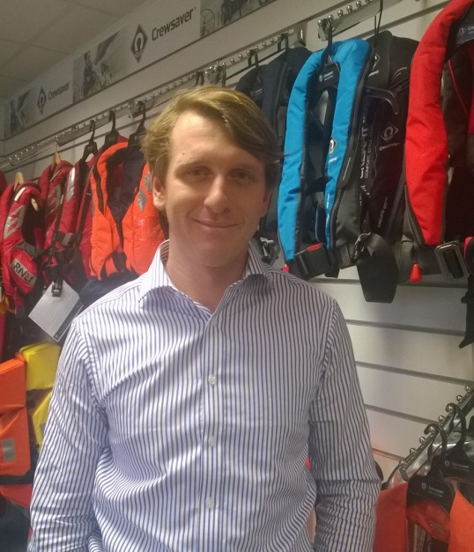
Crewsaver is delighted to announce the new appointment of Tom Bowker as European Sales Manager – Leisure. Tom has devoted his career to the marine industry and has a particularly strong sales and customer service focused background. Both his role as Area Sales Manager for SailLaser & LaserPerformance and as UK Training and Fleet Sales Manager for RS Sailing have been heavily focused on building on and developing business to business relationships.

With an enthusiasm for taking on new challenges, Tom’s main objective within his new role will be to develop and grow Crewsaver’s European distributor network making the Crewsaver leisure product range more accessible throughout Europe.

Sales Director for Crewsaver, David Duffin says ‘We are excited to welcome Tom and his experience in marine industry sales. He will be a key player in the development of the company and a great addition to the team.’

Tom says 'I am very excited to be joining Crewsaver and am looking forward to meeting and working with the entire European distribution network.’

With the recently launched Fusion 3D lifejacket range Tom couldn’t have a more exciting product range to promote to consumers throughout Europe!

Ends//

For media information, hi-res images or product tests please contact:

Crewsaver
Hannah Burywood, Marketing Dept
T +44 (0) 1329 820024
E hannah.burywood@survitecgroup.com

Or

Alison Willis – Marine Advertising Agency Ltd
T +44 (0) 23 9252 2044
E Alison@marineadagency.com

Notes to Editors

Crewsaver is a world-leading manufacturer of marine safety equipment and clothing for the commercial and leisure marine industries. Based in Gosport, Hampshire, the company designs and manufactures bespoke safety equipment for several countries’ Special Forces, the UK government’s Environment Agency and the aviation and oil industries. Crewsaver is part of the Survitec Group.

www.crewsaver.com

Survitec Group holds market-leading positions worldwide in marine, defence and aerospace survival technology. Headquartered in Southampton, the company employs 2000 people across 10 manufacturing sites and 50 service centres, operating through a network of a further 550 distributors and agents to bring its best-in-class products and services to a global customer base. With an extensive history spanning over 160 years and a portfolio of some of the most reputable brands in the safety and survival industry, Survitec is committed to product innovation, technological advancement and quality assurance.
Key products within Survitec’s portfolio include marine, defence and aviation Liferafts, world leading submarine escape technology, lifejackets for commercial airlines and the offshore industry as well as pilot flight equipment, including anti-g clothing used for the Eurofighter and JSF programmes. The Group also pioneered marine evacuation technology and today the unique MarinArk system is used on many major cruise ships across the globe.

www.survitecgroup.com

