PRESS RELEASE
For release 18th November 2014
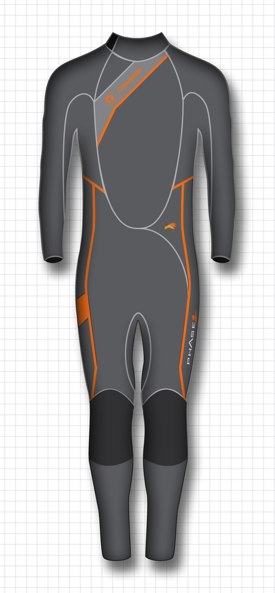
Wetsuit added into Crewsaver Phase2 dinghy range.

A year on from the successful launch of the Crewsaver Phase2 complete dinghy range Crewsaver is pleased to announce the addition of a full length Phase2 wetsuit.

Crewsaver’s Phase2 range is designed with one aim; to offer sailing gear that works in the most demanding of environments, that’s affordable and with its unique colour ways – it looks good too!

The NEW Phase2 wetsuit is no exception, 4/3mm neoprene with advanced reinforced panels on the knees and seat for extra protection and longevity.

- Glues and blind stitched
- Key pocket
- Reinforces knees and seat
- 4/3mm neoprene construction
- Long back zip for easy donning

The Phase2 wetsuit officially launches to the trade during METS trade show 2014. To see this fantastic new product visit the Crewsaver stand during the show:

Stand No. 03.114
British Pavilion
18th – 20th November 2014

£125 RRP Inc. VAT

Note to editors

For media information, hi-res images or product tests please contact:

Crewsaver
Hannah Burywood, Marketing Dept
T +44 (0) 1329 820024
E hannah.burywood@survitecgroup.com

Marine Advertising Agency Ltd
Alison Willis
T +44 (0) 23 9252 2044
E Alison@marineadagency.com
Crewsaver
Crewsaver is a world-leading manufacturer of marine safety equipment and clothing for the commercial and leisure marine industries. Based in Gosport, Hampshire, the company designs and manufactures bespoke safety equipment for several countries’ Special Forces, the UK government’s Environment Agency and the aviation and oil industries. Crewsaver is part of the Survitec Group.
www.crewsaver.com
About Survitec Group
Survitec Group holds market-leading positions worldwide in marine, defence and aerospace survival technology. Headquartered in Southampton, the company employs 2000 people across 10 manufacturing sites and 50 service centres, operating through a network of a further 550 distributors and agents to bring its best-in-class products and services to a global customer base. With an extensive history spanning over 160 years and a portfolio of some of the most reputable brands in the safety and survival industry, Survitec is committed to product innovation, technological advancement and quality assurance.
Key products within Survitec’s portfolio include marine, defence and aviation Liferafts, world leading submarine escape technology, lifejackets for commercial airlines and the offshore industry as well as pilot flight equipment, including anti-g clothing used for the Eurofighter and JSF programmes. The Group also pioneered marine evacuation technology and today the unique MarinArk system is used on many major cruise ships across the globe.
www.survitecgroup.com

