PRESS RELEASE
For release 18th November 2014

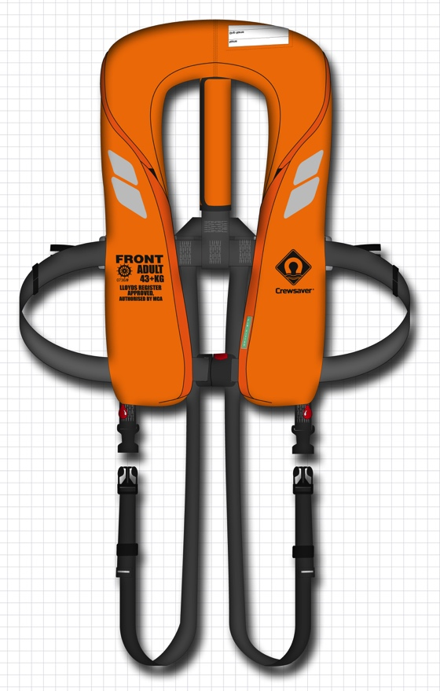
SEACREWSADER 290N 3D
Crewsaver are pleased to announce the launch of the Seacrewsader 290N 3D to the industrial and commercial range - Designed to perform in the most arduous environments, Crewsaver has developed a range that suits all your safety needs from oil and gas to wind farms and other commercial industries.
Building on the success of the Seacrewsader 275N chosen for its unique safety attributes and development of Crewsaver’s NEW Fusion 3D technology - Crewsaver now offer you a jacket with advanced safety features and a completely unique removable cover providing longevity as well as superior comfort.
The Seacrewsader 290N 3D’s unique design allows the user to remove the outer cover of the lifejacket, providing the ability to replace covers easily when they are no longer fit for use or to change its application.
In addition to this its 3D cover molds to the shape of your body providing the ultimate comfort and endurance in the harshest environments - when abandonment is a very real possibility.

- Easy to replace cover system
- Waterproof service labels
- Can be used with a PLB & AIS
- 3D Cover
- High strength plastic quick release buckle
- YKK QBZ Tri-burst zip
- Foam padded cover for added protection
- Spare covers can be purchased separately including Fire Retardant and wipe clean options
- Unique chin support
- Unique bladder distribution
- Twin UML automatic inflator

The Seacrewsader 290N 3D lifejacket officially launches to the trade during METS trade show 2014. To see this fantastic new product visit the Crewsaver stand during the show:

Stand No. 03.114
British Pavilion
18th – 20th November 2014

For media information, hi-res images or product tests please contact:

Crewsaver
Hannah Burywood, Marketing Dept
T +44 (0) 1329 820024
E hannah.burywood@survitecgroup.com
Crewsaver
Crewsaver is a world-leading manufacturer of marine safety equipment and clothing for the commercial and leisure marine industries. Based in Gosport, Hampshire, the company designs and manufactures bespoke safety equipment for several countries’ Special Forces, the UK government’s Environment Agency and the aviation and oil industries. Crewsaver is part of the Survitec Group.
www.crewsaver.com
About Survitec Group
Survitec Group holds market-leading positions worldwide in marine, defence and aerospace survival technology. Headquartered in Southampton, the company employs 2000 people across 10 manufacturing sites and 50 service centres, operating through a network of a further 550 distributors and agents to bring its best-in-class products and services to a global customer base. With an extensive history spanning over 160 years and a portfolio of some of the most reputable brands in the safety and survival industry, Survitec is committed to product innovation, technological advancement and quality assurance.
Key products within Survitec’s portfolio include marine, defence and aviation Liferafts, world leading submarine escape technology, lifejackets for commercial airlines and the offshore industry as well as pilot flight equipment, including anti-g clothing used for the Eurofighter and JSF programmes. The Group also pioneered marine evacuation technology and today the unique MarinArk system is used on many major cruise ships across the globe.
www.survitecgroup.com

