PRESS RELEASE
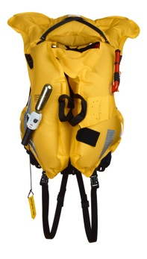
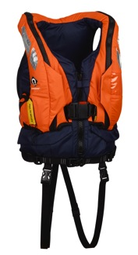
Crewsaver Evolution 250N Lifejacket entered into the Sea Work Innovation showcase.

We have great pleasure in announcing that we will be entering the Crewsaver Evolution 250N lifejacket into this year’s Innovation Awards at Seawork International – the largest and fastest growing commercial marine and workboat event, which commences June 10th. Statistics show more than 80% of all visitors attend Seawork specifically to see new products and vessels. The Seawork Innovations Showcase is situated in a prominent, high-traffic area of the exhibition. Its purpose is to provide visitors with a fast-track route to stands and berths of interest and a "shop window" for the latest in new technology and innovation. Products entered into the showcase have a dedicated area on the Seawork website, coverage in the Seawork newsletters and e-newsletters plus a feature in Maritime Journal.

The Evolution 250N is a hybrid, general purpose, waistcoat style lifejacket designed for working in an environment where frequent water immersion is probable. Moving on from our traditional lifejacket, the Harvester, the Evolution 250N is a more modern design that gives you additional buoyancy, comfort and manoeuvrability.

Constructed with 60N of inherently buoyant foam, a 190N quick turn inflation chamber provides you with all the benefits of a buoyancy aid coupled with the increased safety of a lifejacket.

The Evolution 250N is available in Manual or Automatic inflation option. With the Manual version you can enter and work safely in the water ready-buoyed with 60N of foam and with the option to inflate the lifejacket if required. With the Automatic operation, should you fall into the water, the Evolution 250N inflates automatically to ensure your safety. Both models are single chamber jackets that use a 38g CO2 cylinder. This can be removed from the jacket for service and repair as required.

Open side panels promote air circulation for your comfort and the jacket closes with a front zip, waist belt and front buckle. You can easily adjust how the jacket sits and prevent it riding up with the adjusters provided.

The Evolution 250N will be on full display throughout the show on Survitec stand B137.

Ends//

For media information, hi-res images or product tests please contact:
Hannah Burywood, Marketing Dept, Crewsaver
T +44 (0) 1329 820024
E hannah.burywood@survitecgroup.com

Seawork June 10th-12th 2014

Seawork International is one of Europe’s largest international commercial maritime and workboat exhibition and business forums. It takes place over three days in June every year at the Port of Southampton, UK, attracting more than 6000 visitors from 40 countries.

www.ssa.org.uk

About Crewsaver
Crewsaver is a world-leading manufacturer of marine safety equipment and clothing for the commercial and leisure marine industries. Based in Gosport, Hampshire, the company designs and manufactures bespoke safety equipment for several countries’ special forces, the UK government’s Environment Agency and the aviation and oil industries. Crewsaver is part of the Survitec Group.
www.crewsaver.com

About Survitec Group
Survitec Group holds market-leading positions worldwide in marine, defence and aerospace survival technology. Headquartered in Southampton, the company employs 2000 people across 10 manufacturing sites and 50 service centres, operating through a network of a further 550 distributors and agents to bring its best-in-class products and services to a global customer base. With an extensive history spanning over 160 years and a portfolio of some of the most reputable brands in the safety and survival industry, Survitec is committed to product innovation, technological advancement and quality assurance.
Key products within Survitec’s portfolio include marine, defence and aviation Liferafts, world leading submarine escape technology, lifejackets for commercial airlines and the offshore industry as well as pilot flight equipment, including anti-g clothing used for the Eurofighter and JSF programmes. The Group also pioneered marine evacuation technology and today the unique MarinArk system is used on many major cruise ships across the globe.
www.survitecgroup.com

