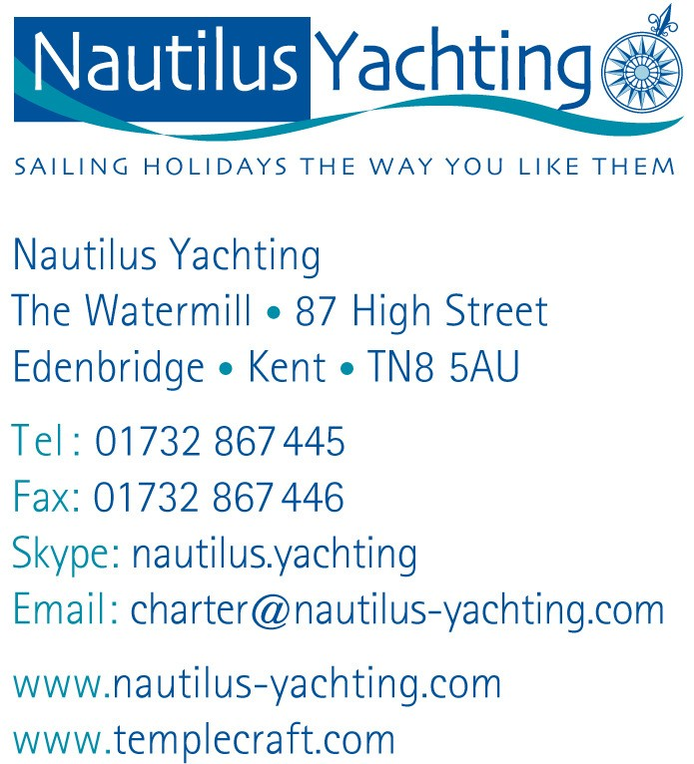

NEWS RELEASE
9th September 2014

Nautilus Yachting adds new yachts, a new flotilla, new sailing destinations in the Med & Caribbean and a new RYA sailing school for 2015
Nautilus Yachting offers sailing holidays throughout the Mediterranean and Caribbean, both bareboat charter and family-friendly flotillas. Here’s what’s new for 2015:
- 2015 prices have now been released with early booking discounts up to 15%. In addition there are exciting Boat Show discounts for holidays booked at the PSP Southampton Boat Show. Brand new yachts are being added across all destinations to the fleets of Bavaria, Sun Odyssey, Dufour and Beneteau yachts.
- A new flotilla in the Greek Sporades islands has been introduced to meet high demand for a quality flotilla in this stunning sailing area. The fleet is based at Loutraki, a charming harbour on Skopelos island. Choose from an excellent fleet of 2, 3 and 4 cabin yachts, all built 2011 or newer. A water taxi from Skiathos airport is included and flights can be arranged.
- In the Caribbean a new base at Blue Lagoon on the south coast of St Vincent gives the exciting opportunity to sail one-way from St Vincent to Grenada, the perfect “down wind ”way to explore the idyllic Grenadines.
- In the Mediterranean two new bases have been introduced, San Antonio in Ibiza is the place from which to explore the beautiful bays of Ibiza and Formentera. Portoroz in Slovenia allows easy access to the Italian Adriatic coast, including the Lagoon in Venice, the historic town of Grado and the city of Trieste with its piazzas and Roman remains
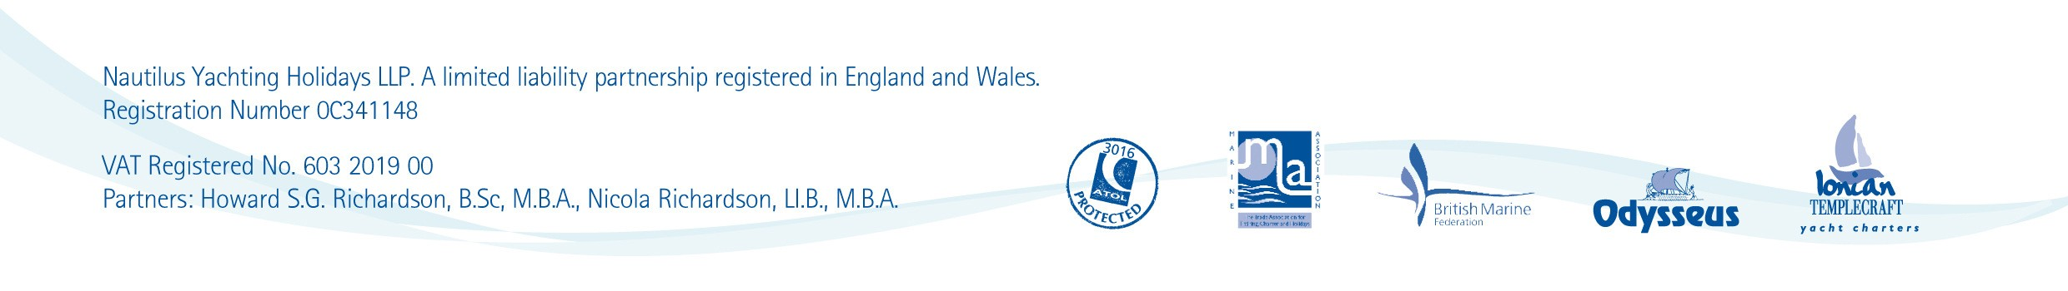
- An RYA school in Aegina has been added to give more choice for getting an RYA qualification in the sun. This excellent British-owned sailing school in Aegina is just south of Athens, so skippers can enjoy a week’s course leading to an RYA Day Skipper qualification followed by a week’s sailing on the Athens flotilla, an ideal two-week sailing holiday.

Nautilus Yachting is committed to providing an excellent service and is proud to have earned an Excellent 5* rating on TRUSTPILOT with clients raving about the great service they get from the staff at Nautilus Yachting when booking their sailing holiday.
With an excellent choice of yachts and cruising areas, there is a yachting holiday to suit everyone and Nautilus Yachting’s experienced team can help clients find their perfect sailing break. Nautilus can book flights for clients wanting an ATOL-bonded flight-inclusive holiday or clients can book their own. Clients really like the transparency of our pricing and the opportunity to tailor-make their own holiday arrangements.
For full details on all Nautilus Yachting holidays come and see them at PSP Southampton Boat Show on Stand J062 in the Mayflower Hall or visit www.nautilusyachting.com.

ENDS

About Nautilus Yachting:
Nautilus Yachting has been selling sailing holidays throughout the Mediterranean and Caribbean since 1992 and has established itself as the leading UK independent yacht charter agency. Nautilus Yachting is a fully bonded tour operator and hold Air Travel Organiser’s Licence ATOL 3016. Nautilus is also a member of the British Marine Federation leisure Division.

For further information & images, please contact:

Alison Willis, Marine Advertising Agency

Tel: 023 92 522 044 Email: alison@marineadagency.com

Howard Richardson, Nautilus Yachting

Jonathan Shears, Nautilus Yachting

Tel: 01732 867 445 Email: charter@nautilusyachting.com

Website: www.nautilusyachting.com

