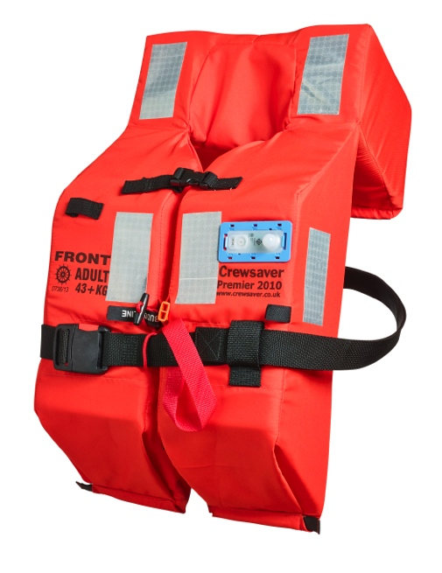
PRESS RELEASE
For release 6th August 2014

New Lifejacket Lights from Crewsaver

Crewsaver are pleased to announce a new range of lifejacket lights, suitable for all foam lifejackets of the type most commonly used for quick deployment in an emergency among some of the largest cruise ships and commercial vessels worldwide.

CRL-C
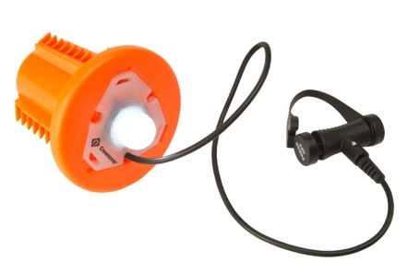
Circular recess light suitable for all Crewsaver foam lifejackets including the widely successful Premier 2010.

- Activates manually on contact with water
- Flashing LED light
- SOLAS, MED & USCG Approved
- Minimum 16hrs light duration
- Maximum 5 Year storage life

CRL-R
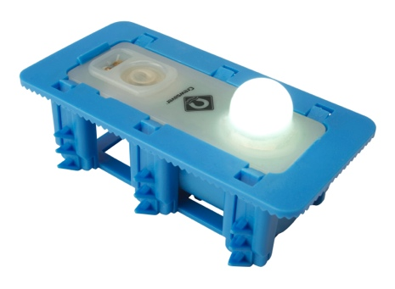
Rectangular recess light suitable for all Crewsaver foam lifejackets, including the widely successful Premier 2010.

- Activates manually on contact with water
- Flashing LED light
- SOLAS, MED & USCG Approved
- Minimum 16hrs light duration
- Maximum 5 Year storage life

CSL-Surface Light

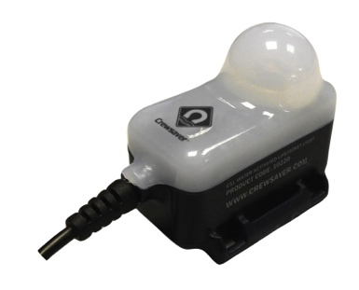
For those looking for non-recess light options, the extensively popular Crewsaver Surface Light is available and compatible with all Crewsaver lifejackets.
- High powered white LED lifejacket light
- Flashing for optimum visibility at sea
- Optimum output levels exceeds 3cd
- Powered by lithium-ion battery

Ends//

About Crewsaver
Crewsaver is a world-leading manufacturer of marine safety equipment and clothing for the commercial and leisure marine industries. Based in Gosport, Hampshire, the company designs and manufactures bespoke safety equipment for several countries’ special forces, the UK government’s Environment Agency and the aviation and oil industries. Crewsaver is part of the Survitec Group.
www.crewsaver.com
About Survitec Group
Survitec Group holds market-leading positions worldwide in marine, defence and aerospace survival technology. Headquartered in Southampton, the company employs 2000 people across 10 manufacturing sites and 50 service centres, operating through a network of a further 550 distributors and agents to bring its best-in-class products and services to a global customer base. With an extensive history spanning over 160 years and a portfolio of some of the most reputable brands in the safety and survival industry, Survitec is committed to product innovation, technological advancement and quality assurance.
www.survitecgroup.com

