News Release
For immediate release
24th November 2014

Tecsew extends its 30th anniversary deal to tie in with end of
CWM FX London Boat Show 2015

Tecsew, the south coast based yacht canopy company, has announced it is extending its special 30th anniversary offer, giving customers 10% off orders, to cover all orders placed up to 18th January 2015. The company introduced the 10% off deal ahead of PSP Southampton Boat Show to celebrate 30 years of delighting customers with its boat covers, canopies, sprayhoods, biminis and awnings. The extension until 18th January 2015, which is also the last day of the CWM FX London Boat Show, means that customers looking to get ready for the new season with the addition of one of Tecsew’s products can also benefit from this great deal.

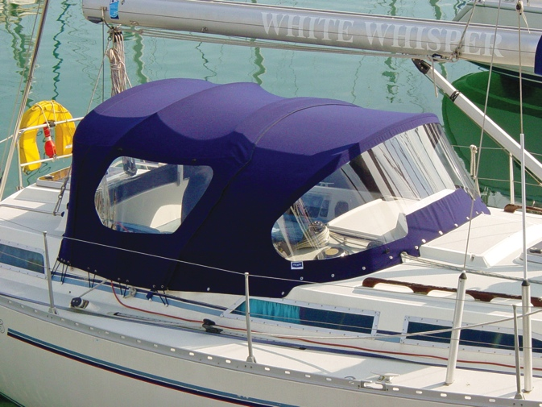
Tecsew’s quality covers can also extend boat owners’ sailing seasons, allowing them to get in some winter sailing whilst giving protection from the elements.

Tecsew prides itself on its high levels of customer service, with customers’ praising its “professional service” and “invaluable” experience.

The company brought real excitement to the marine textile industry with their innovative use of 3D CAD design. 2014 represents the company’s 30th anniversary.

“Although I began the business with my father in 1981 as a part time venture, the company really took off in 1984,” explains John Bland, Tecsew’s Managing Director and the man with a passion for providing the high quality products and service that are the envy of the industry. “We grew the company in the early years from my parents’ garage but always with the desire to make the very best products for our customers.”

“Even back then we designed everything from scratch and ultimately that approach has brought us to where we are now, some 30 years later. Today we use our unique in-house 3D CAD design process to achieve outstanding marine canopies that are completely bespoke for each individual customer, as well as for boat builders themselves. This has been revolutionary for the industry and a great example of how over the past 30 years we have led while others followed.”

With a product range that spans all marine covers and upholstery and has naturally diversified into industrial covers and garden awnings, the can-do attitude of John and his wife Ally has plainly infused

the whole company. Ally, who is Tecsew’s Financial Director, echoes this. “We have a very strong company ethos inspired by John and that’s what I really love about the business. We use cutting edge
design coupled with our own technical manufacture skills to improve quality and consistency, reduce delivery time and to give our customers real pleasure in their purchase.”

Tecsew also makes the buying process as easy as possible for their customers. Measuring up to have the very best covers fitted to your craft is straightforward and, as a customer, you quickly see your brief translated into a beautiful 3D rendered drawing.

From here you can tweak what you see, making the kind of alternations that, with traditional production methods, you would not have known you wanted until too late when the finished
product had been fitted to your boat. With any amendments made, a further 3D drawing will be supplied for you to approve, before the Tecsew team fire up their CNC cutting machine and go
on to produce your bespoke cover. This professional, computer controlled process, means your cover will normally fit first time with rarely any need for final alterations.

With such industry leading capability and great enthusiasm for its field, Tecsew richly deserves to celebrate its first rewarding 30 years. Together the team members look forward to the coming years and to continuing to push forward innovations which truly lead the industry, while benefiting their customers and protecting their crafts.

Find out more about all Tecsew’s products at www.tecsew.com or call 02392 586640.

ENDS//

Notes to editors

Media enquiries via Marine Advertising Agency:
Emma Stanbury or Alison Willis
Email: emma@marineadagency.com or Alison@marineadagency.com
Tel: 023 9252 2044

For high resolution images, please go to:
http://www.marineadagency.com/gallery/1478/tecsew-30th-anniversary

Tecsew designs and manufactures marine covers, marine upholstery, and industrial covers. It supplies boat builders and importers, as well as private owners, with canopies and covers designed and made to clients’ specifications.
Based in Gosport, Tecsew cover the south coast boating area from Lymington to Hamble, and along to Chichester.
Tecsew is run by Managing Director John Bland, with his wife Ally Bland as Financial Director.
Tecsew’s 3D CAD design to manufacture process was developed in house by the company and is a process entirely unique to it. The process neatly demonstrates how the company leads the way within the marine textile industry.
Amongst its wealth of individual customers, Tecsew clients include Ancasta International, Clipper Marine, Hunton Power Boats and SD Yachts along with a host of other marine businesses.

