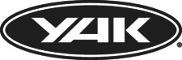

PRESS RELEASE
For immediate release 16th September 2014
Yak Mega Kit Launch at PADDLEexpo - major new gear developments for all paddlers

Stand A16, 28-30th September 2014, Nuremberg, Germany
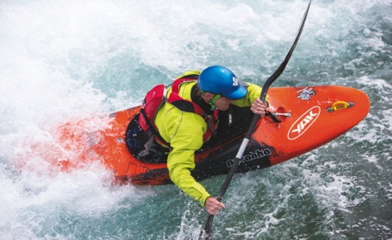
The future of paddle kit is here. Witness its unveiling by Yak at this September’s PADDLEexpo. See how paddlers of all disciplines will be gearing up for the 2015 season and beyond.

Rock up to the Yak stand and become immersed in Yak’s new world, where colours are more vibrant, kit more functional, innovations more compelling. With its ultra new touring and recreational range launching right there at the show, plus the recently launched new whitewater range bursting out from the display stands, there’s more to see - and more to want – at Yak.

Brand New Launch:

Touring and Recreational range

Yak approached the development of this gutsy new range with one objective: to design exactly the kit touring and recreational paddlers need and want. Paddlers range widely in abilities, experience and type of paddling discipline. Yet the spirit of Yak ensures that no paddlers ever have to deviate from great kit that utterly suits them and their individual purpose.

The aficionados of the touring world are destined to settle for nothing less than the finesse of the Greenburg 70N - the ultimate touring buoyancy companion. The Greenburg combines Yak’s proprietary 4D cast foam and Axial Core technologies to equip the elite paddler with complete ease of movement over even the lengthiest days on the water. Those who prefer a more laid back approach to paddling will choose the Xipe 60N or Kallista 50N buoyancy aid for comfortable, practical touring.

As for cags, the high spec Sladek is the choice of champions while the Glacier offers an equally seamless fit with serious comfort built in. Alternatively the feature-packed Apollo or Comet cags will soundly see off the elements. Recreational paddlers might prefer the lighter weight of supremely efficient, paddler-friendly Waimea.

Newcomers, paddler-dabblers and those that go for lightweight, back-to-the-essentials touring can pack a punch with the cleanly efficient Blaze buoyancy aid and fuss-free Sumit cag. For recreational users, substitute the Bravo cag-wise for breathtaking simplicity all wrapped up in a full-on technical cag. In either case, add the Sybilla Basic Trousers to for the perfect waterproof, weatherproof, paddler-proof solution.

All these solutions have been specially tailored by Yak to keep every paddler protected and comfortable no matter what their personal goal. In addition, Yak’s array of touring and recreational accessories is as comprehensive as it is impressive in detail and quality. From towlines to paddle bags, the gear is first rate and destined to gratify paddlers from enthusiasts to the dedicated specialists alike.

The Whitewater range

By now, adventure paddlers will be aware that the new season Yak whitewater range is already gracing the whitewater ways of rivers, gorges and seascapes worldwide. The range spans buoyancy aids, cags, base layers, drysuits, rescue equipment, helmets and buoyancy bags. Throughout it, Yak has showed consistently intelligent use of the most technologically advanced materials coupled with superior design.

With these superbly designed ranges, Yak continues to push paddle equipment through new frontiers. Come visit the Yak team on stand A16 at PADDLEexpo and see the paddling future light up before your eyes.

ENDS//
Notes to Editors
Part of the Survitec Group which also owns Crewsaver, Yak, produces and manufactures products that are purposely designed for the whitewater, recreational and touring kayaking and canoe markets. A wide range of products suit all styles and experience, giving paddlers more choice and more opportunities to enjoy their sport with total peace of mind. Yak’s products include buoyancy aids, drysuits, cags, trousers, spray decks, gloves, footwear, headwear and buoyancy bags.

Together with Crewsaver, Yak has 50 years of experience manufacturing marine safety products that combine cutting edge technology with high performance and ultimate practicality.

PADDLEexpo is the global paddlesport trade show, taking place this year on 28th to 30th September in Nuremberg, Germany. Begun in 2003, it is now the leading annual paddlesports-exclusive trade fair globally. All the newest products and trends are found here and the fair has also become a networking event for buyers, manufacturers, importers, retailers, media and associations worldwide.

For media information, hi-res images or product tests please contact:
Hannah Burywood, Marketing Dept, Crewsaver
T +44 (0) 1329 820024 E hannah.burywood@survitecgroup.com

