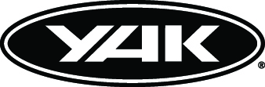

PRESS RELEASE
For release 29th July 2014
Yak launches complete new Whitewater range – Upgrade yourself
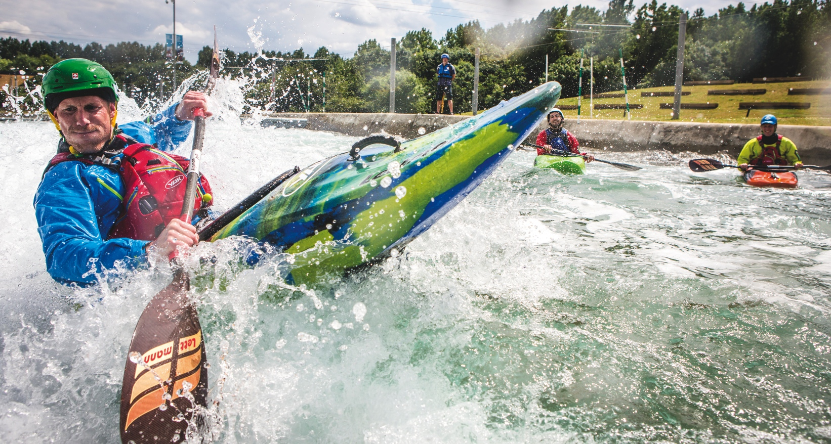
Hallertau, Rakau, Galena, Riwaka, Tomahawk, Galaxy, Junga, Vanguard, Chinook & Target are some of the names that you will be hearing in your local paddling retailer this winter.
Yak, the perfect partner for all paddling adventurers, is pleased to announce the launch of a pioneering new Whitewater range. The new range includes buoyancy aids and technical clothing for the wilder side of whitewater action.
Yak's experience in the wet stuff, combined with its ability to innovatively entwine safety with practicality and style, has resulted in a striking, top flight collection. It comprises all the paddling adventure equipment needed both by those coming in to the sport, as well as by those battle hardened experts seeking that next adventure paddle fix.
The new range spans buoyancy aids, cags, base layers, drysuits and trousers. Throughout it, Yak has showed consistently intelligent use of the most technologically advanced materials coupled with superior design. For example, with its TX20K, DX10K and DX5K water and windproof fabrics, Yak has engineered a comprehensive range of waterproof cags to suit all levels within the sport. These range from the uber robust elite cag, the Riwaka, to the stripped down, lightweight Junga.
The range also includes many other thoughtful and elegant design solutions, including the energy saving Axial Core Technology in the Hallertau buoyancy aid, and the game-changing Fusion Fit. Expect these innovations to change the perception of buoyancy aids forever.
Such sophisticated solutions are Yak to the core. This pro team designs specifically to meet the unique needs of paddlers, making Yak the choice of the purist and the recreational user alike.

Buoyancy Aids
Looking deeper into the range, Yak has developed three buoyancy aids to significantly enhance the job specific movements of the whitewater adventurer, whatever their size or shape, with colour options to suit every adrenaline-fired individual.
Shaped to fit and offering total freedom of paddling movement, the range is headed by the Hallertau 70N - the ultimate whitewater buoyancy aid. Innovative and primed for performance, it offers the most advanced solutions for freedom, comfort and control when out on the water.
Next up, the Rakau 70N is at home both on the river and out in the surf and is the absolute top choice for adventure paddlers looking for a vest style buoyancy aid. Incorporating Fusion Fit, it boasts pioneering technology coupled with air mesh fabric for a breathable solution.
Meanwhile the Galena 70N is the stripped-down whitewater buoyancy aid for those who carry only the essential accessories. 4D Cast technology hugs the body, wrapping up a winning design that's super safe, super comfy and super cool.

Cags
Yak’s whitewater cags do everything and more required by the whitewater paddler – and look the business while they’re at it. Yak has used its magic to sculpt each one of the four styles into technical clothing that enhances the paddler’s athletic performance while making his time on the water supremely comfortable. With a funky range of colour options, stylish paddlers can also plan their look on the water.
At the top of the range, the Riwaka Whitewater Cag is destined for uncompromising whitewater experts. Built to take on the biggest surf, its seamless underarm wizardry combined with 3 way performance cut sleeves provides the ultimate in technology and performance.
The Tomahawk is a high spec whitewater cag that works as hard as the paddler, leaving him cool, calm and collected. It is wear resistance and features an action-sympathetic cut.
A star in itself, the Galaxy Whitewater Cag is perfect for taking on the white stuff with DX10K 2.5 layer waterproof, windproof and breathable fabric, fully taped seams and thoughtful comfort additions.
For those looking for whitewater action stripped to the core, the Junga Whitewater Cag elegantly meets every essential for performance and comfort, while being free of any fripperies that might leave those travelling light feeling cluttered and bothered. Being Yak, it’s still always waterproof, windproof and breathable – always a great choice on the water.
Drysuit and trousers
Yak’s Vanguard drysuit offers the best protection from the elements combined with the comfort and freedom of movement expected from a wetsuit and cag combo.
It combines best in class TX20K 3 layer fabric with seamless underarm technology and 3 way performance cut sleeves.
Alternatively Yak’s Chinook Trousers can be worn alone or paired with any Yak twin-waist jacket. Perfect for the job, they are sculpted around the leg for flexibility. They are weatherproof yet wear-resistant, ensuring paddlers are well prepared for anything the water might throw at them.

Base Layers
The Target Top is a comfortable and functional base layer to keep paddlers warm and dry all day long. Designed to be flexible and chafe free, it teams perfectly with the Target Trouser polypro long johns for the full works in base layer heaven.
These new clothing options and buoyancy aids add to Yak's existing collection of whitewater accessories, ranging from headwear and buoyancy bags to spraydecks and rescue essentials. Together the complete range gives all adventure paddlers the ability to look and perform better on the water, while at the same time staying safe and comfortable.
This is serious blast sports equipment dedicated specifically to all whitewater enthusiasts from Yak, the professionals in designing and manufacturing paddling equipment for whitewater, recreational and touring kayaking and canoeing.
ENDS//

Notes to Editors
Part of the Survitec Group which also owns Crewsaver, Yak, produces and manufactures products that are purposely designed for the whitewater, recreational and touring kayaking and canoe markets. A wide range of products suit all styles and experience, giving paddlers more choice and more opportunities to enjoy their sport with total peace of mind. Yak’s products include buoyancy aids, drysuits, cags, trousers, spray decks, gloves, footwear, headwear and buoyancy bags.
Together with Crewsaver, Yak has 50 years of experience manufacturing marine safety products that combine cutting edge technology with high performance and ultimate practicality.

For media information, hi-res images or product tests please contact:
Hannah Burywood, Marketing Dept, Crewsaver
T +44 (0) 1329 820024
E hannah.burywood@survitecgroup.com

