PRESS RELEASE
For immediate release 2nd October 2014

The future of Yak is now – upgrade yourself.
There’s more to see - and more to want – at Yak.
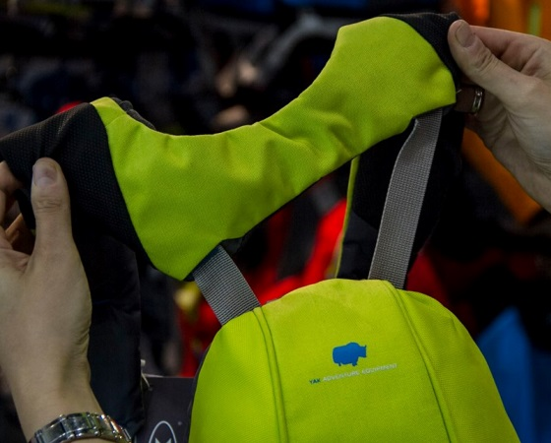
The future of paddling kit is here! Hundreds witnessed its unveiling by Yak at PADDLEexpo 2014. Drawn in by the colours and innovative technology paddlers of all disciplines will be gearing up with Yak for the 2015 season and beyond.

Visitors became immersed in Yak’s new world, where colours are more vibrant, kit more functional, innovations more compelling.

Bursting out from the display stands the ultra-new touring and recreational range was on full show, giving a taste of what to expect for the 2015 season, including a variety of buoyancy aids, cags and accessories.

The complete whitewater range was also on display for all to see – this range is already available in stores throughout the UK and Europe and proving to be extremely popular.
There was certainty lots of interest and excitement surrounding the highly innovative Axial Core technology encompassed in the Hallertau 70N & Greenburg 70N buoyancy aids. The shoulder straps of these jackets articulate to allow total freedom of movement and eliminate ride up.

#wheresyourYAK
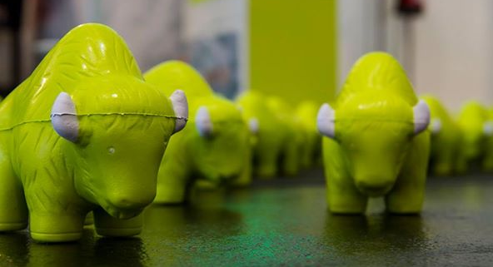
Stampeding the stand were the hugely popular 500 squishy Yaks’ that were given out during the show – the competition is now to get a picture of your Yak in the most obscure place around the world. Get snapping and upload to our Facebook page.

Yak Brand Manager Peter Ford quotes; ‘it was a very exciting show for us, this was the first time that Yak has launched a complete new range of paddling clothing & safety equipment in a number of years and we are delighted it was so well received.’

Those keen to know more can check out the entire whitewater range on the Yak website; www.YakAdventureEquipment.com and don’t forget to check out the awesome launch video.

ENDS//

Notes to Editors

Part of the Survitec Group which also owns Crewsaver, Yak, produces and manufactures products that are purposely designed for the whitewater, recreational and touring kayaking and canoe markets. A wide range of products suit all styles and experience, giving paddlers more choice and more opportunities to enjoy their sport with total peace of mind. Yak’s products include buoyancy aids, drysuits, cags, trousers, spray decks, gloves, footwear, headwear and buoyancy bags.

Together with Crewsaver, Yak has 50 years of experience manufacturing marine safety products that combine cutting edge technology with high performance and ultimate practicality.

