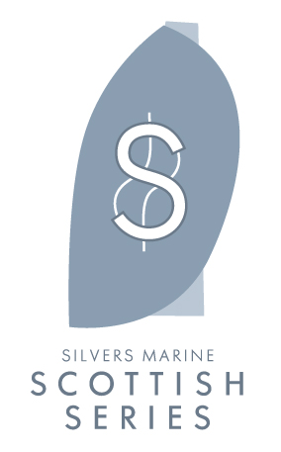
Press Release
For release 29th April 2015
Crewsaver to sponsor Scottish Series 2015
Crewsaver is delighted to announce a new partnership with Silvers Marine Scottish Series. The series runs from the 22nd – 25th May 2015, with over 100 entries it is sure to make for an exciting event!
Crewsaver is the safety partner and product sponsor of the 41st edition of the series. Crewsaver will be providing a brand new set of inflatable marker buoys for the event and for use at Clyde Cruising Club thereafter.
"At Silvers Marine Scottish Series we are very aware of how important it is to have sponsors who value the audience they get at Scottish Series and therefore are delighted to welcome Crewsaver into our event family! The Scottish Series race management team have been using Crewsaver racing marks for years and they have always performed even on the most challenging days we have on Loch Fyne.
I know all our race competitors will welcome a brand as well known on the sailing scene as Crewsaver." Dane Ralston, Chairman Scottish Series 2015.
Ross Wilkinson, Managing Director for Crewsaver commented: “We are delighted to become a part of the Scottish Series; it is both professionally run and well respected throughout the community and will be a great platform to showcase our products.”
As part of the sponsorship Crewsaver has also teamed up with the local retailers, who all have the Crewsaver Fusion 3D lifejacket range in stock.
Competitors should visit the following retailers to find out more:
- Ardfern Yacht Chandlery
- Tarbert Yacht Chandlery
- Duncan Yacht Chandlers
- Largs Chandlers
- Kip Chandlery
In addition to this, competitors can also purchase the new Crewsaver lifejackets from Ardfern on site during the entire event.
- ENDS -

For media information, hi-res images or product tests please contact:

Crewsaver
Hannah Burywood, Marketing Dept
T +44 (0) 1329 820024
E hannah.burywood@survitecgroup.com

Or

Alison Willis – Marine Advertising Agency Ltd
T +44 (0) 23 9252 2044
E Alison@marineadagency.com

Notes to Editors

Crewsaver is a world-leading manufacturer of marine safety equipment and clothing for the commercial and leisure marine industries. Based in Gosport, Hampshire, the company designs and manufactures bespoke safety equipment for several countries’ Special Forces, the UK government’s Environment Agency and the aviation and oil industries. Crewsaver is part of the Survitec Group.

www.crewsaver.com

Survitec Group holds market-leading positions worldwide in marine, defence and aerospace survival technology. Headquartered in Southampton, the company employs 2000 people across 10 manufacturing sites and 50 service centres, operating through a network of a further 550 distributors and agents to bring its best-in-class products and services to a global customer base. With an extensive history spanning over 160 years and a portfolio of some of the most reputable brands in the safety and survival industry, Survitec is committed to product innovation, technological advancement and quality assurance.

Key products within Survitec’s portfolio include marine, defence and aviation Liferafts, world leading submarine escape technology, lifejackets for commercial airlines and the offshore industry as well as pilot flight equipment, including anti-g clothing used for the Eurofighter and JSF programmes. The Group also pioneered marine evacuation technology and today the unique MarinArk system is used on many major cruise ships across the globe.

www.survitecgroup.com

