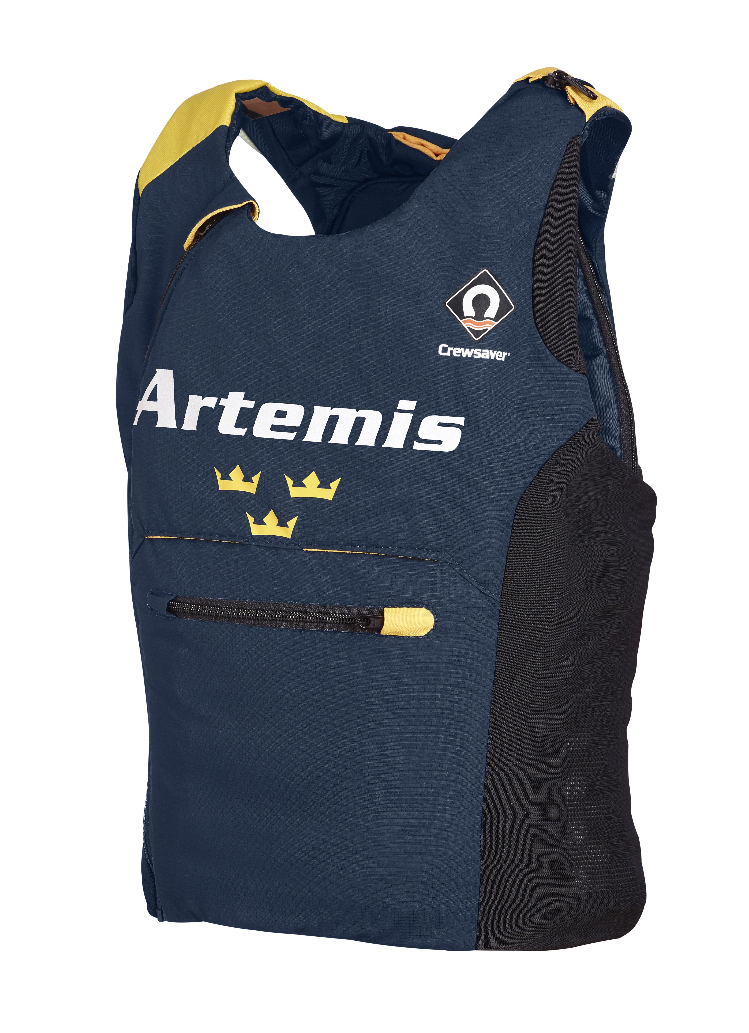
ARTEMIS RACING APPOINTS CREWSAVER AS OFFICIAL SAFETY SUPPLIER FOR THE 35TH AMERICA'S CUP
Southampton, 23 June 2015 - Crewsaver today announces that it has been selected by Artemis Racing to become its Official Safety Supplier for the 35th America’s Cup.
With the America’s Cup taking place in Bermuda in June 2017, and with the preliminary Louis Vuitton America's Cup World Series commencing in July 2015, there’s mounting tension and excitement as the teams prepare their campaigns and equipment to take on each other in extreme foiling catamarans.
Crewsaver, a Survitec company, and one of the world’s leading personal floatation equipment manufacturer, is excited to announce its exclusive safety equipment partnership with Artemis Racing; Crewsaver will be working with the Artemis Racing team to develop the most advanced, cutting edge performance technology available to date.
The new designs will enable Artemis Racing’s elite sailors to perform safely, yet to the very best of their ability, under the most challenging of conditions. Specifically, two radical new buoyancy aids, including one designed to meet the sailors’ unique needs aboard the foiling AC Class boat for the 2017 America’s Cup itself, give the team light weight, breathable solutions that provide total freedom of movement and temperature control.
Artemis Racing’s safety officer and three time Olympian Anthony Nossiter commented: “We understand the dangers of racing these high performance catamarans at 40+ knots, and the safety of the guys on board is a top priority which is why Crewsaver are our number one choice for taking on this project.”
Iain Percy, Team Manager of Artemis Racing and double Olympic Champion, agreed saying: “in elite sport, the finest margins can make the difference between winning or losing, and as a team we are leaving no stone unturned, whether it be in design and manufacture of our AC Class yacht, or in the development of our safety gear.”
Ross Wilkinson, Managing Director of Crewsaver, commented: “Crewsaver is delighted to partner with Artemis Racing and Iain Percy in their quest to win the 35th America’s Cup. We have designed each piece to help keep all the sailors safe, comfortable and functioning without compromise. Our in-depth knowledge gleaned in many other fields has enabled us to design safety apparel that truly aids the Artemis Racing sailors in their uniquely challenging environment.”
Keep up to date with the latest performance technologies at:
www.crewsaver.com / www.ArtemisRacing.com
For media information, hi-res images or product tests please contact:
Crewsaver
Hannah Burywood, Marketing Dept
T +44 (0) 1329 820024
E hannah.burywood@survitecgroup.com
or
Alison Willis – Marine Advertising Agency Ltd
T +44 (0) 23 9252 2044
E Alison@marineadagency.com
Notes to Editors
Crewsaver is a world-leading manufacturer of marine safety equipment and clothing for the commercial and leisure marine industries. Based in Gosport, Hampshire, the company designs and manufactures bespoke safety equipment for several countries’ Special Forces, the UK government’s Environment Agency and the aviation and oil industries. Crewsaver is part of the Survitec Group.
www.crewsaver.com
Survitec Group holds market-leading positions worldwide in marine, defence and aerospace survival technology. Headquartered in Southampton, the company employs 2000 people across 10 manufacturing sites and 50 service centres, operating through a network of a further 550 distributors and agents to bring its best-in-class products and services to a global customer base. With an extensive history spanning over 160 years and a portfolio of some of the most reputable brands in the safety and survival industry, Survitec is committed to product innovation, technological advancement and quality assurance.
Key products within Survitec’s portfolio include marine, defence and aviation Liferafts, world leading submarine escape technology, lifejackets for commercial airlines and the offshore industry as well as pilot flight equipment, including anti-g clothing used for the Eurofighter and JSF programmes. The Group also pioneered marine evacuation technology and today the unique MarinArk system is used on many major cruise ships across the globe.
www.survitecgroup.com
Artemis Racing is a professional sailing team challenging for the 35th America's Cup, representing Kungliga Svenska Segel Sällskapet (KSSS – the Royal Swedish Yacht Club), the fifth-oldest yacht club in the world. Founded in 2006 by Torbjörn Törnqvist and named after the Greek goddess Artemis, the team has won numerous competitions worldwide, including the MedCup, TP52 World Championships and the RC44 World Championship. Artemis Racing was the Challenger of Record for the 34th America’s Cup.
www.artemisracing.com
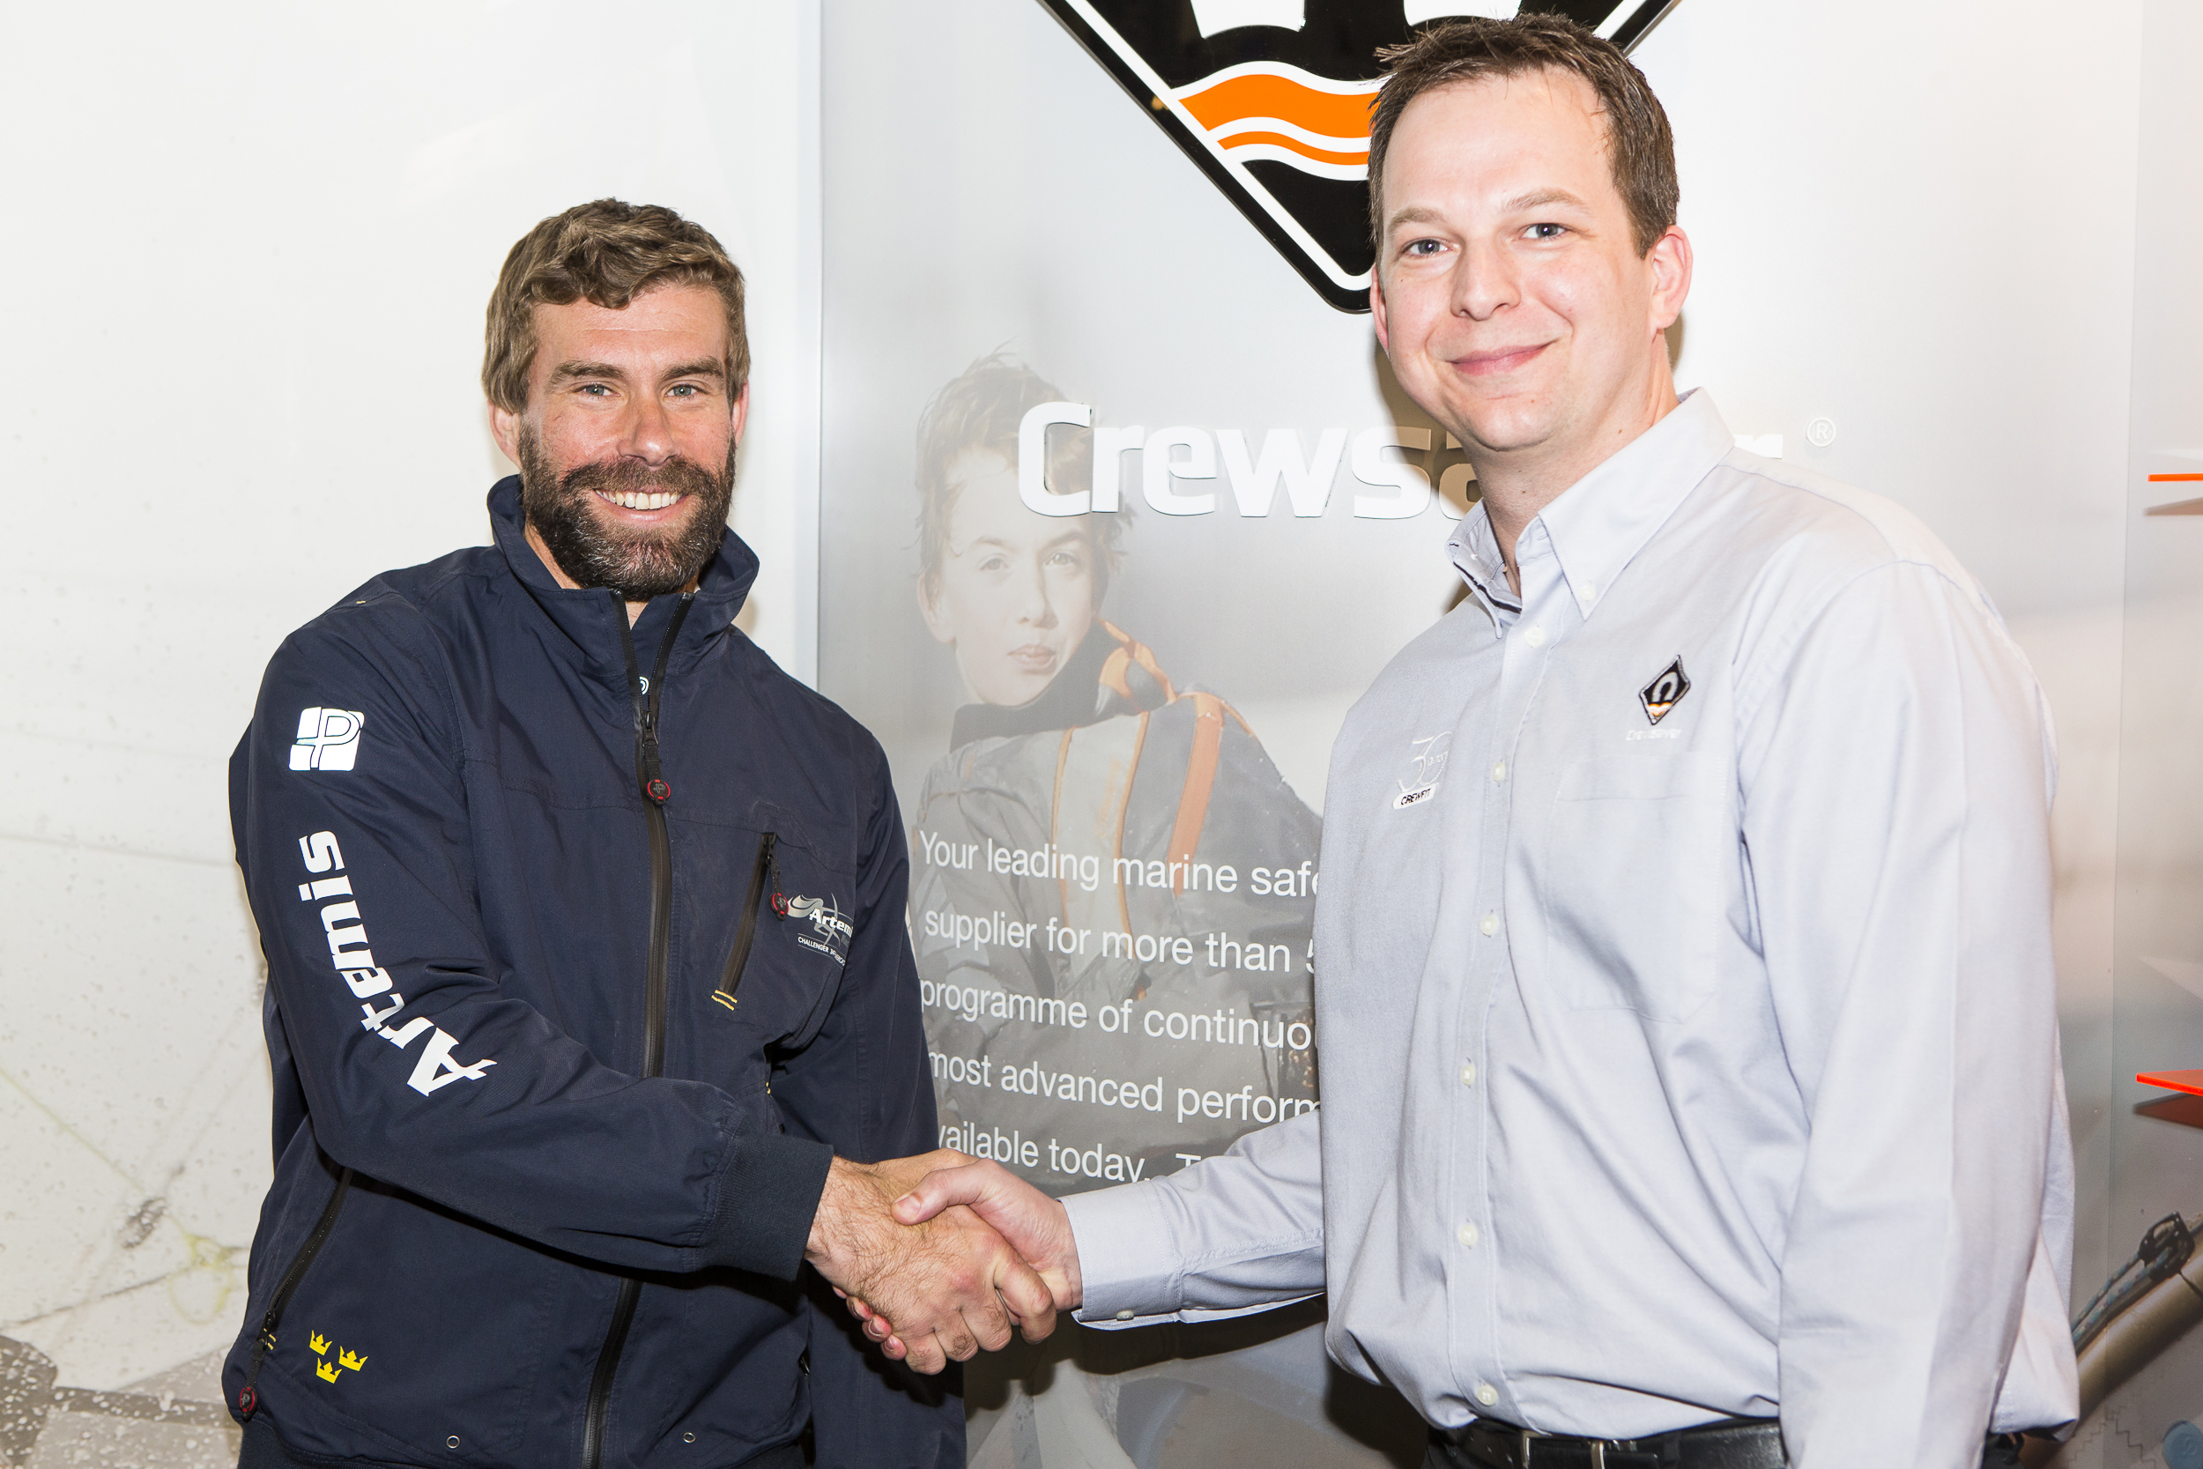
Iain Percy (Artemis Racing) and Ross Wilkinson (Crewsaver) Photo Credit @Sportography

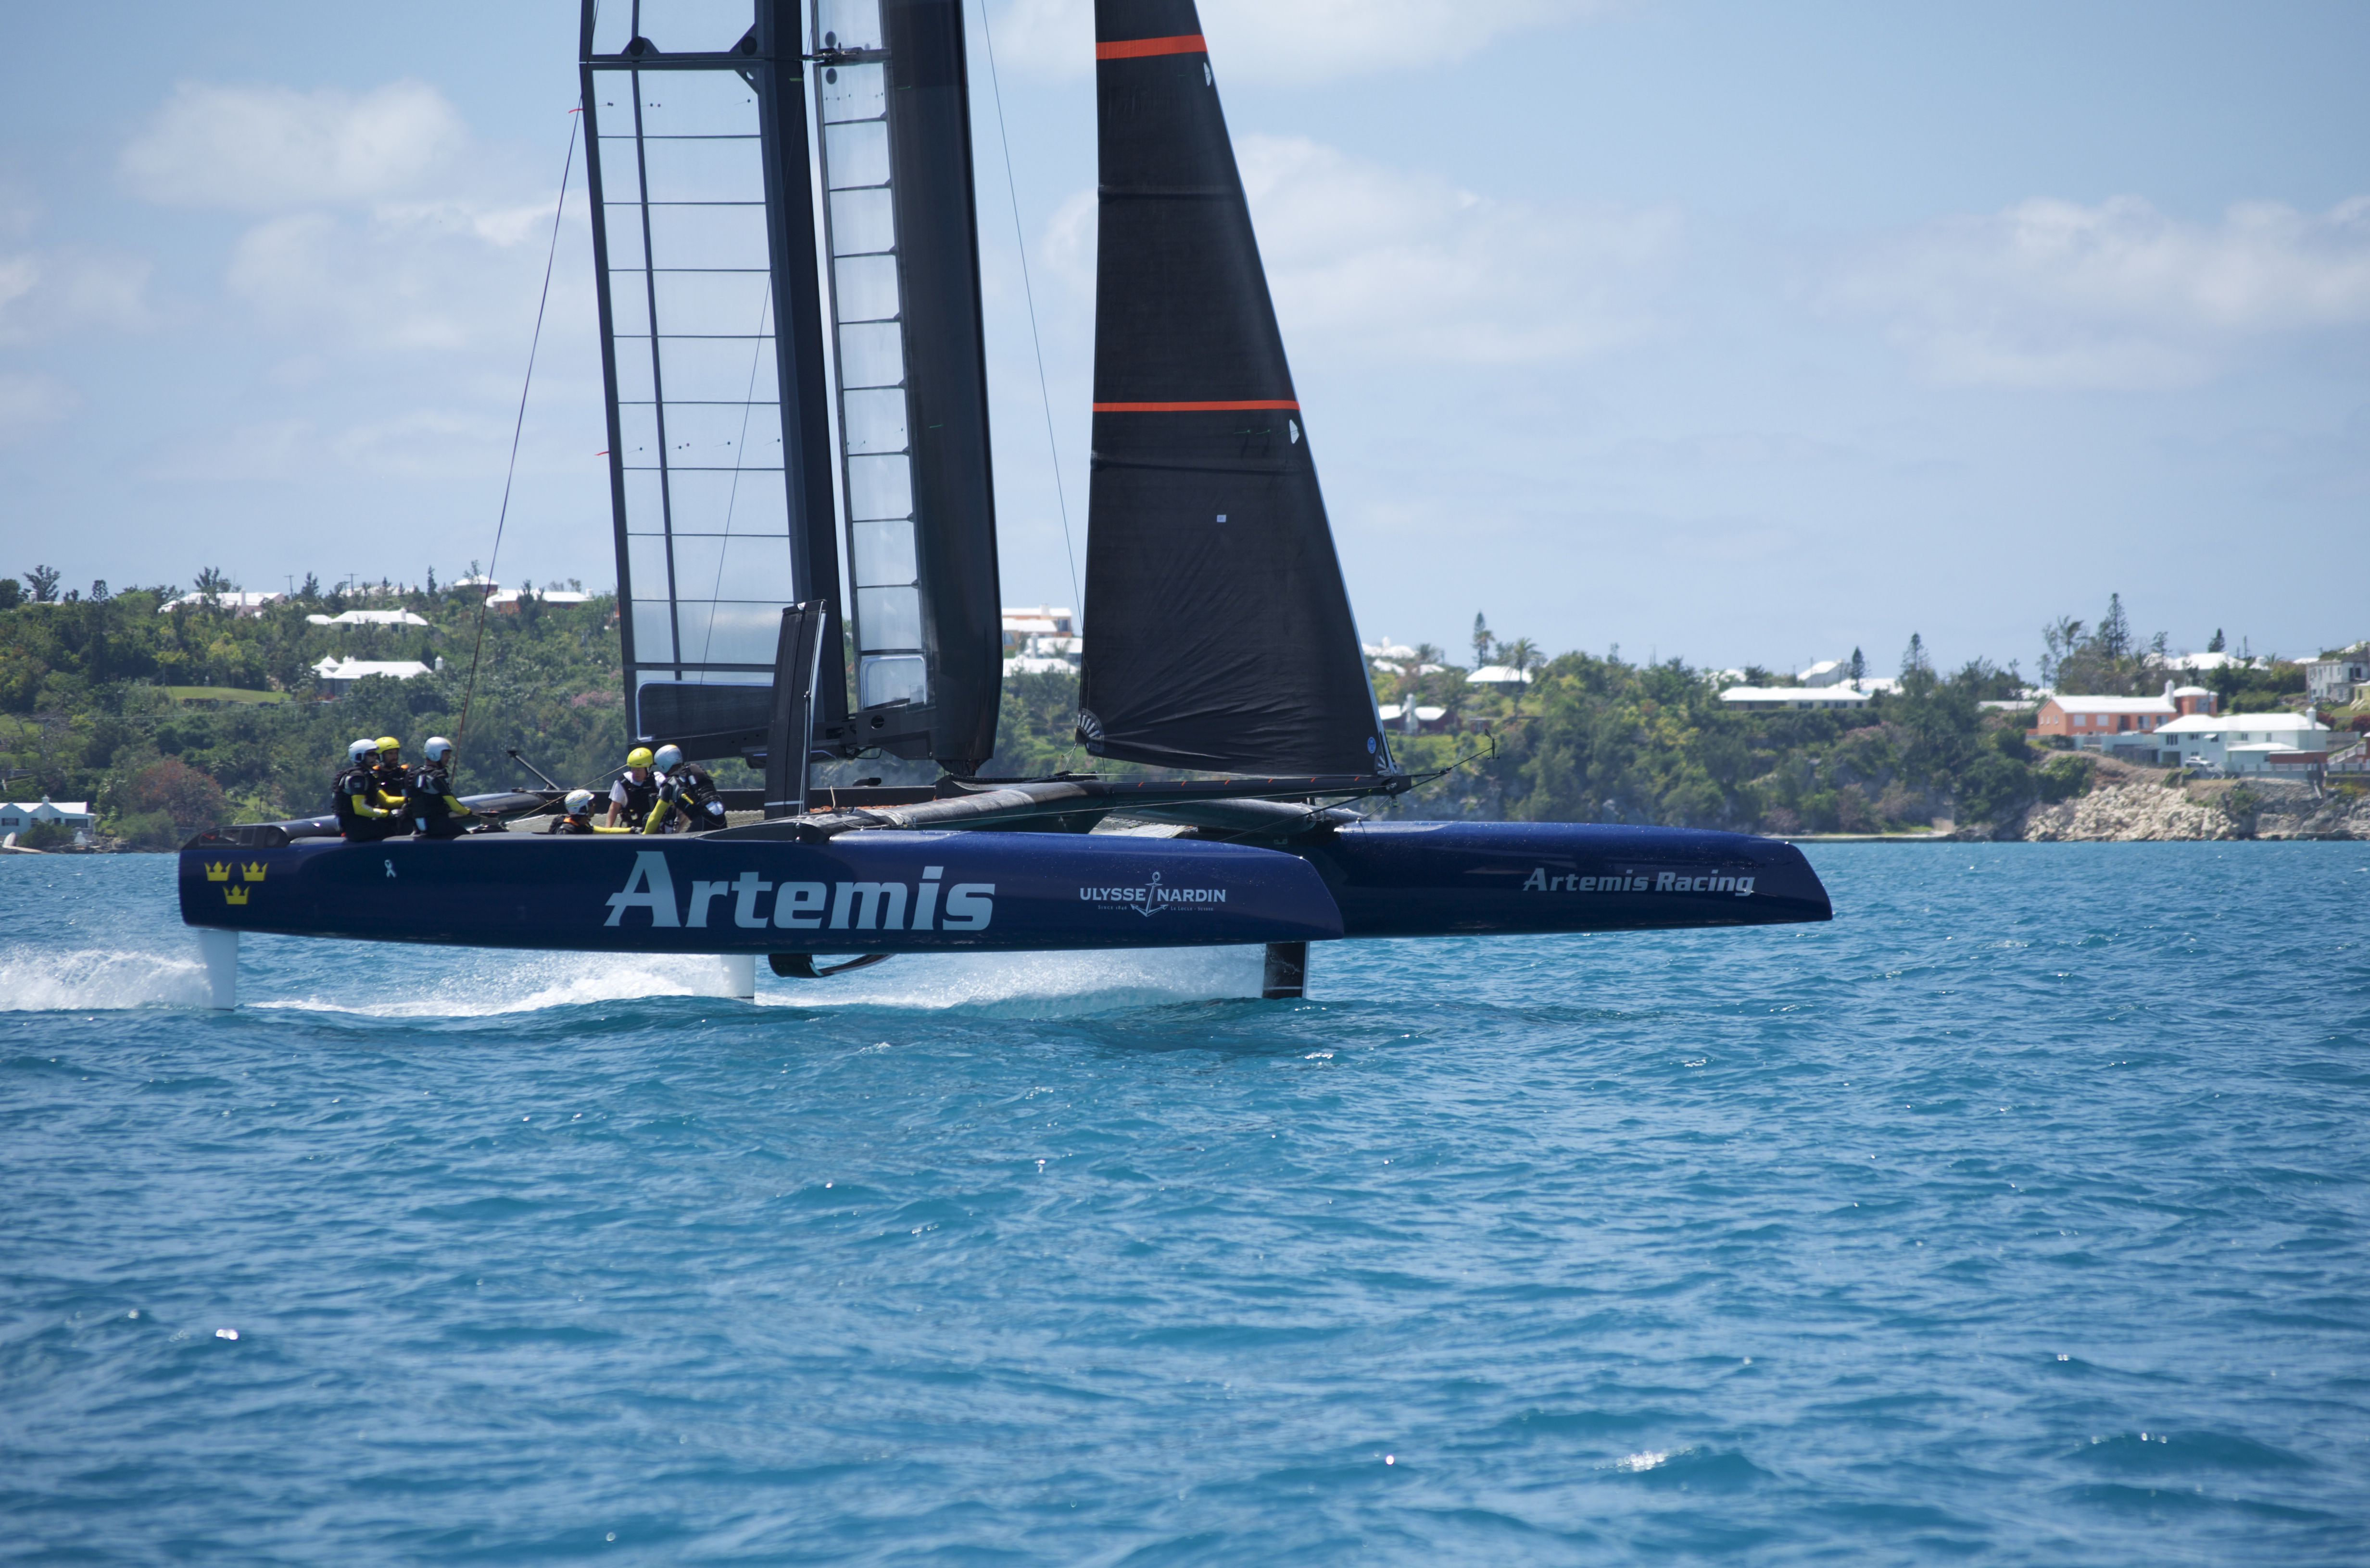
Artemis Racing’s foiling AC45 Turbo training in Bermuda

