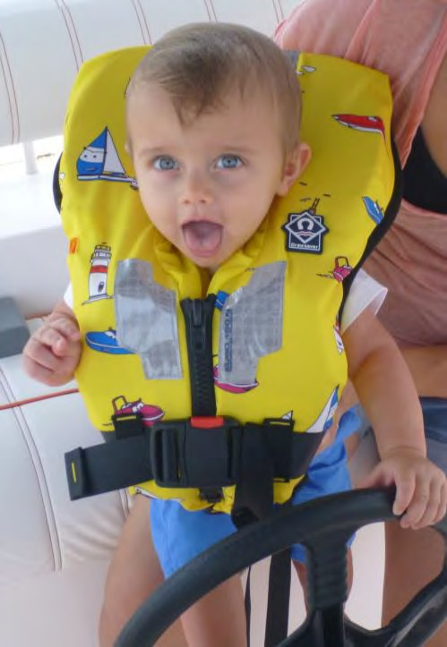
PRESS RELEASE
Crewsaver Baby & Children's Lifejackets really are 'Safer By Design'.

Visit our stand to view the range: 01.440
Crewsaver has yet again pushed the boundaries of re-design by making a radical change to baby and children's lifejackets. A move from 100N to 150N buoyancy plus other key safety and comfort features sets the benchmark in providing the ultimate performance when taking your loved ones on the water.

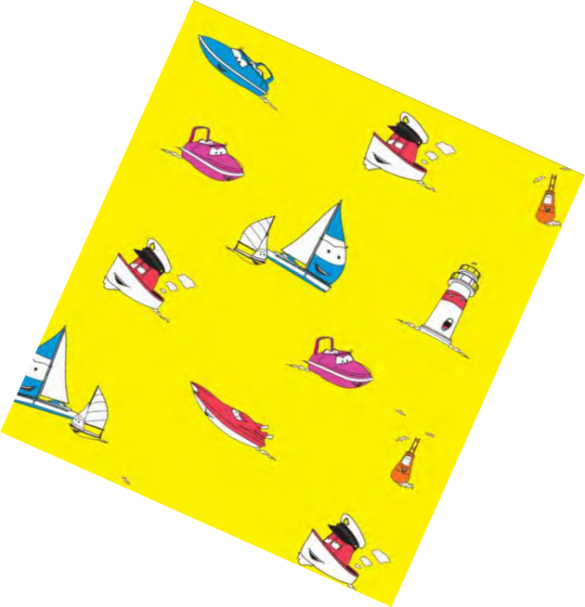
This is the first complete range of baby & children 150N Lifejackets, designed to outperform existing children's products. Tried and tested initially on mannequins and eventually children ensures that these lifejackets are the safest around and provide the ultimate performance.

Nigel Parks head of design at Crewsaver quotes 'we decided that 100N lifejacket simply wasn't enough when going offshore which is why we have created this 150N range. Rigorous testing proved that the initial buoyancy significantly improved the safety of the jackets. The extra bulk the additional 50N creates was initially met with some trepidation however once the considerable safety aspects were realised
this was soon forgotten.'

What makes these lifejackets safer than a standard children's lifejacket?:
Quicker Spin Time - Increasing the level of buoyancy means a direct drop in time it takes for the child to turn around should they fall in face down. With the 150N the baby/childs face can be up and out of the water in 3-5 seconds!

Increased buoyancy means increased distance from the water - Babies and Children are small which means they need more buoyancy than your average adult to stay high out of the water. Having a jacket which provides 150N of buoyancy means the wearer's head and mouth will stay high out of the water increasing their safety if they were to fall in.

Continues overleaf...

Funky cartoon print used on the Euro 150N ensures that the product will
appeal to children!

Increased safety specification ensures that the products will
appeal to adults!

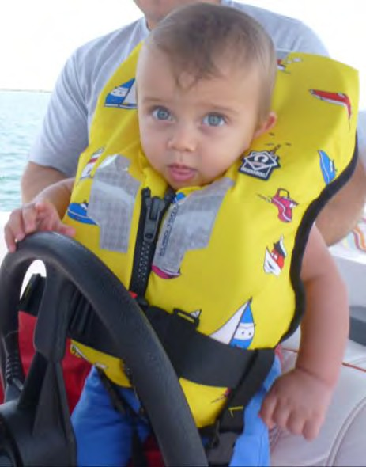
Increased collar stability to reduce lolling of the head - The 50N extra buoyancy also means the baby & child has increased stability when in the water. This can be particularly useful when the child is moving/splashing around or has fallen in in rough seas.

Sculpted neck construction for comfort and stability and supersoft cut and profiled foam - 50N extra foam means slightly more bulk on the jacket which is why we have ensured that this jacket has a neck specifically sculpted to ensure maximum comfort AND has been made out of supersoft cut and profiled foam. The outside fabric has also been chosen to ensure it provides a soft feel.

High visibility yellow with child friendly patterns - High visibility yellow means your children will always be seen if they do fall in, a funky cartoon on the Euro lifejackets keep the jacket appealing to the children as well as the adults.

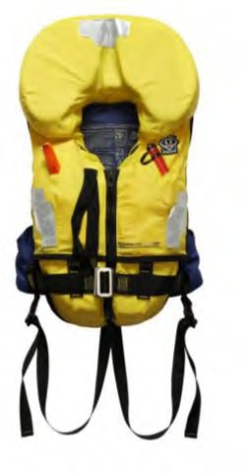
What these lifejackets have to offer/key safety features:

Jacket | Key Features |  | Suitable For | Size: Baby & Child | Size: Junior & Large Child | RRP
Supersafe Air & Foam | ✓  ✓  ✓  ✓  ✓  ✓  ✓  ✓ | Harness with built in D-ring at the back Manual inflation tube for additional buoyancy  Contour cut foam for comfort and excellent turning Adjustable crotch and waist straps Comfort back brace Reflective tape Lifting Becket Whistle | Ocean Offshore Coastal | 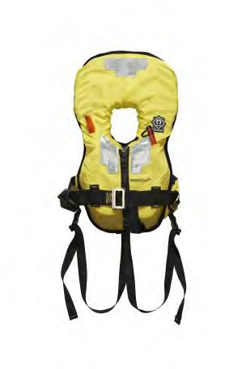 |  | £72 - £80
Supersafe | ✓  ✓  ✓  ✓  ✓  ✓ | Contour cut foam for comfort and excellent turning speed  Adjustable crotch and waist straps Comfort back brace Reflective tape Lifting Becket Whistle | Offshore Coastal | 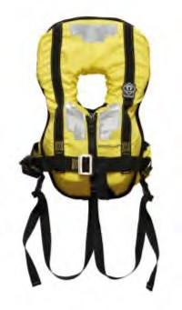 | 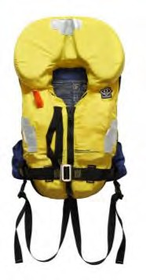 | £62 - £70
Continues overleaf...

Euro | - Contour cut foam for comfort and excellent turning  - Adjustable crotch and waist straps  - Comfort back brace  - Reflective tape  - Lifting Becket  - Whistle | Ocean Offshore Coastal | 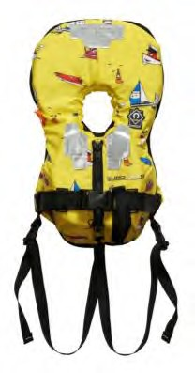 | 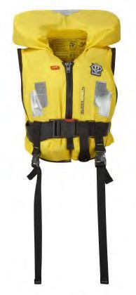 | £52 - £55
All jackets are designed with swimmers and non swimmers in mind.

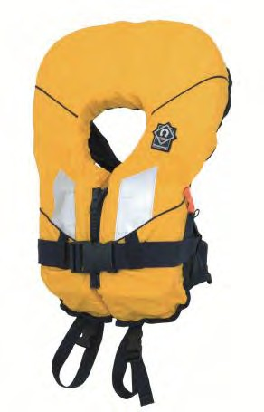
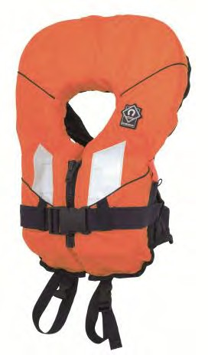
Still Available:
For those not going offshore and just looking for something more basic to splash about in Crewsaver offer the 100N Spiral Lifejacket. A jacket that benefits from the same rigorous safety tests and expert design skills as the other jackets, this product is great for sheltered and coastal water and can be seen on the river bank, canal side, beach or marina. Available in yellow & orange.
Available in a variety of sizes including: Baby, Child, Junior, Large Child, S, M, L, XL

RRP: £35 - £50

Notes to editors About Crewsaver
Crewsaver is the UK’s leading lifejacket and watersports equipment manufacturer, founded in Gosport, England in 1957.

Crewsaver continues to be recognised as the premier lifejacket brand. Many prestigious institutions including the RNLI, the MoD and a number of emergency services choose its products.

For media information, hi-res images or product tests please contact:

Crewsaver
Hannah Burywood, Marketing Dept
T +44 (0) 1329 820024
E Hannah.Leah-Burywood@survitecgroup.com

