News Release
For immediate release
21st October 2013

A great turn out for the opening of Ancasta’s new office in Chichester

Even autumnal downpours couldn’t deter a great turn out for the opening of Ancasta’s new office in Chichester marina. People came from across the South East on Saturday 26th October to meet the team in the new office whilst sampling plenty of Chichester’s finest Appledram Cider!

The opening provided the perfect opportunity to introduce the Ancasta brand to Chichester. The new fully operational office in Chichester’s Premier Marina is easily accessed from the A27 and is open seven days a week (including bank holidays) . It provides access to the entire Ancasta brokerage network as well as new boats from the popular Beneteau, Prestige, Lagoon and CNB brands.

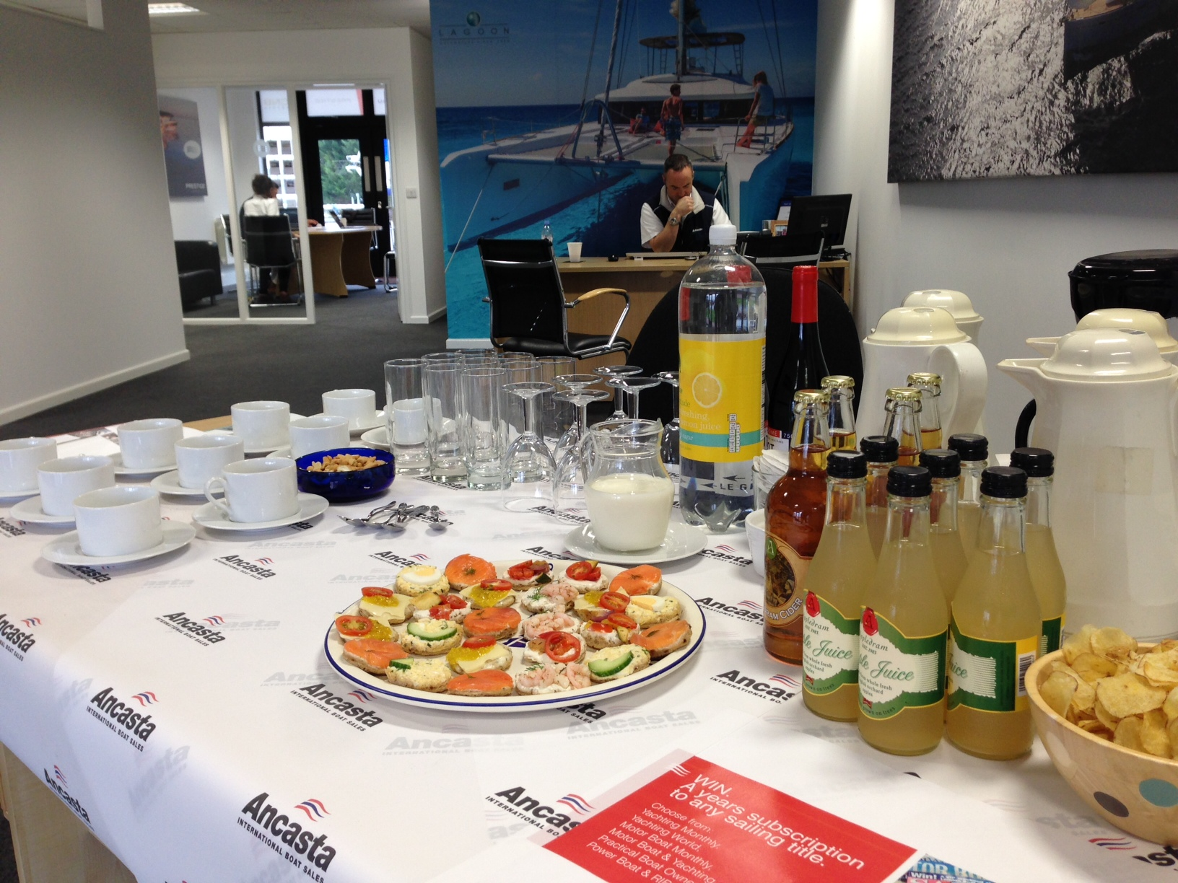
Ancasta has both motor and sail specialists on-site and are currently stocking a brand new Prestige 450 and a Beneteau Oceanis 34 in Chichester which are available to view.

Watch this space for the official opening of the new marina complex with an event scheduled for March 2014.

ENDS//

Notes to editors

- Ancasta International Boat Sales has 15 offices across Europe
- Geraint and his team are looking forward to welcoming clients to the new office:
Ancasta Chichester
Chichester Marina – Unit D2
Birdham, Chichester
West Sussex, PO20 7EJ
T: 01243 885 380
E: chichester@ancasta.com
- Ancasta is a new boat dealer for Prestige Motor Yachts, Beneteau Yachts, Lagoon Catamarans, Bordeaux 60, Fairlie Yachts and McConaghy Yachts
- The Ancasta Group incorporates Hamble Yacht Services, a full service boatyard operating from Port Hamble.
- For more information on Ancasta visit www.ancasta.com

Media enquiries via Marine Advertising Agency:

Kathryn Foulkes or Alison Willis
Email: kathryn@marineadagency.com or alison@marineadagency.com
Tel: 023 9252 2044

