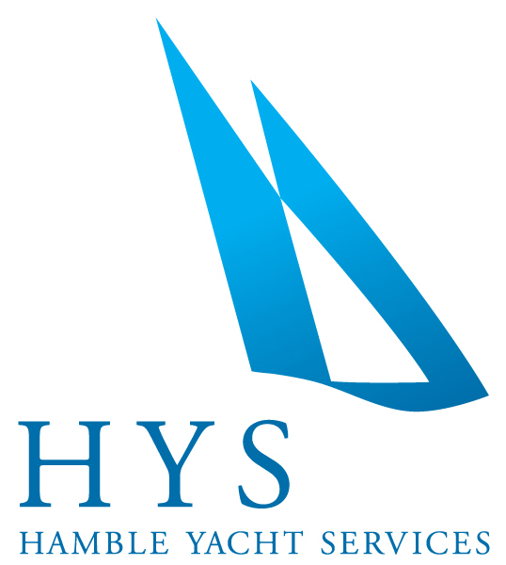

**News Release**

**For immediate release**

**4th March 2014**

**Want to experience the thrill of a REAL racing machine ?**

**Now’s your chance - at the Class 40 Demo Day, Hamble Yacht Services.**

**Saturday April 12th 2014**

Hamble Yacht Services and the Ancasta Group’s Race Boat division are inviting all **Class 40** enthusiasts to join them for their open day on Saturday 12th April - to give it a go!

Understanding the pressure and requirements that serious Race Boat campaigns demand, Hamble Yacht Services have created an environment which fully accommodates their community of Class 40 owners and racers.

Working together with the Class 40 Association, the demo day is being arranged to ensure that everyone has the opportunity to experience the exhilaration of sailing in one of these racers, and as a completely COST FREE social event, will open up and establish contacts within the ever popular fleet.

Sam Pearson, Ancasta’s Race Boat Broker who sails professionally with the Class 40 told us that in their efforts to ensure and allow the Class 40 to thrive, all parties agree.

“It is imperative to share storage, training facilities and tools, but most importantly, experiences and obviously the moral support that bigger racing crews benefit from.”

**Itinerary for the day**

10am –Meet and greet with tea and coffee.

10.30 – 11am – Look around the boats to familiarise everyone

11.30 – 3pm – **TEST SAIL**

3pm - 4.30pm – Finish the afternoon with a BBQ and drinks

Just minutes from the Solent and a couple of miles from the motorway, Hamble Yacht Services is conveniently and perfectly placed to reach by either car or boat. To find out more, please contact Sam Pearson on 02380 450 000 or email [sampearson@ancasta.com](mailto:sampearson@ancasta.com)

ENDS//



**Notes to editors**

* Ancasta International Boat Sales have 15 offices across Europe.
* New boat dealers for Prestige Motor Yachts, Bénéteau Yachts, Lagoon Catamarans, Bordeaux 60, Fairlie Yachts, McConaghy Yachts
* The Ancasta website is www.ancasta.com
* The Ancasta Group incorporates Hamble Yacht Services, a full service boat yard operating from Port Hamble.

**For further information:**

Hamble Yacht Services & Ancasta International Boat Sales

Tel: 02380 450 000

Email: louwaldegrave@ancasta.com

**Media enquiries via Marine Advertising Agency:**

Alison Willis

Tel: 023 9252 2044

Email: alison@marineadagency.com