News Release
For immediate release
5th November 2013

Savings to be had on boat winterising from the south coast’s leading facility*

Hamble Yacht Services are offering a generous helping hand this winter with savings on their laying up services.
The options for winterising are vast and can be as extensive or minimal as required. Winterising at Hamble Yacht Services, Port Hamble Marina, is available from October through to February and covers every aspect of laying up from engine and winch services to rig and steering system checks. Hamble Yacht Services have experts on hand who are happy to discuss individual lay up needs.
Now is the best time to get a ‘head start’ as we coast into the colder months.
An example package of key winter services could look like this:
- Lift out, pressure wash bottom, block off
- Prepare bottom and apply two coats of anti fouling
- Service of seacocks and valves
- Check for wear in cutlass bearing, plus stern gland
- Replace of cathodic protection as required
- Polish deck, superstructure and topsides
- Check steering system and rudder bearings for wear
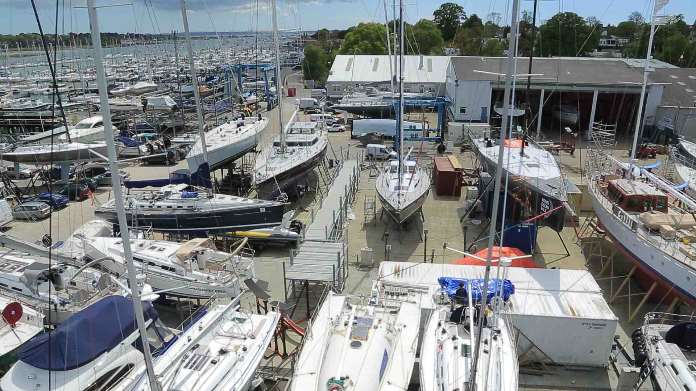
There are savings to be had if booked before 30th November 2013 so contact Hamble Yacht Services
For more information on the services available at Hamble Yacht Services call 02380 454111 or email sales@hambleyachtservices.co.uk.

*savings are subject to availability and vessel inspection. This offer does not apply to all services. Terms Conditions apply.

ENDS//

Notes to editors

Hamble Yacht Services is a well-established full service yacht repair and refit facility with a worldwide reputation for providing professional, friendly service to all types of boat owners. From its two locations on the world-renowned River Hamble, the respected boat yard operator offers services and storage for boats of all types and sizes including cruising and racing yachts, RIBs and motorboats. Full details available at www.hambleyachtservices.co.uk.

For further information:

Hamble Yacht Services
Tel 02380 454 111
email sales@hambleyachtservices.co.uk.

Media enquiries (including requests for high res images) via Marine Advertising Agency:

Kathryn Foulkes or Alison Willis
Email: kathryn@marineadagency.com or alison@marineadagency.com
Tel: 023 9252 2044

