Press Release
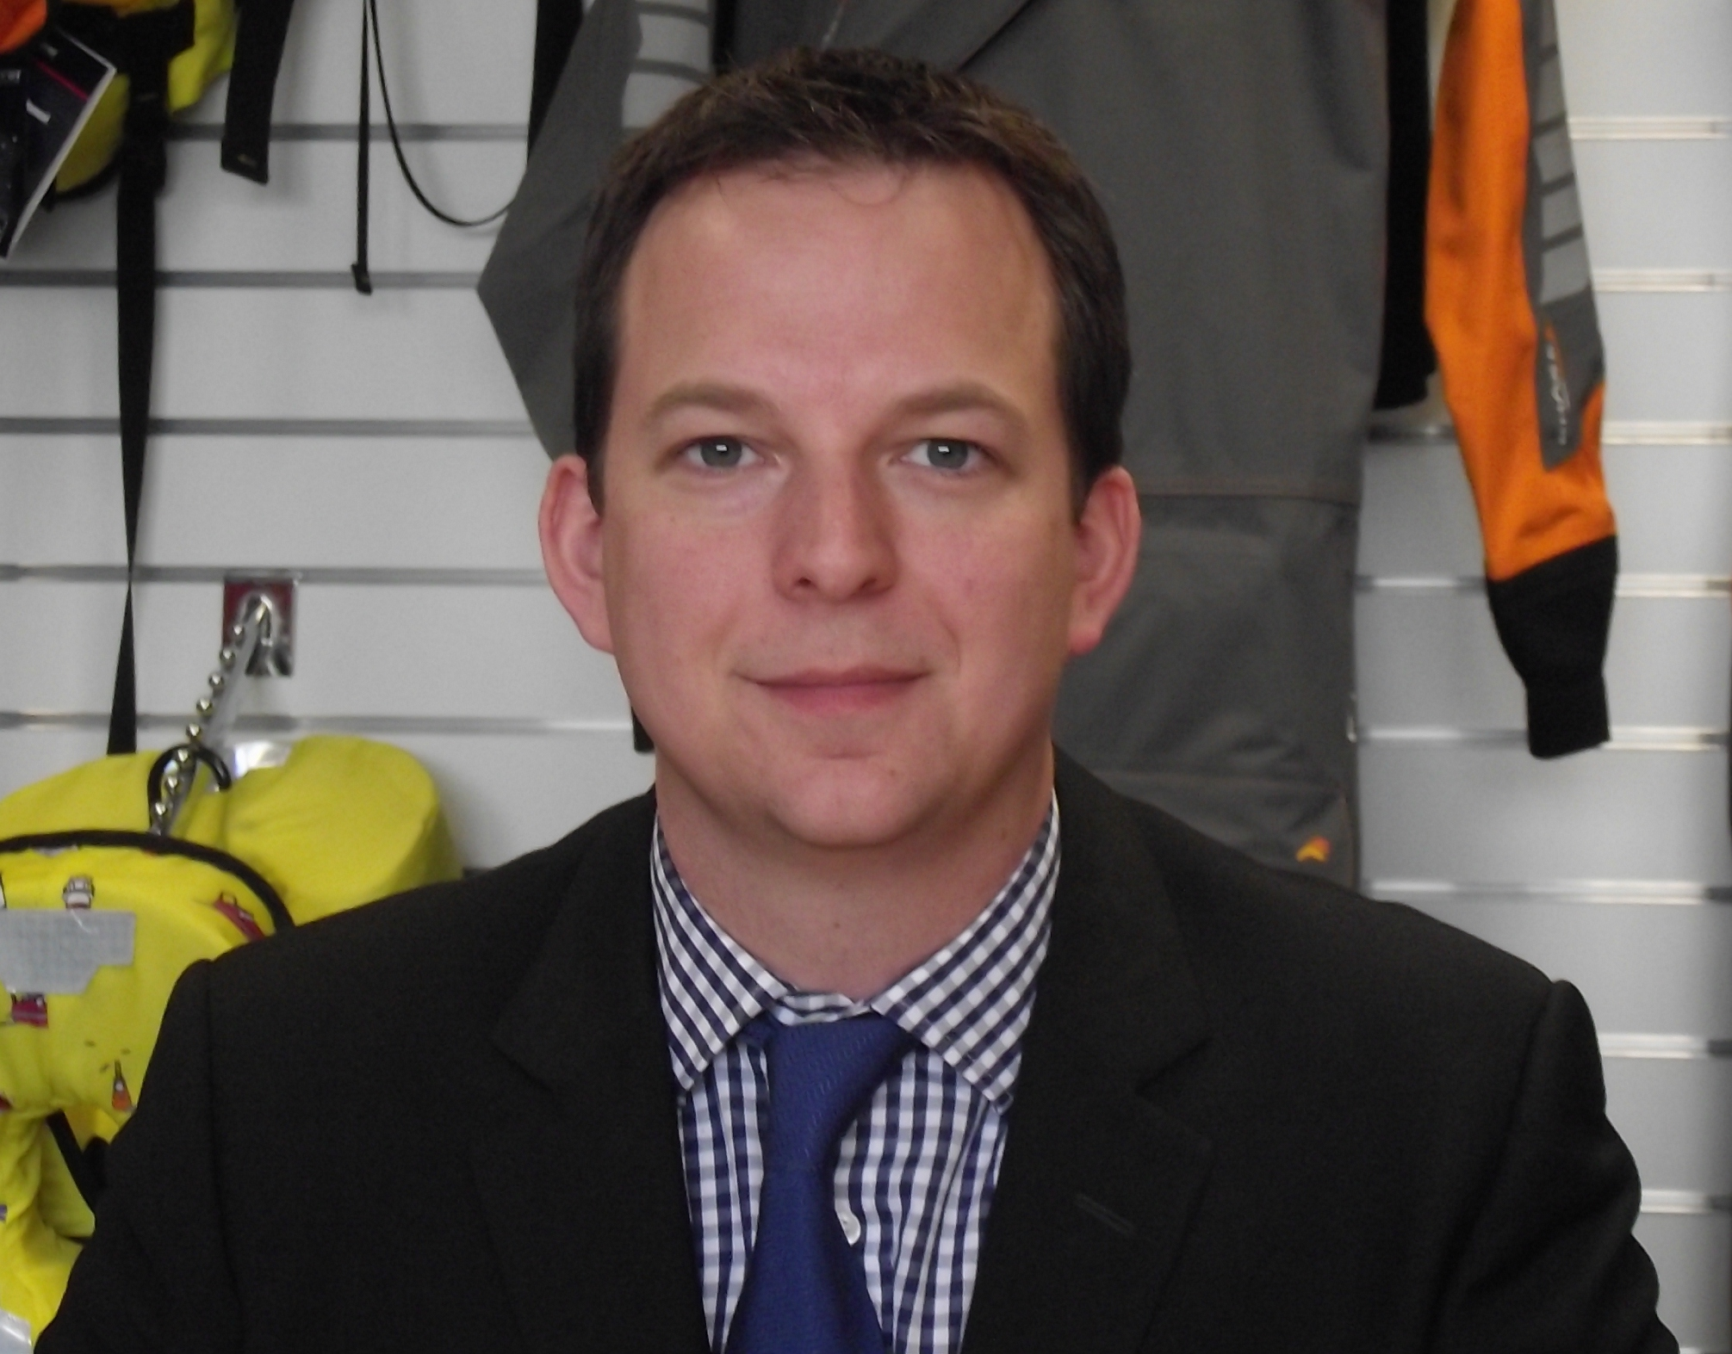
12th June 2015

High Profile Appointments Enrich Survitec Group's UK Services Business
A series of high profile appointments is helping to drive forward Survitec Group's service and distribution business in the UK.
In recent weeks the leading provider of critical safety equipment to the commercial marine market has appointed Ross Wilkinson as Managing Director of the Group’s UK Services and Distribution business.
Ross Wilkinson was formerly Managing Director of Survitec Group's Crewsaver business. He has a wealth of leadership experience in the global marine and leisure industry having worked in the sector for over 18 years.
Before joining Survitec Ross was General Manager and Maritime Business Unit Manager at Orolia Limited. Prior to that, he was the Global Sales Director of the McMurdo business acquired by Orolia in 2009. Ross also spent seven years with Navimo, firstly as Director of Sales and then as General Manager of Navimo UK.
Commenting on his appointment, he said: “I am delighted to be leading our UK business to the next phase. We have worked hard to develop and bring the right products to market, ensuring compliance and quality to our customers. The next stage will be about developing and improving the customer experience through our increased agility and responsiveness - its going to be an exciting few months ahead.”
For more information on Survitec Group visit the team at Seawork International on Stand B137. Details on Survitec Group's products and services are available at www.survitecgroup.com.
ENDS//

For media information, hi-res images or product tests please contact:

Crewsaver
Hannah Burywood, Marketing Dept
T +44 (0) 1329 820024
E hannah.burywood@survitecgroup.com

Or

Alison Willis – Marine Advertising Agency Ltd
T +44 (0) 23 9252 2044
E Alison@marineadagency.com

Notes to Editors

Crewsaver is a world-leading manufacturer of marine safety equipment and clothing for the commercial and leisure marine industries. Based in Gosport, Hampshire, the company designs and manufactures bespoke safety equipment for several countries’ Special Forces, the UK government’s Environment Agency and the aviation and oil industries. Crewsaver is part of the Survitec Group.

www.crewsaver.com

Survitec Group holds market-leading positions worldwide in marine, defence and aerospace survival technology. Headquartered in Birkenhead, the company employs 2000 people across 10 manufacturing sites and 50 service centres, operating through a network of a further 550 distributors and agents to bring its best-in-class products and services to a global customer base. With an extensive history spanning over 160 years and a portfolio of some of the most reputable brands in the safety and survival industry, Survitec is committed to product innovation, technological advancement and quality assurance.
Key products within Survitec’s portfolio include marine, defence and aviation Liferafts, world leading submarine escape technology, lifejackets for commercial airlines and the offshore industry as well as pilot flight equipment, including anti-g clothing used for the Eurofighter and JSF programmes. The Group also pioneered marine evacuation technology and today the unique MarinArk system is used on many major cruise ships across the globe.

www.survitecgroup.com

