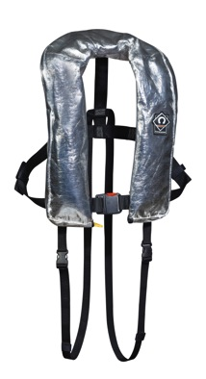
PRESS RELEASE
Thursday 5th June 2014

Crewsaver’s ultimate fire retardant lifejacket
at Seawork 2014

The new state-of-the-art Crewsaver Fire Retardant Lifejacket is the result of intense research, development and testing in collaboration with one of the UK’s busiest fire brigades.

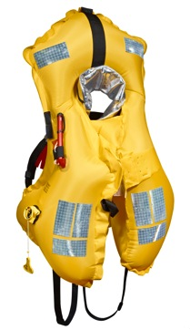
The first consignment of Fire Retardant Lifejackets is already in active service with that fire brigade and will be seen for the first time by the wider maritime industry on stand B137 at Seawork 2014 in Southampton, June 10th-12th.

The jacket is also ideal for industrial use when workers are exposed to sparks when doing jobs such as welding.

A unique feature on the new Crewsaver jacket is a wrap-around fireproof cover that protects all the burst points - on rival jackets these are vulnerable to flying sparks and embers which could damage the zip and velcro.

The slim-profile Fire Retardant Lifejacket is short, light and compact to give total freedom of movement.

Even when wearing heavy-duty clothing and boots, if a firefighter falls into the water the Fire Retardant Lifejacket’s 290 Newtons of buoyancy will keep him afloat with his head held at the optimum angle.

The jacket is fitted with a Hammar inflation system which eliminates the potential problem of the jacket self-inflating if worn in a high-vapour content environment and there is an attachment point for a McMurdo PLB or AIS beacon.

Ends//

For media information, hi-res images or product tests please contact:
Hannah Burywood, Marketing Dept, Crewsaver
T +44 (0) 1329 820024
E hannah.burywood@survitecgroup.com

Seawork June 10th-12th 2014

Seawork International is one of Europe’s largest international commercial maritime and workboat exhibition and business forums. It takes place over three days in June every year at the Port of Southampton, UK, attracting more than 6000 visitors from 40 countries.

www.ssa.org.uk

About Crewsaver
Crewsaver is a world-leading manufacturer of marine safety equipment and clothing for the commercial and leisure marine industries. Based in Gosport, Hampshire, the company designs and manufactures bespoke safety equipment for several countries’ special forces, the UK government’s Environment Agency and the aviation and oil industries. Crewsaver is part of the Survitec Group.
www.crewsaver.com

About Survitec Group
Survitec Group holds market-leading positions worldwide in marine, defence and aerospace survival technology. Headquartered in Southampton, the company employs 2000 people across 10 manufacturing sites and 50 service centres, operating through a network of a further 550 distributors and agents to bring its best-in-class products and services to a global customer base. With an extensive history spanning over 160 years and a portfolio of some of the most reputable brands in the safety and survival industry, Survitec is committed to product innovation, technological advancement and quality assurance.
Key products within Survitec’s portfolio include marine, defence and aviation Liferafts, world leading submarine escape technology, lifejackets for commercial airlines and the offshore industry as well as pilot flight equipment, including anti-g clothing used for the Eurofighter and JSF programmes. The Group also pioneered marine evacuation technology and today the unique MarinArk system is used on many major cruise ships across the globe.
www.survitecgroup.com

