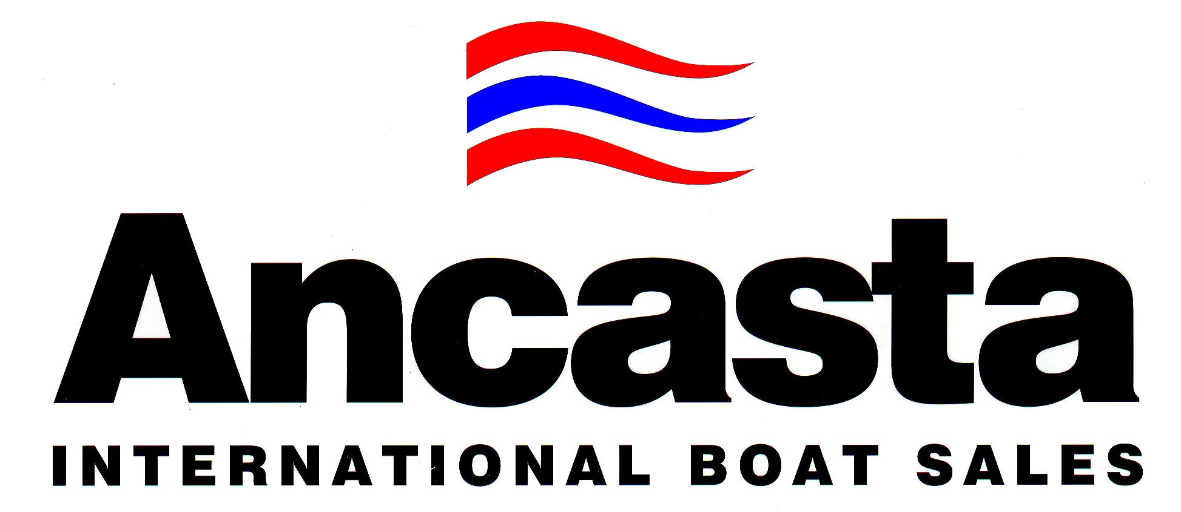

PRESS NOTICE
For immediate release
28th May 2014.
New distribution partnership for Beneteau power.
Dickies International, Ancasta International Boat Sales and Beneteau are very pleased to announce a new distribution partnership for Beneteau’s highly-acclaimed power boat ranges in the UK’s South.
Ranges including: Swift Trawler, Gran Turismo and Antares in-board.
Ancasta now take on the role of exclusive dealers for this area, while Dickies maintain responsibility for Wales and the North West. They will also play an active role in supporting Ancasta in developing this new dealership, providing Ancasta with the benefit of Peter Dickie’s experience of Beneteau power.
Both Dickies and Ancasta combined have over 60 years experience of being Beneteau Dealers.
Dickies will focus its sales efforts on Wales and the North West where they have had a presence for over 100 years. Their existing and future customers in those areas will continue to benefit from their award winning service. Activities concerning their South Coast customers will transfer over the coming weeks, with all clients being kept fully advised on progress.
Ancasta, with its extensive office network in the UK alongside its own service and support centre in the form of Hamble Yacht Services, are perfectly positioned to provide the very highest standards in sales and service for Beneteau customers on the South Coast.
Jean-François Lair, Beneteau’s Export Manager commented, “Beneteau are very fortunate to have two extremely capable organisations in Dickies and Ancasta representing and supporting the Beneteau power boat ranges. These changes will ensure their combined infrastructure is best utilised for sales and support for Beneteau power boat ranges.”
Peter Dickie, Dickies International’s Managing Director commented, “We are very enthusiastic about these changes. It will enable us to enhance our focus on our core markets in Wales and the North-West, in addition to our other interests, while Ancasta’s involvement will strengthen Beneteau power’s presence in the South. The two companies cooperating in this way is an exciting prospect.
Nick Griffith, Ancasta’s Managing Director, also felt that this move was very positive for all. Ancasta gain a fabulous new range of product. Having both Dickies and Ancasta marketing and supporting the range in their specific areas, Beneteau Power will take its rightful position as a major supplier to the UK power boat market. Great product, being sold and supported by two of the UK’s most experienced dealers.”
For more information contact: E: ashleyoverton@ancasta.com E: peterdickie@dickies.co.uk T: 02380 450 000 T: +44 (0) 1248 363400
Find details at: W: www.ancasta.com/beneteaupower W: www.dickies.co.uk
ENDS

