PRESS RELEASE

Wednesday 22nd January 2014

Ross Wilkinson Appointed as New Managing Director Of Survitec Group’s Crewsaver business
Ross Wilkinson has joined Survitec Group to play a key role in promoting worldwide sales growth and developing and maintaining an effective sales distribution and service network for the Crewsaver Commercial and Leisure ranges.
Ross commented, “I am delighted to join such a highly respected brand which has a long heritage in the lifejacket market. My immediate focus will be on how we can grow the Crewsaver Brand by bringing it to new international markets.”
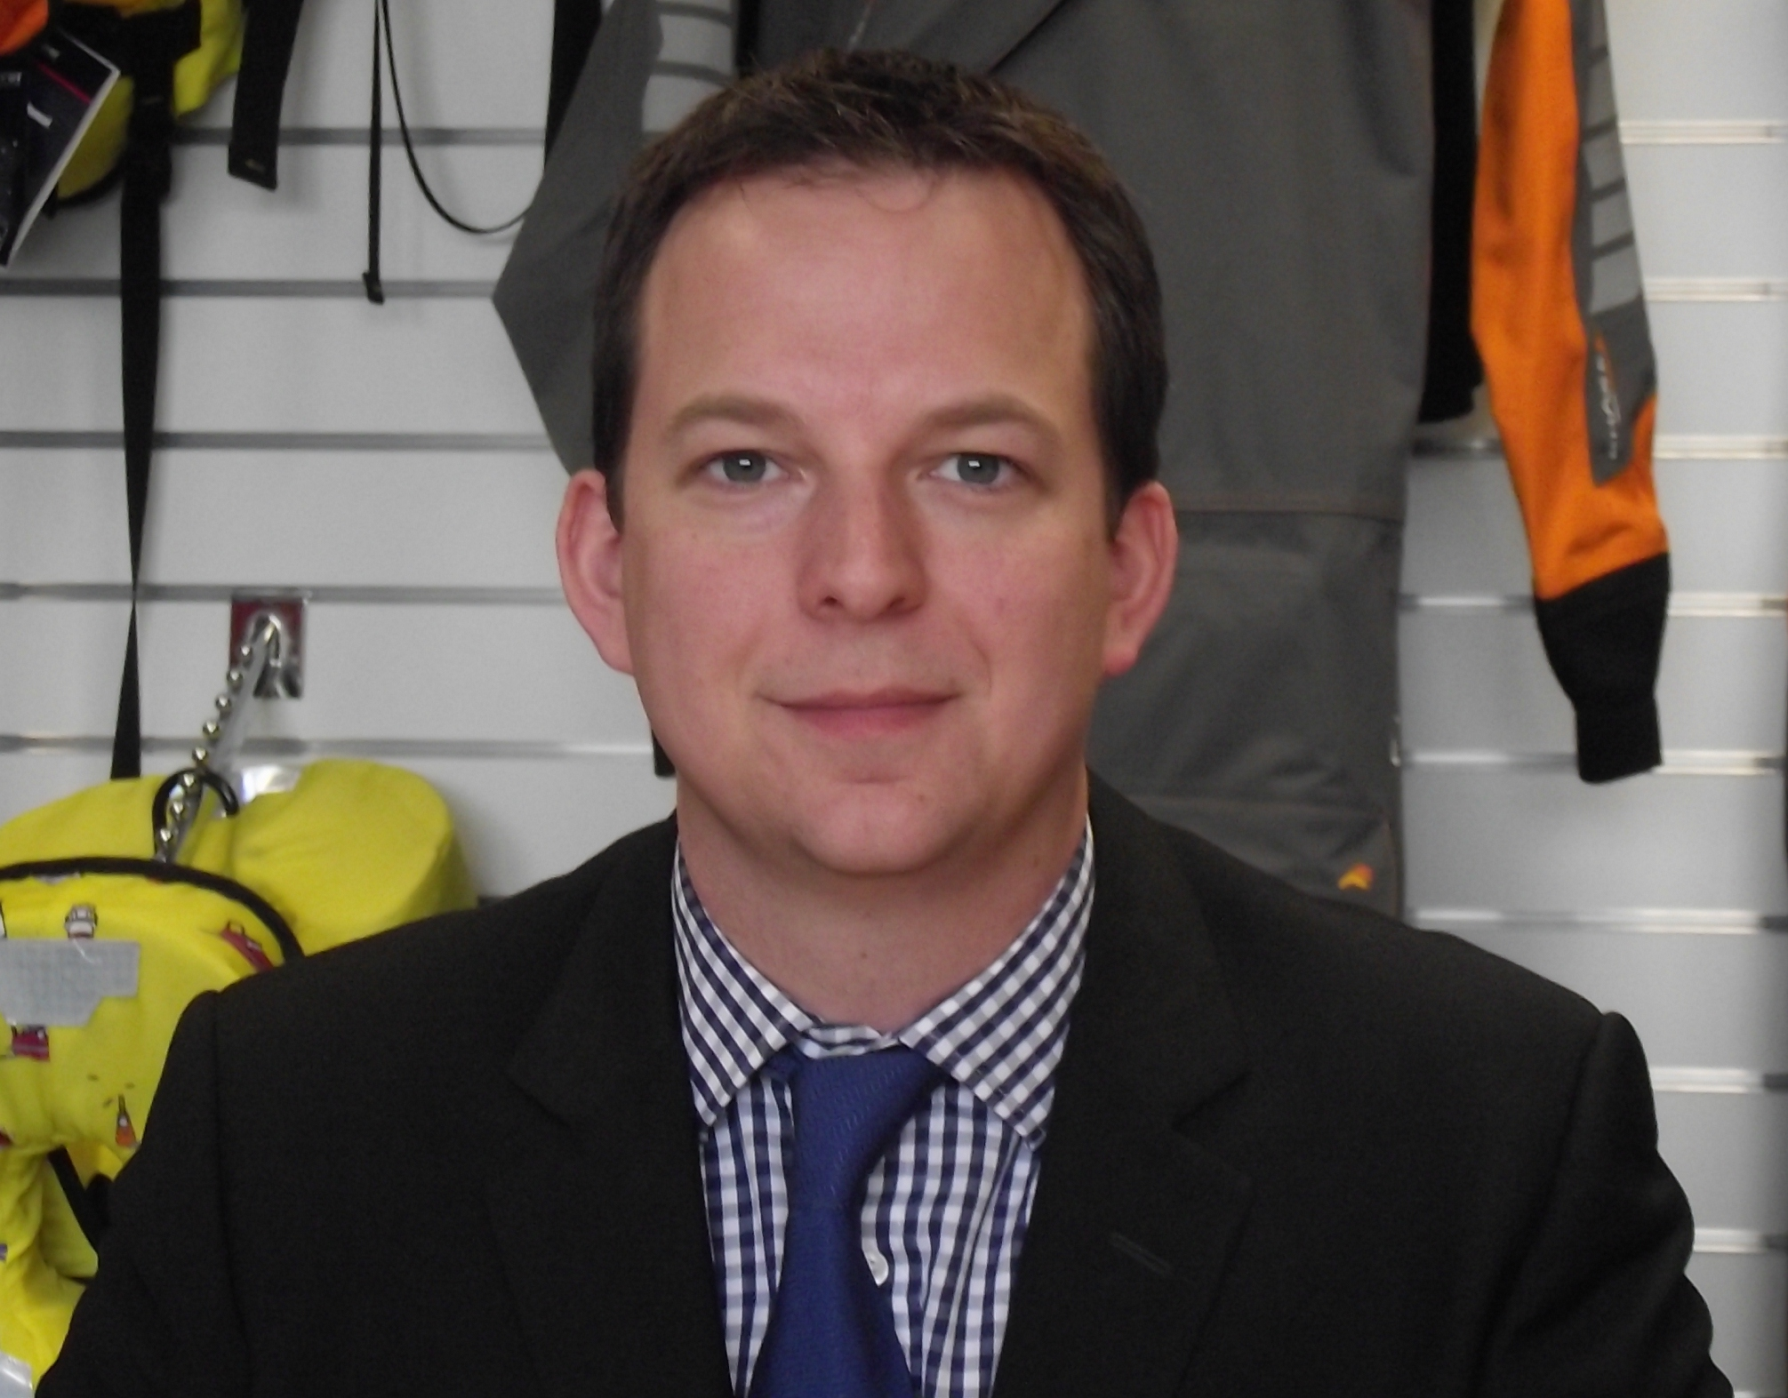
Ross joins us from Orolia Limited, where he was General Manager and Maritime Business Unit Manager. Ross also spent twelve years with Navimo, firstly as Director of Sales and then as General Manager of Navimo UK.

“We’re delighted to have appointed someone of Ross’s capabilities, bringing a wealth of experience in the commercial marine and leisure markets” said Simon Withey, Chief Executive Officer of Survitec Group. “His detailed knowledge of Crewsaver products and the market place will enable him to play a vital part in helping the company internationalise the Crewsaver brand, with its Commercial and Leisure range of products.”

Notes to editors

About Crewsaver

Crewsaver is the UK’s leading lifejacket and watersports equipment manufacturer, founded in
Gosport, England in 1957.

Crewsaver continues to be recognised as the premier lifejacket brand. Many prestigious
institutions including the RNLI, the MoD and a number of emergency services choose its products.

About Survitec Group
Survitec Group holds market-leading positions worldwide in marine, defence and aerospace survival technology. Headquartered in Southampton, the company employs 2000 people across 10 manufacturing sites and 50 service centres, operating through a network of a further 550 distributors and agents to bring its best-in-class products and services to a global customer base. With an extensive history spanning over 160 years and a portfolio of some of the most reputable brands in the safety and survival industry, Survitec is committed to product innovation, technological advancement and quality assurance.
Key products within Survitec’s portfolio include marine, defence and aviation Liferafts, world leading submarine escape technology, lifejackets for commercial airlines and the offshore industry as well as pilot flight equipment, including anti-g clothing used for the Eurofighter and JSF programmes. The Group also pioneered marine evacuation technology and today the unique MarinArk system is used on many major cruise ships across the globe.

For more information please visit www.survitecgroup.com

For media information please contact:

Crewsaver
Greg O’Brien, UK Sales & Marketing Manager
T +44 (0) 1329 820023
E greg.obrien@survitecgroup.com

