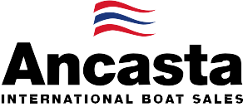

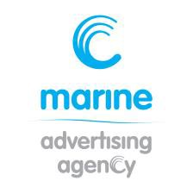
N e w s R e l e a s e
10th July 2015

Ancasta announces CNB 76 to be at 2015 Southampton Boat Show

Ancasta has announced that the CNB 76 will be at Southampton Boat Show and is set to be the biggest sailing boat at the show, which takes place 11-20th September 2015.
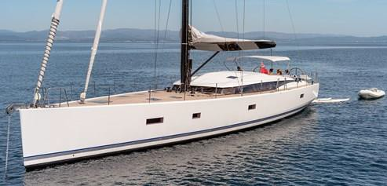
Seaworthy, elegant, and easy to handle, the new CNB 76 embodies 25 years of CNB excellence.
With her superb proportions and unique design from the world famous naval architect Philippe Briand, her lines perfectly integrate a raised saloon and the consequent layout is as harmonious as it is comfortable and functional.
While built to thoroughly spoil her owners, the CNB 76 is home to VIP cabins, a huge saloon boasting panoramic views, and she comes with the possibility of modernising for specific sailing programmes and the amount of guests expected on board.
Designed by Philippe Briand, the CNB 76 presents as a luxury yacht, which is both of a reasonable size and extremely easy to handle. Her hull is fast, powerful and secure. The modern design gives us aft chines and a sharp, vertical bow, while the fairly high freeboard ensures she is an extremely dry boat. The centering of her weights provides a steady ride in challenging seas, and every detail that affords the utmost of comfort has been meticulously adhered too.

Specification:
- Manufacturer CNB Yachts, Bordeaux
- Model CNB 76
- Designer Philippe Briand
- Typical Final Price £2,600,000 inc VAT
- LOA 23.17m / 76 feet
- LWL 21.98m / 72 feet
- Maximum Beam 6.10m / 20 feet

Cruising Speed 9
- Maximum Speed 12
- Category of Sailing A Ocean
- Maximum Power Available Volvo D4 - 180hp
- Standard Sail Area 305 sq metres
- Berths 10

Cabins 5
- Standard Fuel Capacity 2500 litres / 660 gal
- Standard Water Capacity 1500 litres / 396 gal
- Crew cabins 1 double

Tender Garage Yes

T: 023 9252 2044
E: Alison@marineadagency.com www.marineadagency.com
Marine Advertising Agency
15 Haslar Marina
Gosport PO12 1NU

The CNB 76 will be at Southampton Boat Show from 11th to 20th September 2015. Contact Ancasta now to make an appointment to view, email Tim D’Alton (timdalton@ancasta.com) or call +44 2380 450006.

For more information visit: http://www.ancasta.com/boats-for-sale/new-boats/cnb/cnb-76/

ENDS

Notes to editors
  - Ancasta International Boat Sales has 15 offices across Europe
  - Ancasta is the UK’s largest Prestige Luxury Motor Yachts dealer, the UK’s largest Beneteau Power and the UK’s largest Beneteau Sail dealer
  - Ancasta is exclusive UK dealer for Lagoon Catamarans
  - In addition Ancasta is a new boat dealer for CNB Yachts, Fairlie Yachts and McConaghy Yachts
  - The Ancasta Group incorporates Hamble Yacht Services Refit & Repair and Advanced Rigging and Hydraulics, both operating from Port Hamble.
  - For more information on Ancasta visit www.ancasta.com Media enquiries via Marine Advertising Agency:
Alison Willis - alison@marineadagency.com Tel: 023 9252 2044

T: 023 9252 2044
E: alison@marineadagency.com www.marineadagency.com
Marine Advertising Agency
15 Haslar Marina
Gosport PO12 1NU

