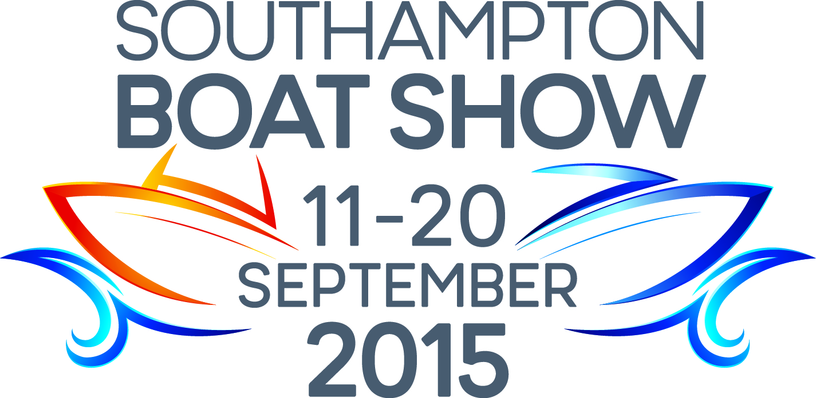
Press Release
For Immediate Release
24th August 2015

The future of leisure lifejackets – Crewsaver’s revolutionary, complete leisure lifejacket range to be showcased at Southampton Boat Show 2015
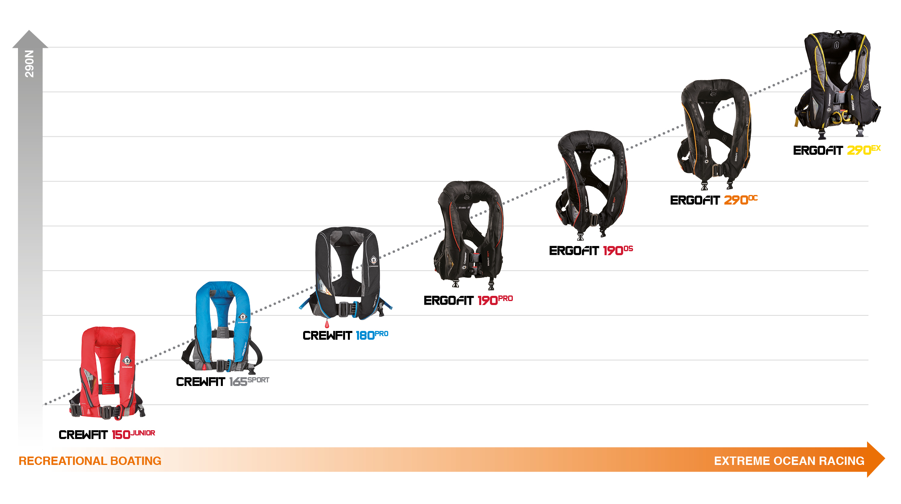
Comfort. Style. Performance.
Since the launch of the Crewsaver leisure lifejacket range, Crewsaver has seen the popularity of its new Fusion 3D designs continue to grow, as customers chose the range for its superior comfort solutions combined with the most advanced safety features.
The complete range of Fusion 3D lifejackets will be on display at the Southampton Boat Show. Visitors will be able to view them by visiting the Crewsaver stand located in the Ocean Hall, Stand No. G1804. On hand will be Crewsaver sales representatives who can talk visitors through the entire lifejacket range and help them select the lifejacket most suitable for them.
By using the same advanced Fusion 3D technology developed in the hugely successful ErgoFit range, Crewsaver is moulding the future of leisure lifejackets – whatever your level there is now a Crewsaver to suit.
“We are delighted to be displaying this revolutionary new 3D lifejacket range for all to view during Southampton Boat Show”, says Crewsaver’s Managing Director, Ross Wilkinson. “Our Fusion 3D technology encapsulates Crewsaver’s passion for designing high performance lifejackets at all levels.”
As a global market-leading manufacturer of integral safety equipment, Crewsaver has taken on the challenge of reducing the number of people that simply do not wear a lifejacket by producing a complete range focused on Comfort. Style. Performance. All of which are key in the leisure industry.
Show offers
Visitors to Southampton Boat Show 2015 can take advantage of some fantastic offers when purchasing their lifejackets including the following:

- FREE lifejacket light with every Crewfit 180N Pro purchase
- FREE ErgoFit safety knife with every ErgoFit lifejacket purchase
- FREE lifejacket bag when any combination of four or more Crewsaver lifejackets are purchased
- FREE McMurdo 220 Fast Find with every 4man liferaft purchase
The Fusion 3D lifejackets and a wide range of Crewsaver products can be purchased from the following retailers at the show:

- Marine Superstore stand F003
- Andark stand F001
- Force 4 Chandlery stand B017/ D025
- Jimmy Green Marine stand G116
- Piplers of Poole stand G136
- P&B stand no.J054

To claim their free gifts, visitors simply need to take their receipts to the Crewsaver stand.

Terms and conditions apply, while stocks last, E&OE.
ENDS

For media information, hi-res images or product tests please contact:

Crewsaver
Hannah Burywood, Marketing Dept
T +44 (0) 1329 820024
E hannah.burywood@survitecgroup.com

Or

Alison Willis – Marine Advertising Agency Ltd
T +44 (0) 23 9252 2044
E Alison@marineadagency.com

Notes to Editors

Crewsaver is a world-leading manufacturer of marine safety equipment and clothing for the commercial and leisure marine industries. Based in Gosport, Hampshire, the company designs and manufactures bespoke safety equipment for several countries’ Special Forces, and the aviation and oil industries. Crewsaver is the only company to hold an exclusive contract to supply lifejackets to the UK government’s Environment Agency and the Royal National Lifeboat Institution (RNLI). They are part of the Survitec Group.

www.crewsaver.com

Survitec Group holds market-leading positions worldwide in marine, defence and aerospace survival technology. Headquartered in Birkenhead, the company employs 2000 people across 10 manufacturing sites and 50 service centres, operating through a network of a further 550 distributors and agents to bring its best-in-class products and services to a global customer base. With an extensive history spanning over 160 years and a portfolio of some of the most reputable brands in the safety and survival industry, Survitec is committed to product innovation, technological advancement and quality assurance.
Key products within Survitec’s portfolio include marine, defence and aviation Liferafts, world leading submarine escape technology, lifejackets for commercial airlines and the offshore industry as well as pilot flight equipment, including anti-g clothing used for the Eurofighter and JSF programmes. The Group also pioneered marine evacuation technology and today the unique MarinArk system is used on many major cruise ships across the globe.

www.survitecgroup.com

