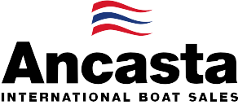

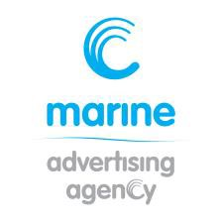
N e w s R e l e a s e
27th August 2015

Ancasta presents UK première of Gran Turismo 40 at 2015 Southampton Boat Show

The Ancasta team is ready for the UK première of the Gran Turismo 40 from Beneteau, which is being presented for the first time in the UK at Southampton Boat Show from 11-20th September 2015.
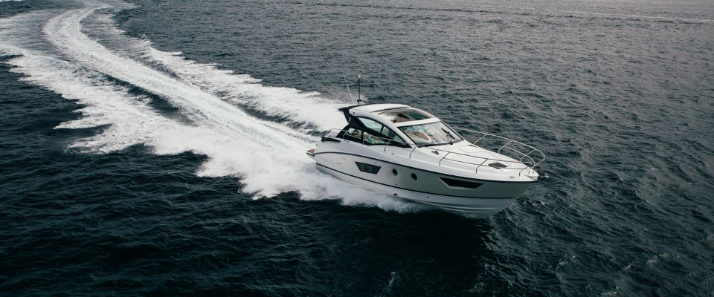

The Gran Turismo 40 beautifully combines generous spaces, power and speed. Her manageable size, remarkable Air Step® hull and stern drive propulsion give her incredible stability resulting in exceptional sea keeping qualities. The acceleration on the Turismo 40 is as powerful as it is fluid, and manoeuvrability and docking has never been easier thanks to the Volvo joystick control. This boat offers the ultimate in quality cruising.

Specification:
- Manufacturer Beneteau
- Model Gran Turismo 40
- Designer Nuvolari - Lenard
- LOA 12.55m / 41’ 2’’
- Hull length 11.5m / 37’ 9”
- Maximum Beam 3.87m / 12’ 8”

Cruising Speed 25-28 knots
- Maximum Speed 37-38 knots
- Maximum Power Available Twin Volvo D6 – 370HP
- Maximum range 178 NM @ 23 knots
- Berths Two plus saloon
- Standard Fuel Capacity Twin 325 litre tanks
- Standard Water Capacity 200 litres

The Gran Turismo 40 will be on stand M537 at Southampton Boat Show from 11th to 20th September 2015. Contact Ancasta now to make an appointment to view, email beneteaupower@ancasta.com or call +44 2380 450000.

For more information visit: http://www.ancasta.com/boats-for-sale/new-boats/beneteau-power/gran-turismo/40/

ENDS

Notes to editors
  - Ancasta International Boat Sales has 15 offices across Europe
  - Ancasta is the UK’s largest Prestige Luxury Motor Yachts dealer, the UK’s largest Beneteau Power and the UK’s largest Beneteau Sail dealer
  - Ancasta is exclusive UK dealer for Lagoon Catamarans
  - In addition Ancasta is a new boat dealer for CNB Yachts, Fairlie Yachts and McConaghy Yachts
  - The Ancasta Group incorporates Hamble Yacht Services Refit & Repair and Advanced Rigging and Hydraulics, both operating from Port Hamble.
  - For more information on Ancasta visit www.ancasta.com Media enquiries via Marine Advertising Agency:
Alison Willis - alison@marineadagency.com Tel: 023 9252 2044

