**News Release**

**For immediate release**

**16th September 2015**

**Marine companies come together during Southampton Boat Show to raise £1000 for Southampton hospital charities**

Marine companies from across the industry fielded players in Marine Advertising Agency’s annual Southampton Boat Show 5-a-side tournament, which took place on Tuesday evening and raised £1,000 for the Paediatric Intensive Care Unit (PICU) and G4 Surgery at Southampton General Hospital.



Over 100 players in 14 teams took part in the annual tournament, which is now a firm fixture on the Southampton Boat Show social calendar. Marine industry teams competed alongside local teams from Southampton FC’s sponsorship department and two teams from Southampton General, made up of staff from PICU and the hospital’s operating theatres.

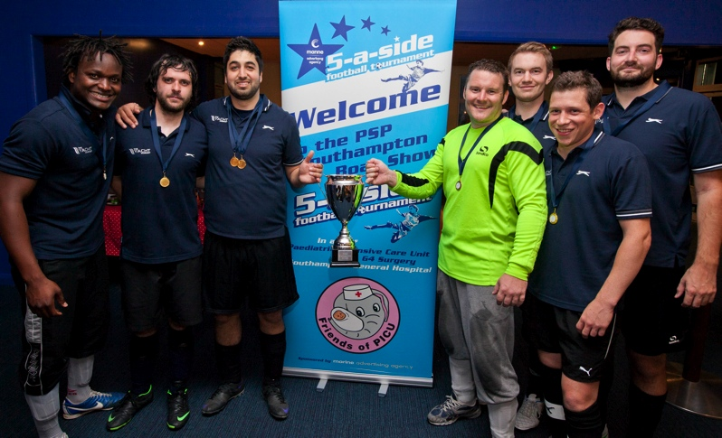

The tournament was won by TheYachtMarket, who stormed to victory on penalties against the Southampton Football Club team.

The Plate competition was won by global marine transport company Peters & May, who beat Marine Advertising Agency in the final. The Peters & May team were delighted to go home with some silverware, having lost in the Plate final last year.

Victorious! TheYachtMarket team, winners of the 2015 MAA 5-a-side tournament, which takes place every year during Southampton Boat Show.



New teams to watch for 2015 included teams from Land Rover BAR, Lewmar, RS Sailing and MarineGiftCards.com.

The tournament raised a total of £1,000 for PICU and G4 Surgery ward at Southampton General Hospital. Mike Shepherd, Director of the Marine Advertising Agency (MAA), which organises the tournament said, “It’s great to see the marine industry come together to support Southampton hospital charities, Friends of PICU and G4 Surgery ward, at the MAA 5-a-side tournament. It’s a bit of friendly competition and everyone seems to really enjoy it.”

Southampton is the lead centre for paediatric intensive care in south central England with a catchment area that stretches from Dorset to Surrey to the Channel Islands. PICU provides first class care and treatment to over 900 critically ill children every year admitting children with both medical and surgical problems ranging in age from birth to 18 years.

The MAA 5-a-side, held at Goals Southampton, has become a fixture on the Southampton Boat Show calendar. The tournament will take place again during next year’s Southampton Boat Show on the evening of 20th September 2016. Teams should get in touch with MAA to book their places.

**ENDS//**

Notes to editors

The Marine Advertising Agency was founded in 2009 by Mike Shepherd. MAA prides itself on providing no-nonsense solutions to marine companies’ advertising, PR and marketing needs. MAA’s current clients include Crewsaver, Ancasta, Raymarine and British Marine Boat Shows, and the company is now providing services on a pan-European and international basis for its growing list of clients. For more information visit: <http://www.marineadagency.com>

The Southampton Boat Show runs from 11-20 September 2015. For more information visit: [http://www.southamptonboatshow.com](http://www.southamptonboatshow.com/2012/home.aspx)

Media enquiries

Email: [mike@marineadagency.com](mailto:mike@marineadagency.com) or alison@marineadagency.com

Tel: +44 (0) 23 9252 2044

Get high-resolution images of all the action from the tournament in the image gallery in our Media Centre:

<http://marineadagency.com/gallery/maa-5-a-side-football-tournament-at-sbs-2015/>