**Press Release – Immediate release**
19th October 2015

Superyacht Tenders and Toys announces expansion of its product lines and services

Superyacht Tenders and Toys is pleased to announce it is currently expanding its product lines and services to the Superyacht Industry.

“Having outfitted the most significant new builds this past year, we are ideally placed for any new projects and can offer the best value and support in the industry.” Says Josh Richardson, Director of Superyacht Tenders and Toys. “It’s not just all about the toys. More and more clients are requesting additional products relating to emerging trends in the industry.”

Some of the new products and services include:
- Ropes, superyacht mooring lines, rigging, tender tow lines
- Fenders, rigid foam cored fixed ones for superyacht transoms and inflatable cylinders
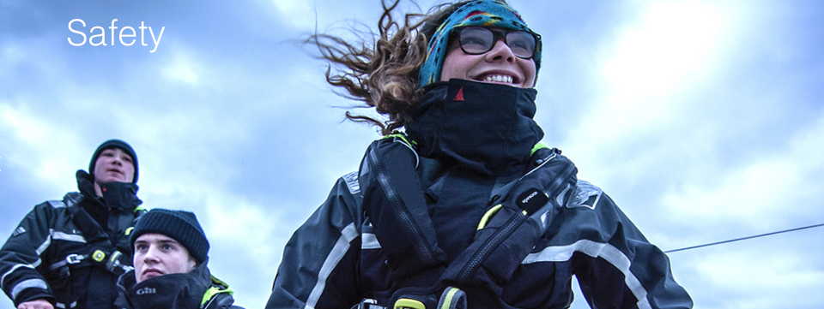
- Gym equipment, including the popular brands Technogym, Life Fitness and Ciclotte stationary bike
- Tender and jet-ski whips
- In-house shipping
- Safety equipment, liferafts, lifejackets etc.

- Tender and jet-ski certified and approved lifting equipment
- Tender chocks

Superyacht Tenders and Toys has had another great year. Global demand for its products and invaluable support services has continued to grow as the company evolves with the changing interests of the superyacht world. The one-stop shop approach clearly works for yachts as they not only get the best value but also invaluable support.

To learn more about the new expanded product lines and services, please visit www.superyachttendersandtoys.com

ENDS

Media enquiries via Marine Advertising Agency:

Alison Willis, alison@marineadagency.com
Emma Stanbury, emma@marineadagency.com
T: 023 9252 2044

For high resolution images to accompany this release, please see:
http://marineadagency.com/gallery/sytt-expanding-products-and-services/

