**Press release – Immediate release**
28th October 2015

Superyacht Tenders and Toys adds PowerBoards, electric motor-assist SUP’s and eSurfboards, to product range

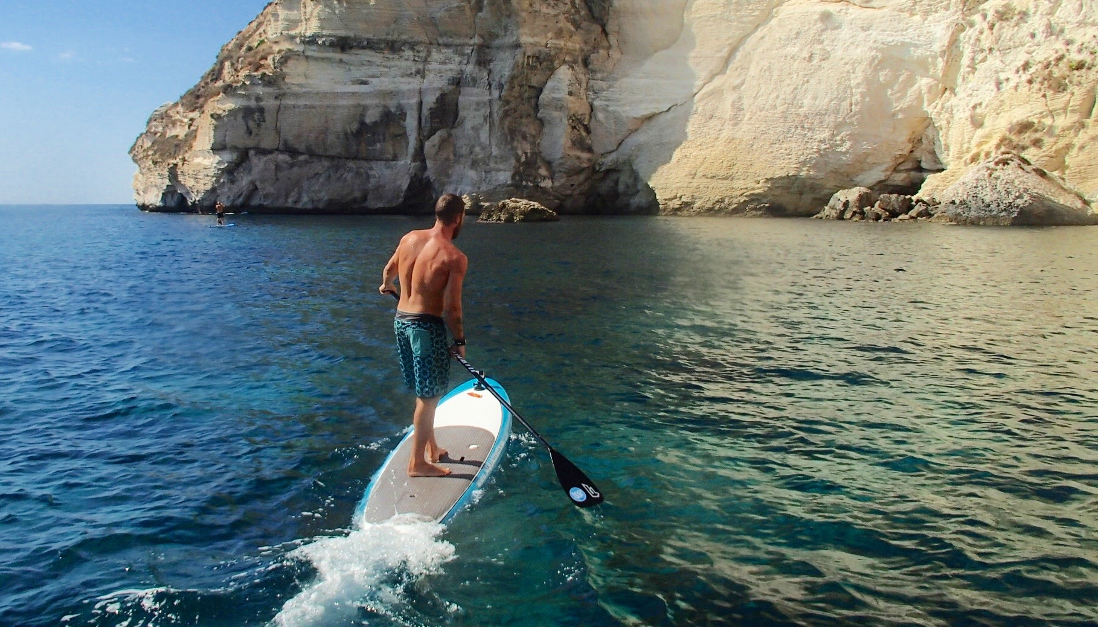

Superyacht Tenders and Toys is excited to announce that it is adding PowerBoards to its product range. PowerBoards are brand new and available exclusively through Superyacht Tenders and Toys to the superyacht market in Europe. These electric motor-assist Stand Up Paddleboards (SUP’s) and eSurfboards are the ultimate in affordable usable luxury toys.

Stand Up Paddleboarding (SUP) is the fastest growing watersport in the world. It’s easy to learn for young and old alike and is a fun, effective way to exercise and build core strength. However, it can sometimes be challenging – wind, currents and waves can create tough conditions, which is why PowerBoards ‘paddle-power-assist’ e-SUP’s were created. The PowerBoards give you instant power at the push of a button to help you handle more difficult conditions, keep safe and have loads of fun. Making your way home against wind and tide has never been easier and safer.

Set to run at 8-11 kilometres per hour, PowerBoards are powered by Fin-Drive Systems™, the most robust, reliable and responsive personal propulsion system on the water.

PowerBoards’ initial runtime is 35 minutes. This improves the more you use them. The boards are immediately chargeable after use without the need for cooling off. Charge time is only 35 minutes. This means more runs in a day.

Simple push-on/push-off power buttons (two on the e-SUP) respond to pressure from your feet, hands or chest.

PowerBoards are designed to be robust, with no delicate electronics. They feature an impact-resistant propellor housing for optimum performance on both sea and fresh water. Built in Australia and being imported into the UK in November 2015, Superyacht Tenders and Toys look forward to providing these to customers in the immediate future.

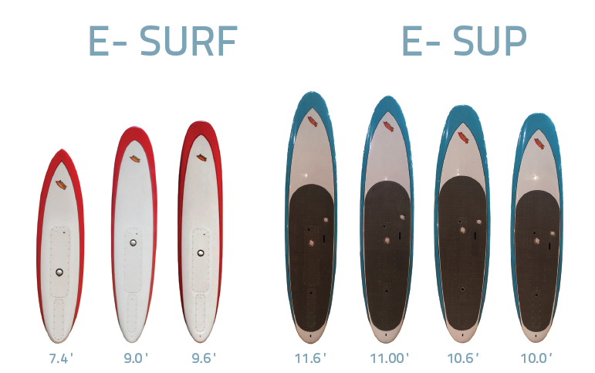

DESCRIPTION | SPECIFCATIONS | PRICE
10’6 e-SUP | Weight: 19kg  35min run time  35min recharge time  Speed: 8-11 kph | £4020.00
9’ e SURF | Weight: 15kg  35min run time  35min recharge time  Speed: 8-11 kph | £3740.00

Boards can be custom branded to match the yacht, and the log and/or name can be added. As standard, they come in red for the Surf range or blue for the SUP range.

To learn more about Superyacht Tenders and Toys product range, visit www.superyachttendersandtoys.com

ENDS

Media enquiries via Marine Advertising Agency:

Alison Willis, alison@marineadagency.com
Emma Stanbury, emma@marineadagency.com
T: 023 9252 2044

or

Josh Richardson, Superyacht Tenders and Toys

T: UK +442380016363
T: France +33489733347
T: US +19643029066
E: info@superyachttendersandtoys.com

For high resolution images to accompany this release, please see:

http://marineadagency.com/gallery/superyacht-tenders-toys-powerboards-e-sup-and-e-surf/

Notes to Editors:

Superyacht Tenders and Toys is the leading independent consultancy and management company specialising in all superyacht tender and toy needs and provides practical solutions for the World’s finest yachts.

