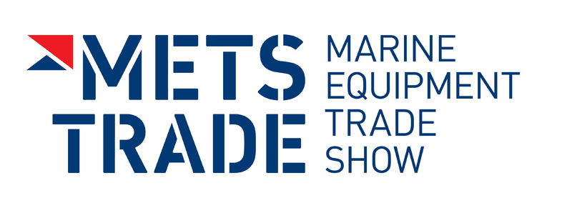
Press Release

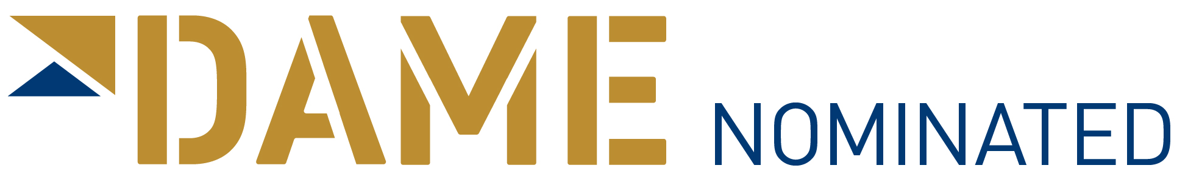
For Immediate Release
17th November 2015

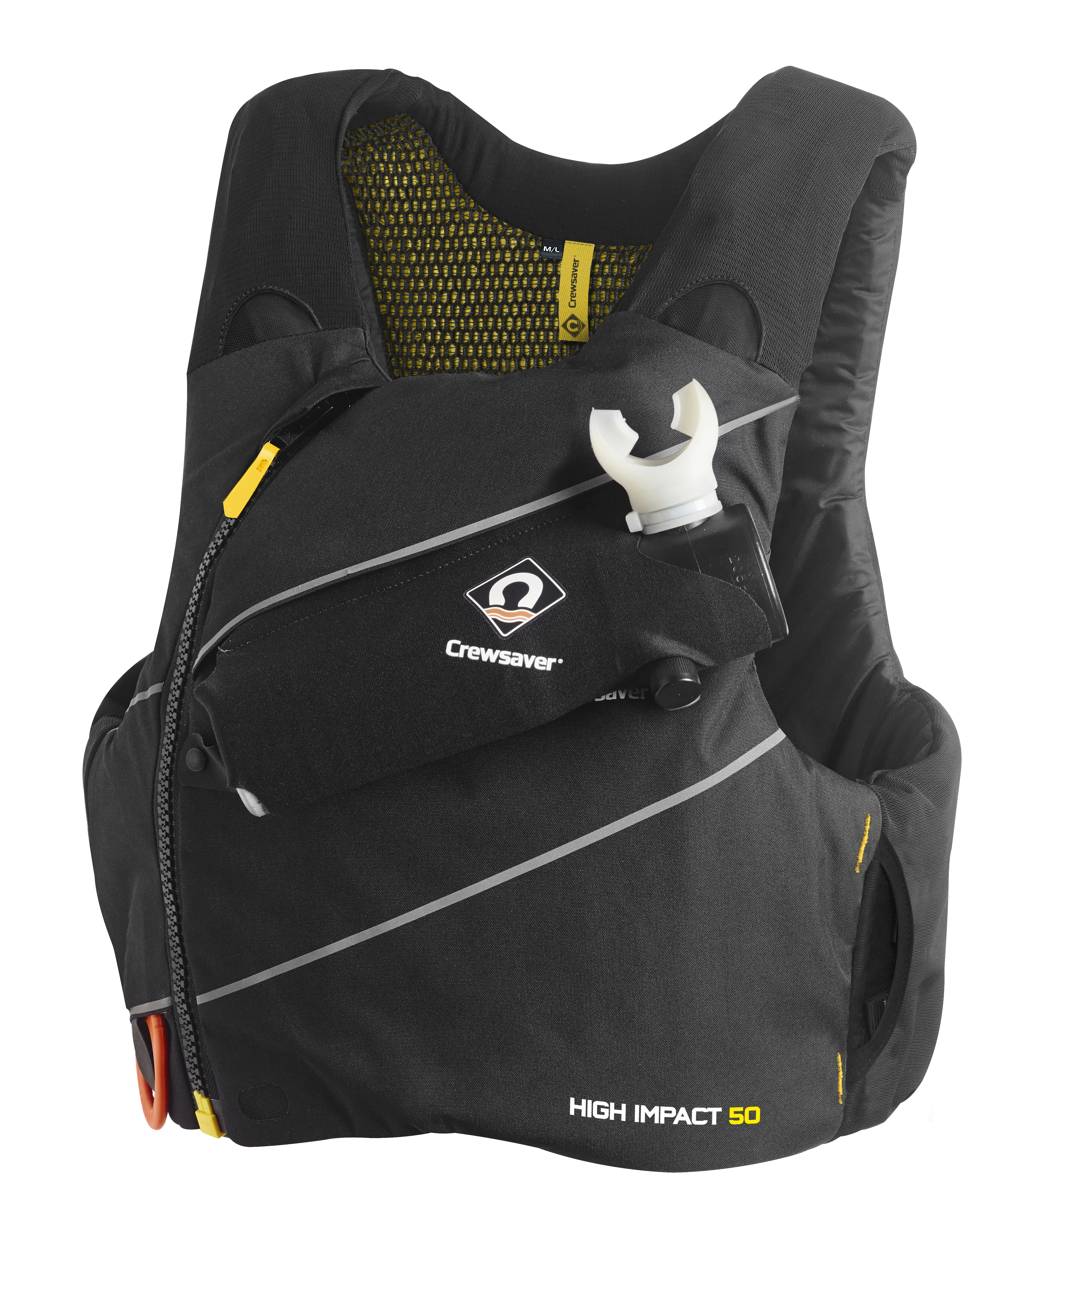
Crewsaver launches DAME nominated state of the art ‘High Impact’ buoyancy aid, designed exclusively with Artemis Racing, to the trade at METS 2015
Crewsaver Stand Number 03.114

Crewsaver launched its DAME nominated ‘High Impact’ buoyancy aid to the trade at the Marine Equipment Trade Show (METS) in Amsterdam on Tuesday 17th November 2015. The Crewsaver ‘High Impact’ buoyancy aid is state-of-the-art and represents a revolution in personal safety equipment. The ‘High Impact’ is a Crewsaver branded version of one of the two buoyancy aids that Crewsaver designed exclusively for the Artemis Racing team after it was selected to be their official Safety Partner for the 35th America’s Cup.
Through the partnership with Artemis Racing, Crewsaver was able to develop this innovative buoyancy aid and then make the same technology available to the consumer, giving everybody the opportunity to benefit from the same advanced safety and performance technology as an America’s Cup sailor!

Ross Wilkinson, Managing Director of Crewsaver says ‘We are very proud to have launched the new Crewsaver ‘High Impact’ buoyancy aid. Through our partnership with Artemis Racing, we were able to apply and design a new technologically advanced buoyancy aid that keeps sailors safer than ever whilst ensuring extreme comfort and functionality, ideal for a fast moving racing environment.’

Among the many new features of this buoyancy aid is the motorcycle grade body armour, with level one impact protection. This unique feature is a first within the marine industry.

In high performance sailing, entrapment is a real risk; as a result Crewsaver has built-in the facility for a chest mounted spare air canister. The canister’s unique positioning allows for hands-free use of the device, meaning that, even with arms trapped, the user is able to receive air underwater. In case of entanglement, the buoyancy aid features a readily accessible integrated line cutter, which is easily deployed with a downward motion. The rear pocket allows for storage of a hydration pack to keep the user properly hydrated whilst out on the water.
Alongside high tech safety features, the buoyancy aid has also been developed for comfort. The minimalist anti-snag cover features stretch mesh shoulders and side panels giving the product a sleek silhouette. The spacer mesh lining allows air to circulate and be expelled from the top of the jacket, keeping the user cool even in the hottest of climates. This 50N buoyancy aid is 3D moulded with superlight foam featuring discreet side adjustment that cinches in to eliminate ride up and ensure the best fit and comfort level.
The Crewsaver ‘High Impact’ Buoyancy Aid has a retail price of £119 Inc. VAT with armour and £89 Inc. VAT without and will be available in the shops from May 2016.
ENDS//
For media information, hi-res images or product tests please contact:

Crewsaver
Hannah Burywood, Marketing Dept
T +44 (0) 1329 820024
E hannah.burywood@survitecgroup.com

Or

Alison Willis – Marine Advertising Agency Ltd
T +44 (0) 23 9252 2044
E Alison@marineadagency.com

Notes to Editors

Crewsaver is a world-leading manufacturer of marine safety equipment and clothing for the commercial and leisure marine industries. Based in Gosport, Hampshire, the company designs and manufactures bespoke safety equipment for several countries’ Special Forces, and the aviation and oil industries. Crewsaver is the only company to hold an exclusive contract to supply lifejackets to the UK government’s Environment Agency and the Royal National Lifeboat Institution (RNLI). They are part of the Survitec Group.

www.crewsaver.com

Survitec Group holds market-leading positions worldwide in marine, defence and aerospace survival technology. Headquartered in Birkenhead, the company employs 2000 people across 10 manufacturing sites and 50 service centres, operating through a network of a further 550 distributors and agents to bring its best-in-class products and services to a global customer base. With an extensive history spanning over 160 years and a portfolio of some of the most reputable brands in the safety and survival industry, Survitec is committed to product innovation, technological advancement and quality assurance.
Key products within Survitec’s portfolio include marine, defence and aviation Liferafts, world leading submarine escape technology, lifejackets for commercial airlines and the offshore industry as well as pilot flight equipment, including anti-g clothing used for the Eurofighter and JSF programmes. The Group also pioneered marine evacuation technology and today the unique MarinArk system is used on many major cruise ships across the globe.

www.survitecgroup.com

