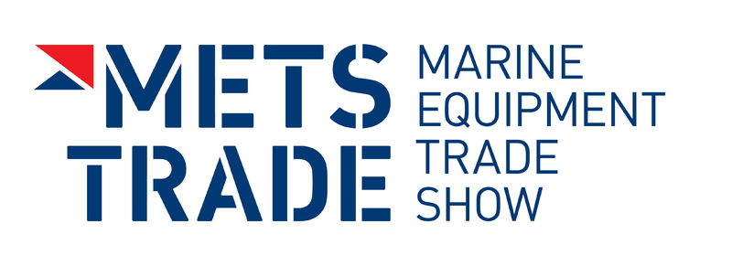
Press Release
For Immediate Release
17th November 2015
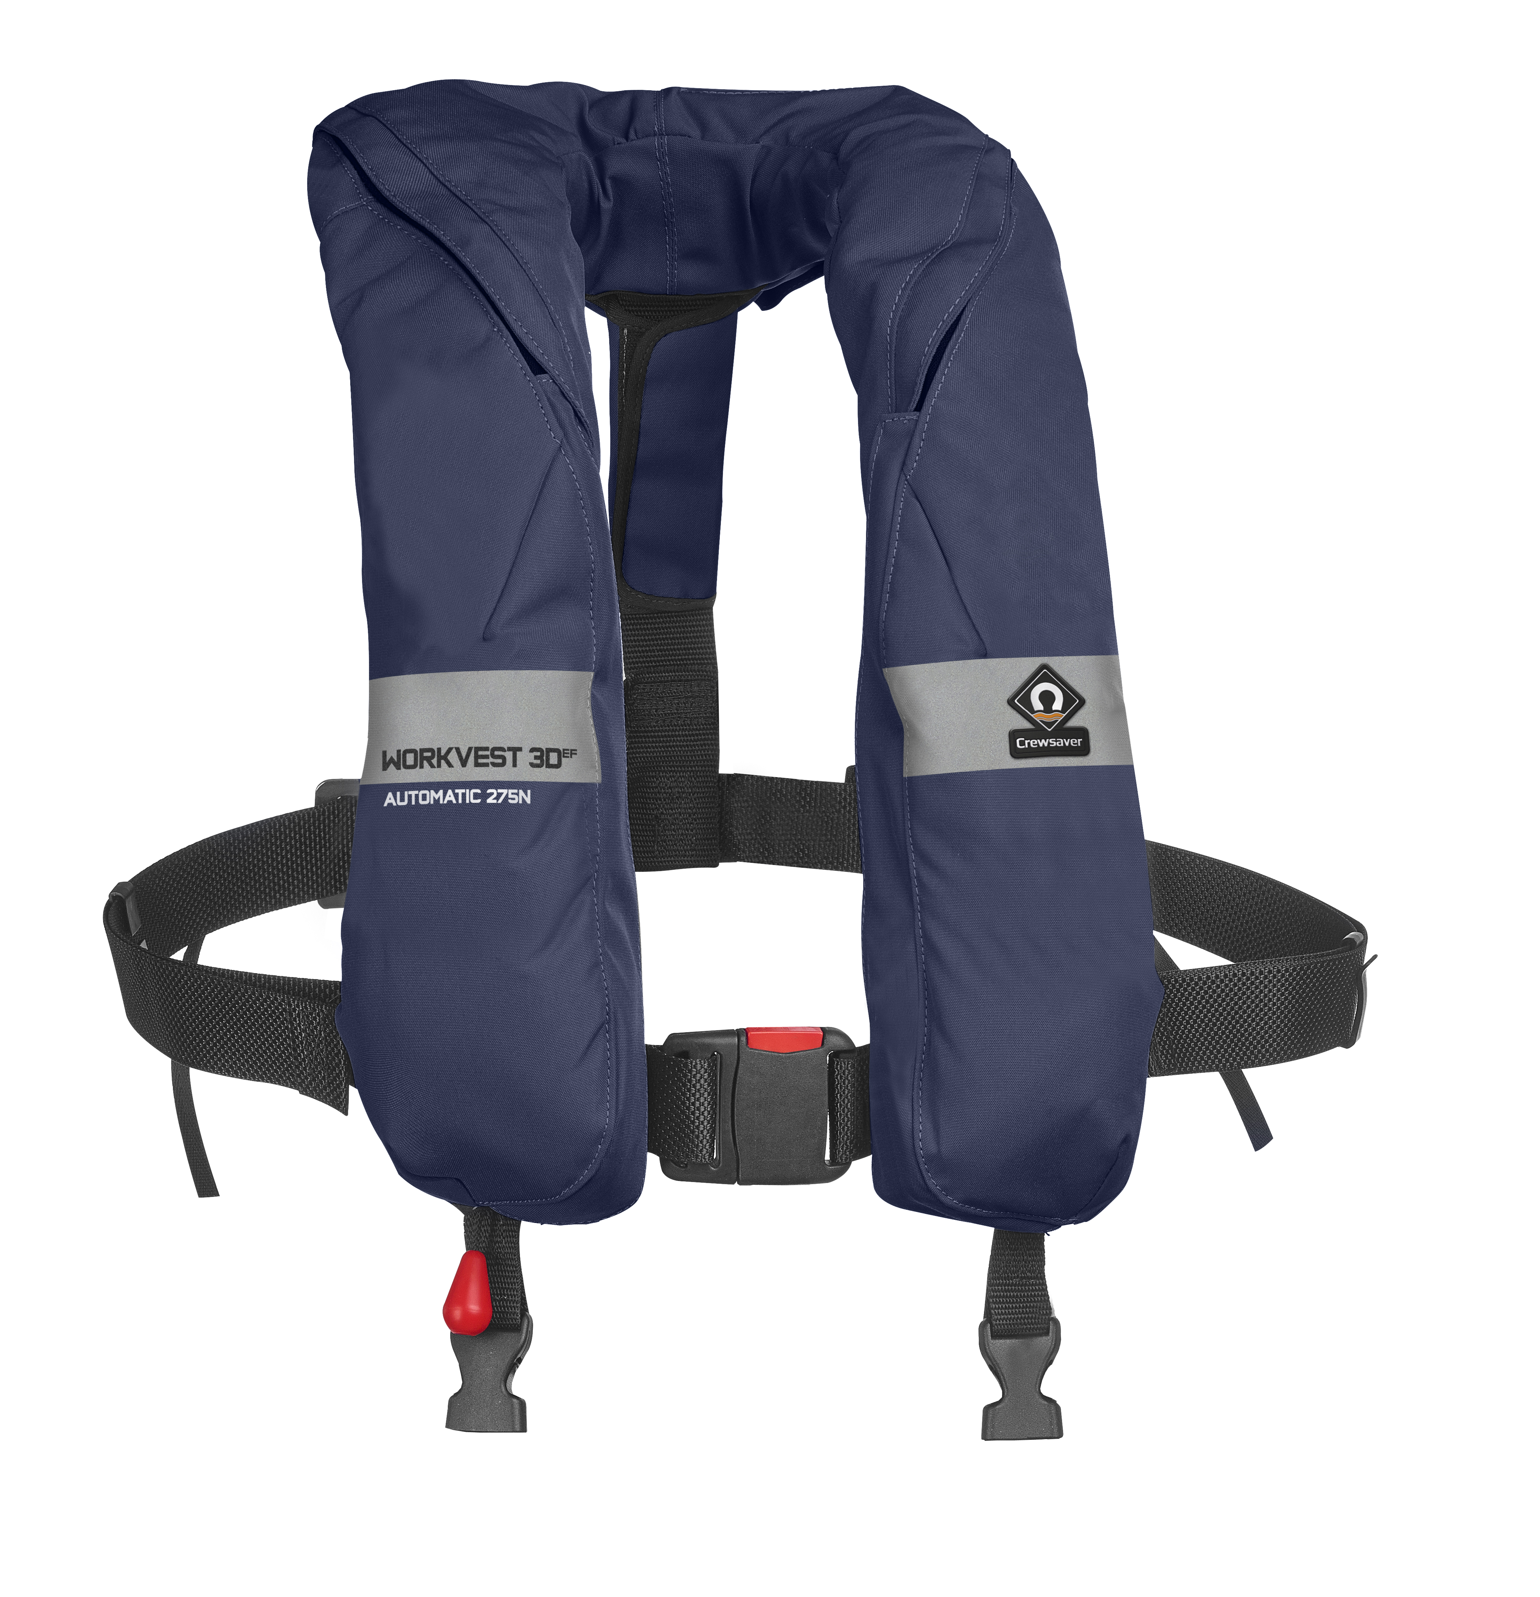
Brand new range of Crewsaver Work Vest lifejackets launched at METS 2015 including Fusion 3D designs for increased comfort levels - Crewsaver Stand Number 03.114

Comfort. Style. Performance.

Crewsaver launched a brand new range of Crewsaver Work Vest lifejackets at the Marine Equipment Trade Show (METS) in Amsterdam on 17th November 2015. The new range includes Work Vest lifejackets that have been designed using Crewsaver’s own innovative Fusion 3D technology, which moulds to the shape of your body and sits off the neck, giving the user total freedom of movement and thus ensuring increased comfort levels.

The new range takes into account the needs of those operating in a marine working environment, who require lifejackets with increased longevity even in the most extreme working environments, have advanced comfort properties so that teams can wear them for long periods of time and above all the most advanced safety features should the unexpected occur.

Tailored to the needs and demands of the industry and following the recent success of the Crewsaver leisure lifejacket range, the new Crewsaver Work Vest range includes the following;

- Crewfit 150N
- Crewfit 275N Work Vest
- Crewfit 275N Wipe Clean Work Vest
- Crewfit 275N 3D
- Crewfit 35 Work Vest – USCG Approved

Increased Longevity
By using the most advanced fabric technology and a thoroughly thought out construction method, Crewsaver has ensured that the lifejacket remains suitable for use even in the most extreme working conditions. Crewsaver’s 3D lifejacket features a replaceable cover system, meaning that covers can be replaced without replacing the entire lifejacket. This ensures that the lifejackets have a longer life.

Fusion 3D Design
This new range of commercial Work Vest lifejackets provides operators with the opportunity to purchase lifejackets created using Fusion 3D design technology (a first for the commercial Work Vest market) providing the user with increased comfort solutions.

Advanced Safety Features – ‘It’s What’s Inside That Counts’
Encompassed within all Crewsaver lifejackets are some of the most advanced safety features, helping the user to remain as safe as possible should the unexpected occur. For example, all work vest lifejackets now include a built in inflatable chin support, comfortably tilting the wearer’s head back and keeping airways clear whilst in the water.

Features incorporated into the entire range include:

- Unique chin support
- Reflective tape on outer cover
- ID Pocket
- Crotch strap/s
- Waist adjustment
ENDS//

For media information, hi-res images or product tests please contact:

Crewsaver
Hannah Burywood, Marketing Dept
T +44 (0) 1329 820024
E hannah.burywood@survitecgroup.com

Or

Alison Willis – Marine Advertising Agency Ltd
T +44 (0) 23 9252 2044
E Alison@marineadagency.com

Notes to Editors

Crewsaver is a world-leading manufacturer of marine safety equipment and clothing for the commercial and leisure marine industries. Based in Gosport, Hampshire, the company designs and manufactures bespoke safety equipment for several countries’ Special Forces, and the aviation and oil industries. Crewsaver is the only company to hold an exclusive contract to supply lifejackets to the UK government’s Environment Agency and the Royal National Lifeboat Institution (RNLI). They are part of the Survitec Group.

www.crewsaver.com

Survitec Group holds market-leading positions worldwide in marine, defence and aerospace survival technology. Headquartered in Birkenhead, the company employs 2000 people across 10 manufacturing sites and 50 service centres, operating through a network of a further 550 distributors and agents to bring its best-in-class products and services to a global customer base. With an extensive history spanning over 160 years and a portfolio of some of the most reputable brands in the safety and survival industry, Survitec is committed to product innovation, technological advancement and quality assurance.
Key products within Survitec’s portfolio include marine, defence and aviation Liferafts, world leading submarine escape technology, lifejackets for commercial airlines and the offshore industry as well as pilot flight equipment, including anti-g clothing used for the Eurofighter and JSF programmes. The Group also pioneered marine evacuation technology and today the unique MarinArk system is used on many major cruise ships across the globe.

www.survitecgroup.com

