**News Release**

**For immediate release**

**4th November 2015**

**Ancasta announces Prestige 680 to make UK debut at London Boat Show 2016**

**Ancasta International Boat Sales is proud to announce that the Prestige 680, the newest luxury motor yacht from Prestige, will make its UK debut at London Boat Show 2016.** The 21m luxury flybridge cruiser was launched at Cannes in September 2015 and will be heading to London Boat Show for its first UK outing at the show, which runs from 8th January to 17th January 2016.

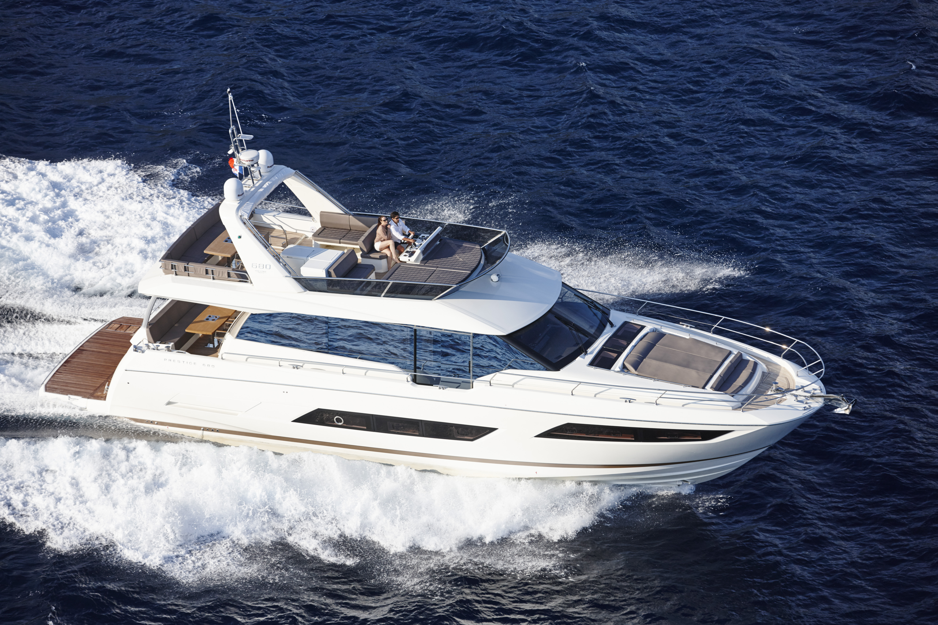The Prestige 680 boasts all the key features that have made the Prestige range so successful, including elements from the flagship Prestige 750, and is set to be unrivalled in the 68 foot motorboat market.

Coming from the drawing board of Garroni Design and with a J&J Design hull the Prestige 680 reflects the stretched lines and layout of the other successful motor yachts in the Prestige range. The Prestige 680 is powered by Twin Volvo IPS 1200 engines, providing high economy and easy manoeuverability even when short-handed. She is capable of a top speed of 30 Knots and with a cruising speed of 25 knots. The flybridge has a very large, private space linking to a lounge area with galley bar and a large forward sun terrace. Manoeuvrability is key to the helm position, which allows for maximum visibility to all areas of the boat.

The interior of the Prestige 680 exudes calm and style, benefiting from the use of beautiful original materials and an exceptional finish. The living space is enhanced by panoramic views thanks to large windows that bathe the area in natural light. The popular aft galley layout that other Prestige models enjoy has been translated into the Prestige 680, the dining area and lounge boast exceptional views and plenty of specially designed storage space, and the galley is cleverly planned for cooking or entertaining. The Prestige 680 additionally offers separate side door access from the helm position to the starboard deck while the large glazed sliding doors extend the saloon area into the cockpit like a balcony.

The innovative layout of the Prestige 680 means that the owner’s cabin is raised and forward, giving an independent cabin on one level that is both private and very light due to its large windows. Guest cabins are on a separate level, with access via their own staircase, adding to the sense of privacy for the owner. The model is available with a 3 or 4-cabin layout, plus crew cabin.



The Prestige 680 is set to be an incredibly popular model. With lines that are still daring and timeless, and a top quality finish and materials, the Prestige 680 maintains the historic technical attributes of the Prestige range whilst benefiting from the latest innovations.

Specification:

• **Designer** Garroni Design / J & J Design

• **Base Price** £1.151M ex VAT

• **On the Water Price** 1.243M ex VAT

• **LOA** 21.46 M

• **Hull Length** 19.08 M

• **LWL** 16.87 M

• **Maximum Beam** 5.33 M

• **Engine Size** Twin Volvo IPS 1200 D13-900HP

• **Cruising Speed** 25 Knots

• **Maximum Speed** 30 Knots

• **Maximum Range** 350 NM @ cruising speed

• **Dry (Light) Weight** 29,800 kg

• **Displacement** 39,600 kg

• **Cabins** Three or Four Cabins plus Crew

• **Standard Fuel Capacity** 3,450 litres

• **Standard Water Capacity** 920 litres

The Prestige 680 will have its UK debut at London Boat Show in January 2016. Contact Ancasta now to make an appointment to view, email Nick Hatfield ([nickhatfield@ancasta.com](mailto:nickhatfield@ancasta.com)) or call +44 2380 450017.

For more information visit <http://www.ancasta.com/boats-for-sale/new-boats/prestige/prestige-yachts/680/>

**ENDS**

**Notes to editors**

* Ancasta International Boat Sales has 15 offices across Europe
* Ancasta is the UK’s largest Prestige Luxury Motor Yachts dealer, the UK’s largest Beneteau Power and the UK’s largest Beneteau Sail dealer
* Ancasta is exclusive UK dealer for Lagoon Catamarans
* In addition Ancasta is a new boat dealer for Bordeaux 60, Fairlie Yachts and McConaghy Yachts
* The Ancasta Group incorporates Hamble Yacht Services Refit & Repair and Advanced Rigging and Hydraulics, both operating from Port Hamble.
* For more information on Ancasta visit www.ancasta.com

Media enquiries via Marine Advertising Agency:

Alison Willis - [alison@marineadagency.com](mailto:alison@marineadagency.com) Tel: 023 9252 2044