Press Release
For Immediate Release
12th January 2016
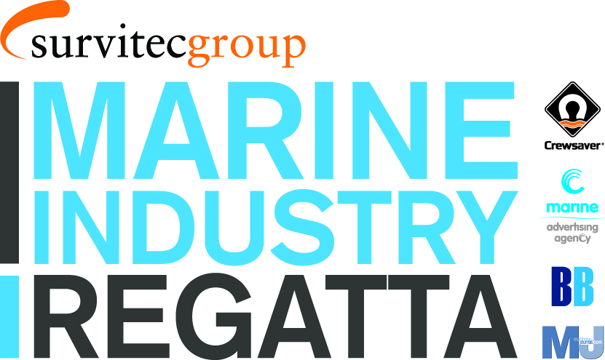
Marine Industry Regatta gets high profile support from Ian Walker at London Boat Show 2016

Ian Walker, who won the Volvo Ocean Race with Abu Dhabi Ocean Racing in 2015, has lent his support to the relaunched Marine Industry Regatta, which takes place on Wednesday 1st June 2016.

Ian spoke of this enthusiasm for the event at a drinks reception held at London Boat Show on 8th January 2016 and hosted by Survitec Group, proud sponsors of the Marine Industry Regatta 2016. He was keen to encourage the industry to take part, particularly as the event will raise funds for both the John Merricks Sailing Trust and the Andrew Simpson Sailing Foundation.

The event was well attended with journalists and industry figures alike indicating their support for the event. Interest has already been keen and more entries are anticipated soon.

The Marine Industry Regatta takes place on Wednesday 1st June 2016, sailing out of Port Solent in Sunsail First 40’s. The regatta is a great way to get together with other marine professionals and to entertain clients and staff. Charitable donations from the event will raise funds for the John Merricks Sailing Trust and the Andrew Simpson Sailing Foundation, another great reason to get involved.

For more information on the Marine Industry Regatta 2016, and to find out who has already signed up, please call Alex Tredget at Sunsail on 02392 222 221 or visit www.marineindustryregatta.com

ENDS//

For media information & hi-res images please contact:

Crewsaver
Hazel Proudlock, Marketing Dept
T +44 (0) 1329 820000
E hazel.proudlock@survitecgroup.com

Or

Alison Willis – Marine Advertising Agency Ltd
T +44 (0) 23 9252 2044
E Alison@marineadagency.com

Notes to Editors

Crewsaver is a world-leading manufacturer of marine safety equipment and clothing for the commercial and leisure marine industries. Based in Gosport, Hampshire, the company designs and manufactures bespoke safety equipment for several countries’ Special Forces, and the aviation and oil industries. Crewsaver is the only company to hold an exclusive contract to supply lifejackets to the UK government’s Environment Agency and the Royal National Lifeboat Institution (RNLI). They are part of the Survitec Group.

www.crewsaver.com

Survitec Group holds market-leading positions worldwide in marine, defence and aerospace survival technology. Headquartered in Birkenhead, the company employs 2000 people across 10 manufacturing sites and 50 service centres, operating through a network of a further 550 distributors and agents to bring its best-in-class products and services to a global customer base. With an extensive history spanning over 160 years and a portfolio of some of the most reputable brands in the safety and survival industry, Survitec is committed to product innovation, technological advancement and quality assurance.
Key products within Survitec’s portfolio include marine, defence and aviation Liferafts, world leading submarine escape technology, lifejackets for commercial airlines and the offshore industry as well as pilot flight equipment, including anti-g clothing used for the Eurofighter and JSF programmes. The Group also pioneered marine evacuation technology and today the unique MarinArk system is used on many major cruise ships across the globe.

www.survitecgroup.com

