**News Release**

**28th January 2016**

**Ancasta announces dates for 2016 Ancasta Spring Collection Event**

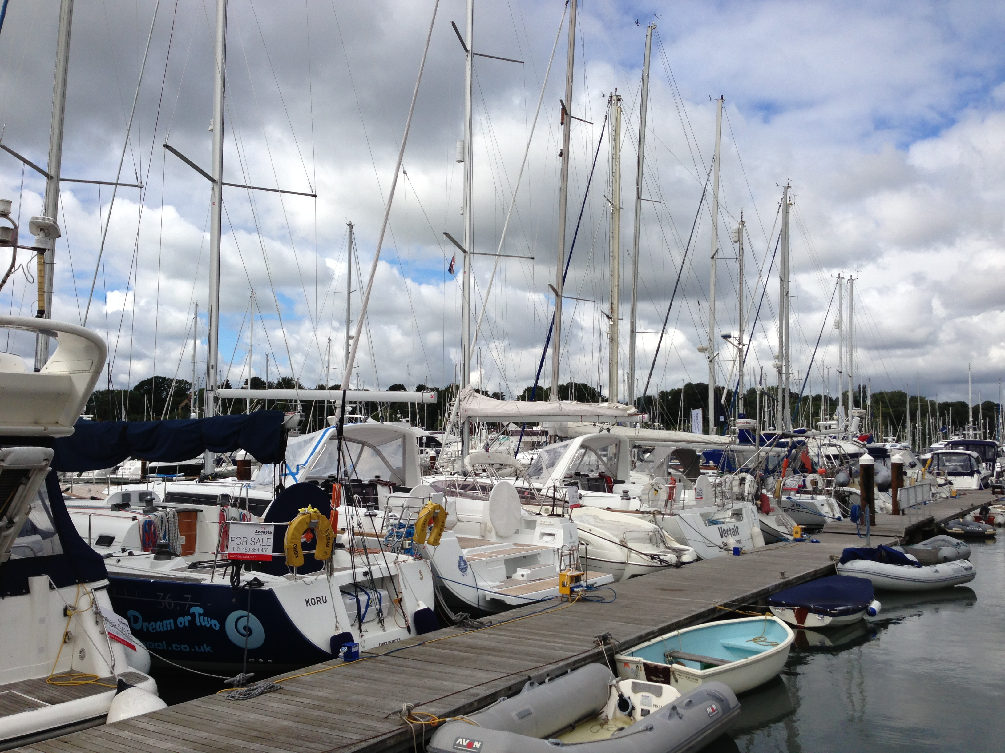Ancasta International Boat Sales has announced the dates for the 2016 **Ancasta Spring Collection Event,** Europe’s biggest brokerage event, which will take place this year between 25th March and 3rd April 2016.

The ten-day event spans two weekends, maximising the opportunities for buyers to see boats. A range of incentives for buyers will be announced nearer the time, making the Collection the ideal time to purchase a boat.

The **Ancasta Spring Collection** boasts a huge catalogue of quality pre-owned sail and power boats from across Ancasta’s network. The listings are presented in the **Ancasta Spring Collection** magazine as well as online.

The **Ancasta Spring Collection** has proved a huge success. The Collection is much anticipated by both vendors and buyers and has grown each year as the level of demand for quality pre-owned sail and power boats increases.

Further details, terms and conditions etc. can be found at [www.ancasta.com/ASC](http://www.ancasta.com/ASC)

Email enquiries@ancasta.com or call Ancasta’s head office on 02380 450 000

**ENDS**

**Notes to editors**

* Ancasta International Boat Sales has 15 offices across Europe
* Ancasta is the UK’s largest Prestige Luxury Motor Yachts dealer, the UK’s largest Beneteau Power and the UK’s largest Beneteau Sail dealer
* Ancasta is exclusive UK dealer for Lagoon Catamarans
* In addition Ancasta is a new boat dealer for CNB Yacht Builders and McConaghy Yachts
* The Ancasta Group incorporates Hamble Yacht Services Refit & Repair and Advanced Rigging and Hydraulics, both operating from Port Hamble.
* For more information on Ancasta visit www.ancasta.com

Media enquiries via Marine Advertising Agency:

Alison Willis - [alison@marineadagency.com](mailto:alison@marineadagency.com) Tel: 023 9252 2044