**News Release**

**For immediate release - 14th January 2016**

**Ancasta celebrates double win as brands scoop Motor Boat Awards**

**Ancasta International Boat Sales is celebrating the fact that two of its new boat brands, Prestige and Lagoon, were winners at the prestigious 2016 Motor Boat Awards, which were presented at a gala dinner on Monday 11th January 2016. The Prestige 680 was the winner in the ‘Flybridges over 60ft’ category while the Lagoon 630 won the ‘Trawler, Aft Cabins and Catamarans’ category.**

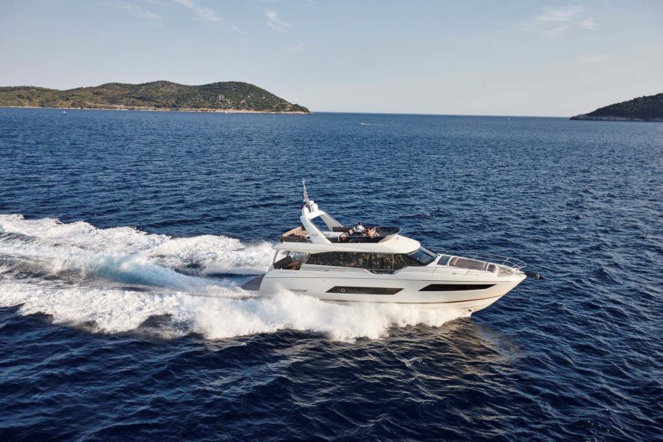

The Prestige 680, which has been very well received on its UK debut at London Boat Show 2016, was praised for its interior layout, leading the judges to comment “Our winner has turned the interior design of boats like this on its head. By delivering a main deck master cabin on a sub-70ft craft, it offers a real hit of superyacht space and luxury at an incredibly competitive price”.

The Lagoon 630 catamaran impressed the judges as, “The perfect long distance cruiser; a supremely effortless and comfortable liveaboard with minimal fuel consumption and cabins that blow you away”.

The Prestige 680

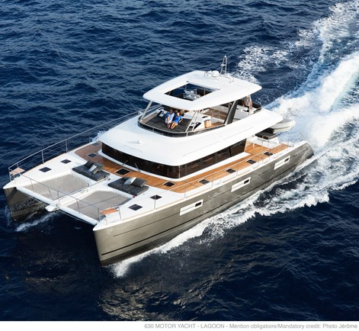

Ancasta was also delighted to see the Judges’ Special Award going to Carla Demaria of Groupe Beneteau. Ancasta is the UK’s largest Beneteau Sail and Beneteau Power dealer.

The Motor Boat Awards are incredibly well respected; a panel of five highly experienced marine journalists are responsible for sea-trialling all the finalists before selecting the winning craft. This year was the tenth anniversary of the awards, which were presented by *Motor Boat & Yachting*’s editor, Hugo Andreae, and deputy editor, Jack Haines, at the dinner hosted by Time Inc UK, the publishers of *Motor Boat & Yachting*.

The Lagoon 630

The Prestige 680 is on show at London Boat Show until 17th January 2016, and will also be presented at Boot Dusseldorf (23rd-31st Jan 2016). To arrange appointments to see these award-winning boats get in touch with Ancasta on +44 (0)2380 450000 or email [prestige@ancasta.com](mailto:prestige@ancasta.com) or [lagoon@ancasta.com](mailto:lagoon@ancasta.com) .

**ENDS**

**Notes to editors**

* Ancasta International Boat Sales has 15 offices across Europe
* Ancasta is the UK’s largest Prestige Luxury Motor Yachts dealer, the UK’s largest Beneteau Power and the UK’s largest Beneteau Sail dealer
* Ancasta is exclusive UK dealer for Lagoon Catamarans
* In addition Ancasta is a new boat dealer for CNB Yacht Builders and McConaghy Yachts
* The Ancasta Group incorporates Hamble Yacht Services Refit & Repair and Advanced Rigging and Hydraulics, both operating from Port Hamble.
* For more information on Ancasta visit www.ancasta.com

Media enquiries via Marine Advertising Agency: Alison Willis - [alison@marineadagency.com](mailto:alison@marineadagency.com) Tel: 023 9252 2044