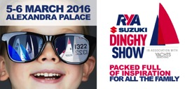
Press Release
For Immediate Release
RYA Suzuki Dinghy Show
5 – 6th March 2016

Spectacular Crewsaver offers at the 2016 RYA Suzuki Dinghy Show

Crewsaver has fantastic offers for visitors to the RYA Suzuki Dinghy Show looking to get kitted out for the season ahead. Visitors to this year’s show will benefit from exciting discounts on Crewsaver drysuits and Phase2 dinghy kit as well as receiving free products on Crewsaver sales over £30 and £150*. Here is a sneak preview to what visitors can expect to see at the show.

- FREE Bute Portage drybag for all Crewsaver purchases over £150. Worth £42.50 (RRP)*
- FREE Phase2 neck gaiter for all Crewsaver purchases over £30. Worth £15 (RRP)*
- Phase2 hikers and hiking pad combo deal. RRP £117.50, show price: £99.95*
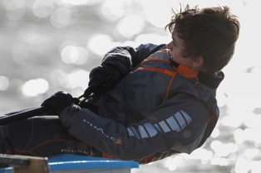
- Huge savings on the Cirrus drysuit, including a fleece under suit and drybag. RRP £345, show price £269*

Visitors can purchase Crewsaver at the show from any of the following Crewsaver retailer stands.

- Andark Diving & Watersports #F6
- Jimmy Green #D12
- Pinnell & Bax #A10
- Nucleus Watersports #C54
- Welsh Harp Boat Centre #G38

A wide selection of the Phase2 dinghy range will be available from Crewsaver retailers at the show. Alongside this, visitors will also be able to choose from other popular Crewsaver ranges including, drysuits, buoyancy aids and the extremely successful Fusion 3D lifejackets.

* T&Cs: Max 1 per purchase. Max 2 per customer. E&OE. Terms and conditions apply. Redeemable at stand of purchase.

ENDS//
For further information, product tests and images please contact:

Crewsaver
Hazel Proudlock, Marketing Dept
T +44 (0) 1329 820406
E hazel.proudlock@survitecgroup.com

Or

Alison Willis – Marine Advertising Agency Ltd
T +44 (0) 23 9252 2044
E Alison@marineadagency.com

Notes to Editors

Crewsaver is a world-leading manufacturer of marine safety equipment and clothing for the commercial and leisure marine industries. Based in Gosport, Hampshire, the company designs and manufactures bespoke safety equipment for several countries’ Special Forces, and the aviation and oil industries. Crewsaver is the only company to hold an exclusive contract to supply lifejackets to the UK government’s Environment Agency and the Royal National Lifeboat Institution (RNLI). They are part of the Survitec Group.

www.crewsaver.com

Survitec Group holds market-leading positions worldwide in marine, defence and aerospace survival technology. Headquartered in Birkenhead, the company employs 2000 people across 10 manufacturing sites and 50 service centres, operating through a network of a further 550 distributors and agents to bring its best-in-class products and services to a global customer base. With an extensive history spanning over 160 years and a portfolio of some of the most reputable brands in the safety and survival industry, Survitec is committed to product innovation, technological advancement and quality assurance.
Key products within Survitec’s portfolio include marine, defence and aviation Liferafts, world leading submarine escape technology, lifejackets for commercial airlines and the offshore industry as well as pilot flight equipment, including anti-g clothing used for the Eurofighter and JSF programmes. The Group also pioneered marine evacuation technology and today the unique MarinArk system is used on many major cruise ships across the globe.

www.survitecgroup.com

