Press Release
For Immediate Release
22nd February 2016

Crewsaver supports the Andrew Simpson Sailing Foundation Grant Programme by providing buoyancy aids to Garden Route Sailing Academy, South Africa.
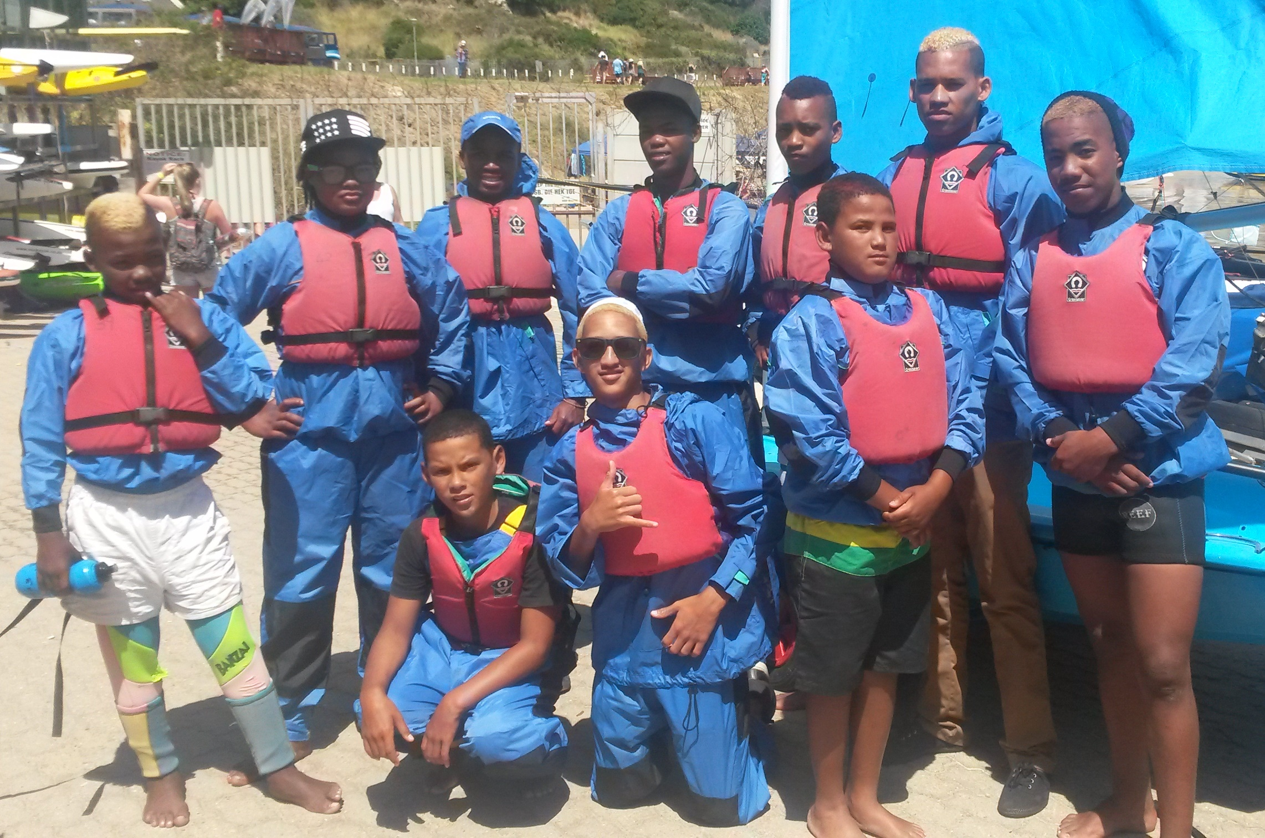
In 2015 the Andrew Simpson Sailing Foundation (ASSF) gave various grants to not-for-profit sailing organisations around the world. As an ASSF supporter, Crewsaver is proud to have provided much needed buoyancy aids to one of the organisations given a grant, Garden Route Sailing Academy.

Garden Route Sailing Academy is working with Ridgeview Primary School and Sao Bra High in Mossel Bay, South Africa, providing children from a local township with transport to and from Mossel Bay for regular sailing sessions.

“With the help of Crewsaver’s generous donation, more children from Mossel Bay townships can go on the water safely. Most children from the townships don’t get the opportunity to be good swimmers; therefore a proper fitting buoyancy aid is a vital piece of equipment. Garden Route Sailing has been operating for 9 years and a lot of our buoyancy aids are fast approaching the end of their usable life so thank you so much Crewsaver.” Elfie Holden, Garden Route Sailing Academy.

“When we saw the buoyancy aids the sailors were wearing it was clear to us that we needed to support the ASSF by ensuring that the organisations they were giving their grants to remained as safe as possible. Donating these buoyancy aids means that the organisations are able to spend the grants on getting the sailors out on the water as much as possible rather than on equipment.” Hannah Burywood, Marketing Manager – Crewsaver

In conjunction with the ASSF, Crewsaver look forward to supporting as many sailing projects as possible over the coming year.

ENDS//

For further information, product tests and images, please contact:

Crewsaver
Hazel Proudlock, Marketing Dept
T +44 (0) 1329 820000
E hazel.proudlock@survitecgroup.com

Or

Alison Willis – Marine Advertising Agency Ltd
T +44 (0) 23 9252 2044
E Alison@marineadagency.com

Notes to Editors

Crewsaver is a world-leading manufacturer of marine safety equipment and clothing for the commercial and leisure marine industries. Based in Gosport, Hampshire, the company designs and manufactures bespoke safety equipment for several countries’ Special Forces, and the aviation and oil industries. Crewsaver is the only company to hold an exclusive contract to supply lifejackets to the UK government’s Environment Agency and the Royal National Lifeboat Institution (RNLI). They are part of the Survitec Group.

www.crewsaver.com

Survitec Group holds market-leading positions worldwide in marine, defence and aerospace survival technology. Headquartered in Birkenhead, the company employs 2000 people across 10 manufacturing sites and 50 service centres, operating through a network of a further 550 distributors and agents to bring its best-in-class products and services to a global customer base. With an extensive history spanning over 160 years and a portfolio of some of the most reputable brands in the safety and survival industry, Survitec is committed to product innovation, technological advancement and quality assurance.
Key products within Survitec’s portfolio include marine, defence and aviation Liferafts, world leading submarine escape technology, lifejackets for commercial airlines and the offshore industry as well as pilot flight equipment, including anti-g clothing used for the Eurofighter and JSF programmes. The Group also pioneered marine evacuation technology and today the unique MarinArk system is used on many major cruise ships across the globe.

www.survitecgroup.com

