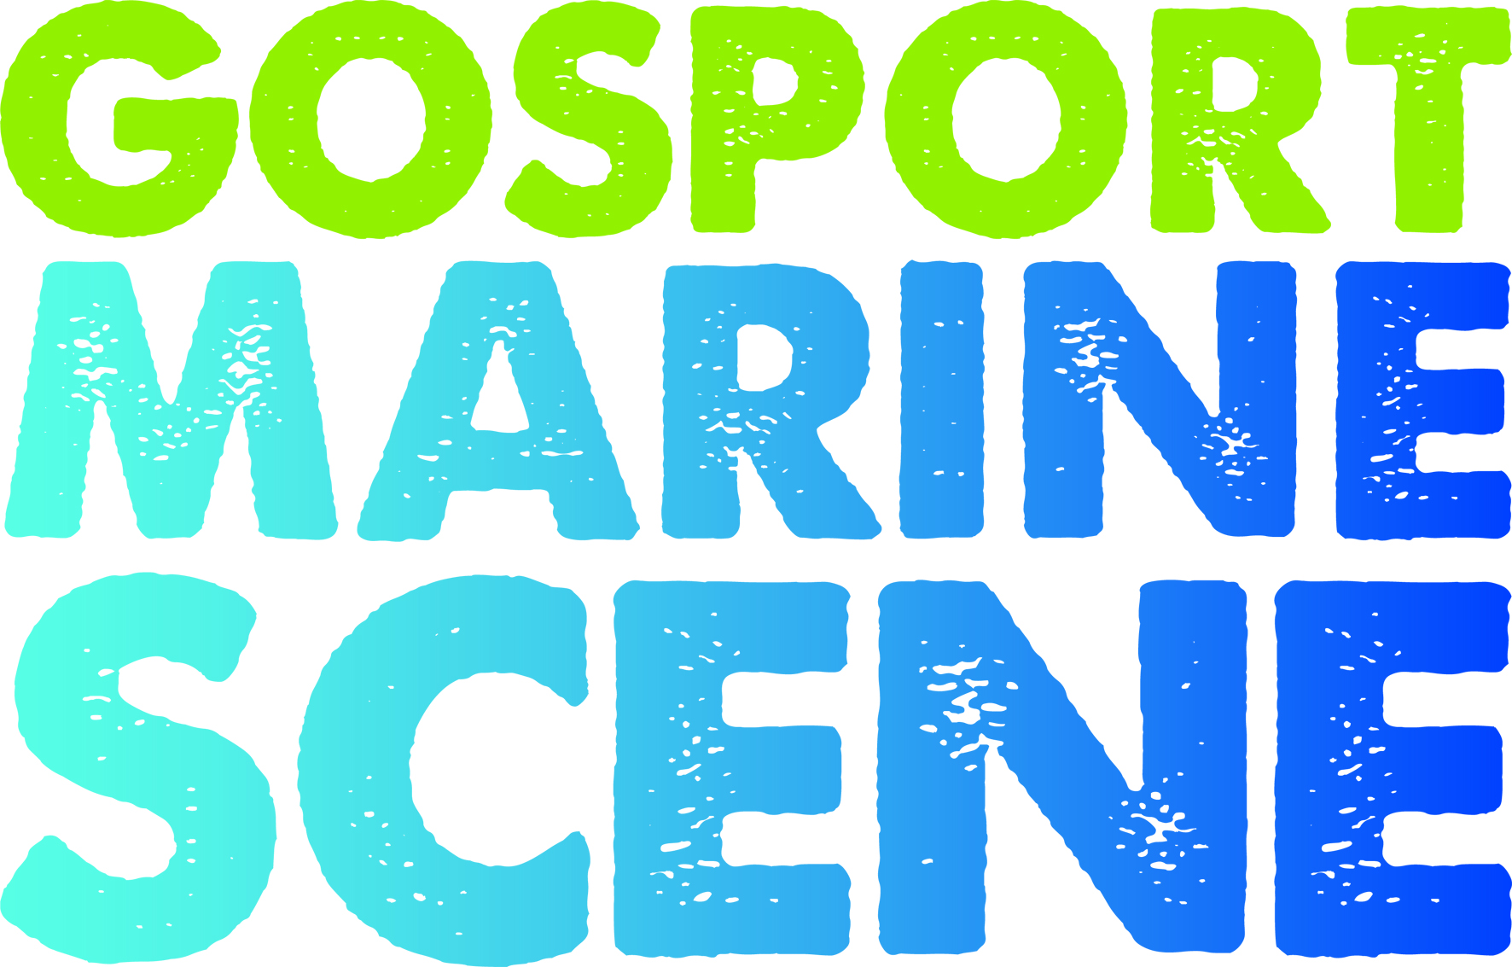

News Release
For immediate release
3rd February 2016

Gosport Marine Scene searches for 10 young crew to represent Gosport in Small Ships Race!

Gosport Marine Scene is offering a life-changing opportunity to ten young people from Gosport in the form of a sail training bursary called ‘Gosport Marine Futures’, which includes a place in the Small Ships Race. All 14-17 years old living in the Gosport area can apply. Learning to sail develops personal skills that improve young people’s ability to succeed in life, and offers a route to maritime jobs and careers.

“The crew will begin a 6-month course of team building activities and sail training, designed around school commitments, with Gosport’s Little Brigs, Cowes-based UKSA and GAFIRS, the Stokes Bay rescue service. In August, our team will race from Dartmouth to Gosport with Discovery Sailing Project, competing against 150 young crew from around the UK,” explains Councillor John Beavis MBE who, together with the teams at Motiv8 and the Gosport Community Safety Partnership, was Gosport Marine Scene’s inspiration to develop the programme.

On completion of the sail training, the crew will earn RYA Competent Crew accreditation, and receive support to join local sailing clubs or the Gosport Sea Cadet Unit, to continue to develop their skills. They will meet local employers for marine work experience and become the Gosport Marine Scene Youth Ambassadors. They will pass on the baton to the next crew at the Gosport Marine Festival on 27th May 2017.

Speaking at Bridgemary School, to students attending the Gosport Enterprising Women event, Abby Thomson, Founding Director of Gosport Marine Scene said ‘We aim to inspire the next generation to take up sailing and careers in the maritime sector. Over 1000 free on-the-water taster sessions have been delivered since 2013. Gosport Marine Futures is the next step for us. This will be an adventure, a challenge, and an experience you will never forget. The skills you learn will help you for your whole life.”

Gosport MP Caroline Dinenage added “I hope all the Gosport community will get behind our crew and follow their progress via the Gosport Marine Festival facebook page”.

To apply for this incredible opportunity visit www.gosportmarinefestival.org.uk to download full details on Gosport Marine Futures, including dates and an application form. Closing date is 21st February 2016. You don’t need previous sailing experience. You must be up for a challenge. The 10 successful crew, together as a team, will fundraise £150pp, which is the final 10% of the cost of the programme.

Businesses are invited to get involved with the Gosport Marine Futures programme through various sponsorship opportunities. To discuss these please email abby@gosportmarinescene.com

ENDS

Notes for Editors

About Gosport Marine Scene and Gosport:
Gosport Marine Scene is the organiser of Gosport's Marine Business Network, the Gosport Marine Festival (June 2015), and a Talent & Career Programme.

Gosport Peninsula is a centre of excellence in ocean racing, sail training, marine tourism and trade.
Gosport is the home of Alex Thomson Racing & Hugo Boss, Clipper Round the World Race, Global Ocean Race, Sail Training International, ASTO, Ocean Youth Trust South, Lee-on-Solent RYA Onboard. . . just for starters

To find out more about Gosport Marine Scene visit www.gosportmarinescene.com

