Press Release
For Immediate Release: 10th March 2016

Crewsaver Inflatable Mark Buoy Range

Used in some of the most prestigious, high profile sailing events around the world including at the 2012 Olympic Games and the 2014 Commonwealth Games, Crewsaver inflatable mark buoys are excellent quality; highly durable and offering great visibility.

The Crewsaver Inflatable Mark Buoy range offers a huge amount of flexibility; with products to suit customers’ needs whatever their event. Core to the range are cylindrical, dumpy and pyramid options, perfect for a multitude of events and sports including sailing regattas, triathlons and powerboat racing. All of these can be easily branded to help promote events, partners and sponsors.

In addition, Crewsaver offers a custom-made service; special colours, shapes and sizes are all a possibility if required.

Key features include:

- Hard wearing construction with durable double skin and inner inflation chamber
- Mooring harness fitted as standard
- Bright orange for high visibility

Crewsaver also has a wide variety of buoys to suit the needs of activity centres and sailing schools, giving instructors quick and reliable solutions for the busy working environment.

For more information on branding and custom-made solutions email: crewsaver.sales@survitecgroup.com

For more on Crewsaver visit www.crewsaver.com
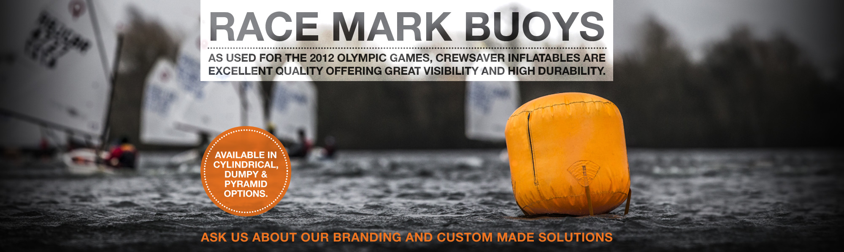

ENDS//

For media information, hi-res images or product tests please contact:

Crewsaver
Hazel Proudlock, Marketing Dept
T +44 (0) 1329 820406
E hazel.proudlock@survitecgroup.com

Or

Alison Willis – Marine Advertising Agency Ltd
T +44 (0) 23 9252 2044
E Alison@marineadagency.com

Notes to Editors

Crewsaver is a world-leading manufacturer of marine safety equipment and clothing for the commercial and leisure marine industries. Based in Gosport, Hampshire, the company designs and manufactures bespoke safety equipment for several countries’ Special Forces, and the aviation and oil industries. Crewsaver is the only company to hold an exclusive contract to supply lifejackets to the UK government’s Environment Agency and the Royal National Lifeboat Institution (RNLI). They are part of the Survitec Group.

www.crewsaver.com

Survitec Group holds market-leading positions worldwide in marine, defence and aerospace survival technology. Headquartered in Birkenhead, the company employs 2000 people across 10 manufacturing sites and 50 service centres, operating through a network of a further 550 distributors and agents to bring its best-in-class products and services to a global customer base. With an extensive history spanning over 160 years and a portfolio of some of the most reputable brands in the safety and survival industry, Survitec is committed to product innovation, technological advancement and quality assurance.
Key products within Survitec’s portfolio include marine, defence and aviation Liferafts, world leading submarine escape technology, lifejackets for commercial airlines and the offshore industry as well as pilot flight equipment, including anti-g clothing used for the Eurofighter and JSF programmes. The Group also pioneered marine evacuation technology and today the unique MarinArk system is used on many major cruise ships across the globe.

www.survitecgroup.com

